List of Currencies by Country
You might use your browsers search function to find a country or a currency
Countries A B C D E F G H I J K L M N O P Q R S T U V W Y Z

 | Country | Currency Name | Code A | Code N
A |  |  |  |  | 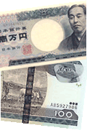  1 Japanese Yen  2 Ethiopian Birr  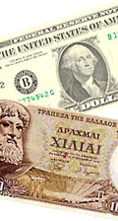  1. U.S. Dollar  2. Greek Drachma (obsolete, or maybe not)
 | Afghanistan | Afghani | AFN | 971
 | Albania | Lek | ALL | 008
 | Algeria | Algerian Dinar | DZD | 012
 | American Samoa | US Dollar | USD | 840
 | Andorra | Euro  Andorran Peseta | EUR  ADP | 978  020
 | Angola | Kwanza | AOA | 973
 | Anguilla | East Carribbean Dollar | XCD | 951
 | Antarctica | No universal currency | - | -
 | Antigua and Barbuda | East Carribbean Dollar | XCD | 951
 | Argentina | Argentine Peso | ARS | 032
 | Armenia | Armenian Dram | AMD | 051
 | Aruba | Aruban Guilder | AWG | 533
 | Australia | Australian Dollar | AUD | 036
 | Austria | Euro  replaced Austrian Schilling | EUR  ATS | 978  040
 | Azerbaijan | Azerbaijan Manat; Beginning January 2006, 1 new Manat (AZN) = 5000 old Manats (AZM). | AZN | 031
top of the page
B
 | Bahamas | Bahamian Dollar | BSD | 044
 | Bahrain | Bahraini Dinar | BHD | 048
 | Bangladesh | Taka | BDT | 050
 | Barbados | Barbados Dollar | BBD | 052
 | Belarus | Belarussian Ruble | BYR | 974
 | Belgium | Euro  replaced Belgium Francs | EUR  BEF | 978  056
 | Belize | Belize Dollar | BZD | 084
 | Benin | CFA Franc BCEAO | XOF | 952
 | Bermuda | Bermudian Dollar | BMD | 060
 | Bhutan | Ngultrum  Indian Rupee | BTN  INR | 064  356
 | Bolivia | Boliviano  Mvdol | BOB  BOV | 068  984
 | Bosnia and Herzegovina | Convertible Marks | BAM | 977
 | Botswana | Pula | BWP | 072
 | Brazil | Brazilian Real | BRL | 986
 | Brunei Darussalam | Brunei Dollar | BND | 096
 | Bulgaria | Lev  Bulgarian Lev | BGL  BGN | 100  975
 | Burkina Faso | CFA Franc BCEAO | XOF | 952
 | Burundi | Burundi Franc | BIF | 108
top of the page
C
 | Cambodia | Riel | KHR | 116
 | Cameroon | CFA Franc BEAC | XAF | 950
 | Canada | Canadian Dollar | CAD | 124
 | Cape Verde | Cape Verde Escudo | CVE | 132
 | Cayman Islands | Cayman Islands Dollar | KYD | 136
 | Central African Republic | CFA Franc BEAC | XAF | 950
 | Chad | CFA Franc BEAC | XAF | 950
 | Chile | Chilean Peso  Unidades de Fomento | CLP  CLF | 152  990
 | China | Yuan Renminbi | CNY | 156
 | Christmas Island | Australian Dollar | AUD | 036
 | Cocos (Keeling) Islands | Australian Dollar | AUD | 036
 | Colombia | Colombian Peso | COP | 170
 | Comoros | Comoro Franc | KMF | 174
 | Congo, Democratic Republic | Franc Congolais | CDF | 976
 | Congo, Republic of | CFA Franc BEAC | XAF | 950
 | Cook Islands | New Zealand Dollar | NZD | 554
 | Costa Rica | Costa Rican Colon | CRC | 188
 | Cote D'Ivoire | CFA Franc BCEAO | XOF | 952
 | Croatia/Hrvatska | Croatian Kuna | HRK | 191
 | Cuba | Cuban Peso | CUP | 192
 | Cyprus | 1 January 2008, the Cyprus Pound (CYP) was replaced by the euro; Northern Cyprus also Turkish lira in use | EUR  TRY | 978  949
 | Czech Republic | Czech Koruna | CZK | 203
top of the page

 | Country | Currency Name | Code A | Code N
D |  |  |  |  | 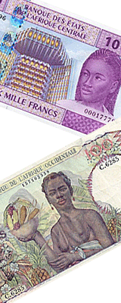  1. Central African CFA franc issued by Banque des États de l'Afrique Centrale  2. Early CFA franc note (1951) issued by Banque d'Afrique Occidentale  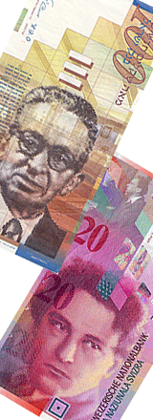
 | Denmark | Danish Krone | DKK | 208
 | Djibouti | Djibouti Franc | DJF | 262
 | Dominica | East Caribbean Dollar | XCD | 951
 | Dominican Republic | Dominican Peso | DOP | 214
top of the page
E
 | Ecuador | US Dollar | USD | 840
 | Egypt | Egyptian Pound | EGP | 818
 | El Salvador | El Salvador Colon  US Dollar | SVC  USD | 222  840
 | Equatorial Guinea | CFA Franc BEAC | XAF | 950
 | Eritrea | Nakfa | ERN | 232
 | Estonia | Kroon | EEK | 233
 | Ethiopia | Ethiopian Birr | ETB | 230
top of the page
F
 | Falkland Islands (Malvinas) | Falkland Islands Pound | FKP | 238
 | Faroe Islands | Danish Krone | DKK | 208
 | Fiji | Fiji Dollar | FJD | 242
 | Finland | Euro  replaced Markka | EUR  FIM | 978  246
 | France | Euro  replaced French Franc | EUR  FRF | 978  250
 | French Guiana | Euro | EUR | 978
 | French Polynesia | CFP Franc | XPF | 953
 | French Southern Territories | Euro | EUR | 978
top of the page
G
 | Gabon | CFA Franc BEAC | XAF | 950
 | Gambia | Dalasi | GMD | 270
 | Georgia | Lari | GEL | 981
 | Germany | Euro  replaced Deutsche Mark | EUR  DEM | 978  280
 | Ghana | Cedi | GHC | 288
 | Gibraltar | Gibraltar Pound | GIP | 292
 | Greece | Euro  replaced Drachma | EUR  GRD | 978  300
 | Greenland | Danish Krone | DKK | 208
 | Grenada | East Caribbean Dollar | XCD | 951
 | Guadeloupe | Euro | EUR | 978
 | Guam | US Dollar | USD | 840
 | Guatemala | Quetzal | GTQ | 320
 | Guinea | Guinea Franc | GNF | 324
 | Guinea-Bissau | Guinea-Bissau Peso  CFA Franc BCEAO | GWP  XOF | 624  952
 | Guyana | Guyana Dollar | GYD | 328
top of the page

 | Country | Currency Name | Code A | Code N
H |  |  |  |  | 1. Israel new shekel  2. Swiss franc  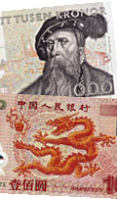  1. Swedish Krona  2. Chinese Yuan Renminbi  (yuan (元/圆) (sign: ¥))  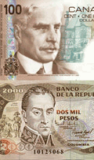  1 Canadian Dollar  2 Colombian Peso  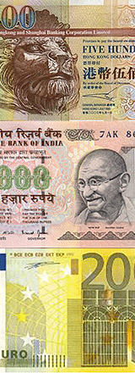  1. Hongkong Dollar  2. Indian Rupee  3. Euro
 | Haiti | Gourde  US Dollar | HTG  USD | 332  840
 | Holy See | Euro  replaced Lira | EUR  ITL | 978  380
 | Honduras | Lempira | HNL | 340
 | Hong Kong | Hong Kong Dollar | HKD | 344
 | Hungary | Forint | HUF | 348
top of the page
I
 | Iceland | Iceland Krona | ISK | 352
 | India | Indian Rupee | INR | 356
 | Indonesia | Rupiah | IDR | 360
 | Iran | Iranian Rial | IRR | 364
 | Iraq | Iraqi Dinar | IQD | 368
 | Ireland | Euro  replaced Irish Pound (Punt) | EUR  IEP | 978  372
 | Israel | New Israeli Sheqel | ILS | 376
 | Italy | Euro  replaced Lira | EUR  ITL | 978  380
top of the page
J
 | Jamaica | Jamaican Dollar | JMD | 388
 | Japan | Yen | JPY | 392
 | Jordan | Jordanian Dinar | JOD | 400
top of the page
K
 | Kazakhstan | Tenge | KZT | 398
 | Kenya | Kenyan Shilling | KES | 404
 | Kiribati | Australian Dollar | AUD | 036
 | Korea (North Korea) | North Korean Won | KPW | 408
 | Korea (South Korea) | Won | KRW | 410
 | Kuwait | Kuwaiti Dinar | KWD | 414
 | Kyrgyzstan | Som | KGS | 417
top of the page
L
 | Lao | Kip | LAK | 418
 | Latvia | Latvian Lats | LVL | 428
 | Lebanon | Lebanese Pound | LBP | 422
 | Lesotho | Loti (plural Maloti). It is equivalent to the South African Rand. | LSL | 426
 | Liberia | Liberian Dollar | LRD | 430
 | Libya | Lybian Dinar | LYD | 434
 | Liechtenstein | Swiss Franc | CHF | 756
 | Lithuania | Lithuanian Litas | LTL | 440
 | Luxembourg | Euro  replaced Luxembourg Franc | EUR  LUF | 978  442
top of the page
M
 | Macau | Pataca | MOP | 446
 | Macedonia, Rep. of | Denar | MKD | 807
 | Madagascar | Malagasy Franc | MGF | 450
 | Malawi | Kwacha | MWK | 454
 | Malaysia | Malaysian Ringgit | MYR | 458
 | Maldives | Rufiyaa | MVR | 462
 | Mali | CFA Franc BCEAO | XOF | 952
 | Malta | Maltese Lira | MTL | 470
 | Marshall Islands | US Dollar | USD | 840
 | Martinique | Euro | EUR | 978
 | Mauritania | Ouguiya | MRO | 478
 | Mauritius | Mauritius Rupee | MUR | 480
 | Mayotte | Euro | EUR | 978
 | Mexico | Mexican Peso  Mexican Unidad de Inversion (UDI) | MXN  MXV | 484  979
 | Micronesia, Federal States of | US Dollar | USD | 840
 | Moldova, Republic of | Moldovan Leu | MDL | 498
 | Monaco | Euro | EUR | 978
 | Mongolia | Tugrik (Tugrug) | MNT | 496
 | Montenegro | Euro | EUR | 978
 | Montserrat | East Caribbean Dollar | XCD | 951
 | Morocco | Moroccan Dirham | MAD | 504
 | Mozambique | Metical | MZM | 508
 | Myanmar | Kyat | MMK | 104
top of the page

 | Country | Currency Name | Code A | Code N
N |  |  |  |  | 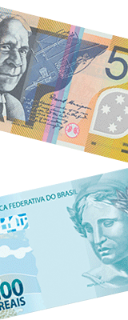  1 Australian Dollar  2 Brazilian Real  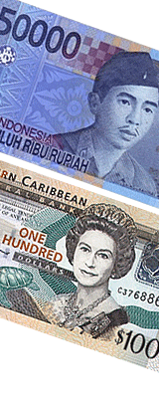1. Indonesian Rupiah  2. East Caribbean Dollar  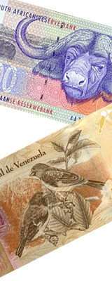  1 South African Rand  2 Venezuelan Bolivar  !!! All banknote images depicted on this page, are scaled down, cropped, and in a low resolution.  The purpose of use is to illustrate some of the worlds most used currencies. It is considered to be "fair use".
 | Namibia | Rand  Namibia Dollar | ZAR  NAD | 710  516
 | Nauru | Australian Dollar | AUD | 036
 | Nepal | Nepalese Rupee | NPR | 524
 | Netherlands | Euro  replaced Netherlands Guilder | EUR  NLG | 978  528
 | Netherlands Antilles  Curaçao, Sint Maarten | Netherlands Antillan Guilder | ANG | 532
 | New Caledonia | CFP Franc | XPF | 953
 | New Zealand | New Zealand Dollar | NZD | 554
 | Nicaragua | Cordoba Oro | NIO | 558
 | Niger | CFA Franc BCEAO | XOF | 952
 | Nigeria | Naira | NGN | 566
 | Niue | New Zealand Dollar | NZD | 554
 | Northern Mariana Islands | US Dollar | USD | 840
 | Norway | Norwegian Krone | NOK | 578
top of the page
O
 | Oman | Rial Omani | OMR | 512
top of the page
P
 | Pakistan | Pakistan Rupee | PKR | 586
 | Palau | US Dollar | USD | 840
 | Palestinian National Authority | - | - | -
 | Panama | Balboa  US Dollar | PAB  USD | 590  840
 | Papua New Guinea | Kina | PGK | 598
 | Paraguay | Guarani | PYG | 600
 | Peru | Nuevo Sol | PEN | 604
 | Philippines | Philippine Peso | PHP | 608
 | Pitcairn Island | New Zealand Dollar | NZD | 554
 | Poland | Zloty | PLN | 985
 | Portugal | Euro  replaced Portugese Escudo | EUR  PTE | 978  620
 | Puerto Rico | US Dollar | USD | 840
top of the page
Q
 | Qatar | Qatari Rial | QAR | 634
top of the page
R
 | Reunion Island | Euro | EUR | 978
 | Romania | Leu | ROL | 642
 | Russian Federation | Russian Ruble  Russian Ruble | RUR  RUB | 810  643
 | Rwanda | Rwanda Franc | RWF | 646
top of the page
S
 | Saint Helena | Saint Helena Pound | SHP | 654
 | Saint Kitts and Nevis | East Caribbean Dollar | XCD | 951
 | Saint Lucia | East Caribbean Dollar | XCD | 951
 | Saint Vincent and the Grenadines | East Caribbean Dollar | XCD | 951
 | Samoa | Tala | WST | 882
 | San Marino | Euro | EUR | 978
 | Sao Tome and Principe | Dobra | STD | 678
 | Saudi Arabia | Saudi Riyal | SAR | 682
 | Senegal | CFA Franc BCEAO | XOF | 952
 | Serbia | Serbian Dinar | CSD | 891
 | Seychelles | Seychelles Rupee | SCR | 690
 | Sierra Leone | Leone | SLL | 694
 | Singapore | Singapore Dollar | SGD | 702
 | Slovakia (Slovak Republic) | Slovak Koruna | SKK | 703
 | Slovenia | Euro since 1.1.2007 replaced Slovenian Tolar | EUR  SIT | 978  705
 | Solomon Islands | Solomon Islands Dollar | SBD | 090
 | Somalia | Somali Shilling | SOS | 706
 | South Africa | Rand | ZAR | 710
 | South Sudan | South Sudanese pound  since 18 July 2011 | SSP | 728
 | Spain | Euro  replaced Spanish Peseta | EUR  ESP | 978  724
 | Sri Lanka | Sri Lanka Rupee | LKR | 144
 | Sudan | Sudanese Dinar [obsolete]  since 10 Jan. 2007 Sudanese Pound | SDD  SDG | 736  938
 | Suriname | Suriname Guilder | SRG | 740
 | Swaziland | Lilangeni | SZL | 748
 | Sweden | Swedish Krona | SEK | 752
 | Switzerland | Swiss Franc | CHF | 756
 | Syrian Arab Republic | Syrian Pound | SYP | 760
top of the page

 | Country | Currency Name | Code A | Code N
T |  |  |  |  | 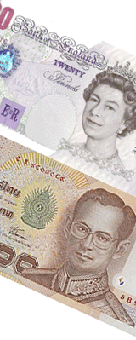  1. British Pound  2. Thai Baht  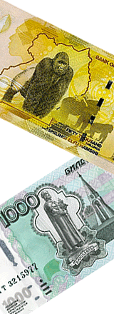  1. Uganda Shilling  2. Russian Ruble
 | Taiwan, Republic of China | New Taiwan Dollar | TWD | 901
 | Tajikistan | Somoni | TJS | 972
 | Tanzania | Tanzanian Shilling | TZS | 834
 | Thailand | Baht | THB | 764
 | Timor Leste | US Dollar | USD | 840
 | Togo | CFA Franc BCEAO | XOF | 952
 | Tokelau | New Zealand Dollar | NZD | 554
 | Tonga | Pa¥anga | TOP | 776
 | Trinidad and Tobago | Trinidad and Tobago Dollar | TTD | 780
 | Tunisia | Tunisian Dinar | TND | 788
 | Turkey | Yeni Türk Liras (YTL)  on 1 January 2005 New Turkish Lira replaced Turkish Lira (TRL) | TRY | 949
 | Turkmenistan | Manat | TMM | 795
 | Turks and Caicos Islands | US Dollar | USD | 840
 | Tuvalu | Australian Dollar | AUD | 036
top of the page
U
 | Uganda | Uganda Shilling | UGX | 800
 | Ukraine | Hryvnia | UAH | 980
 | United Arab Emirates | UAE Dirham | AED | 784
 | United Kingdom | Pound Sterling | GBP | 826
 | United States | US Dollar r (Same day)  US Dollar r (Next day) | USS  USN | 998  997
 | Uruguay | Peso Uruguayo | UYU | 858
 | Uzbekistan | Uzbekistan Sum | UZS | 860
top of the page
V
 | Vanuatu | Vatu | VUV | 548
 | Vatican City State (Holy See) | Euro  replaced Lira | EUR  ITL | 978  380
 | Venezuela | Bolívar fuerte venezolano (since 1 January 2008;  replaced at 1 bolívar fuerte for 1000 old bolívares)  (until 31 December 2007) Bolivar | VEF  VEB | 937  862
 | Viet Nam | Dong | VND | 704
 | Virgin Islands (British) | US Dollar | USD | 840
 | Virgin Islands (U.S.) | US Dollar | USD | 840
top of the page
W
 | Wallis and Futuna Islands | CFP Franc | XPF | 953
 | Western Sahara | Moroccan Dirham | MAD | 504
top of the page
Y
 | Yemen | Yemeni Rial | YER | 886
top of the page
Z
 | Zambia | Kwacha | ZMK | 894
 | Zimbabwe | Zimbabwe Dollar | ZWD | 716
top of the page

