TOPIC 2/4
Field fortifications fundamentals, types of protective structures

Protective structures ensure close protection of personnel, equipment and material against destructive means through their protective layers, bearing structure and equipment. Thus they ensure conditions in according to occupancy.
Blast wave protection is ensured through structure strength and back pressure adjustment of door and other apertures. This requirements are met by shelters. Other protective structures only decrease blast wave effects.
Nuclear blast thermal radiation protection is ensured through using of non-combustible material for structure construction or through using of non-compustible wall finish (cement or lime paste, clay layer, asbestos etc.). It is necessary to dispose combustible materials from structure's surrounding.
Nuclear blast ionizing radiation protection is ensured through the protective layer (overhead cover) thickness and through thickness of bearing structure. Neutron radiation protection level depends on protective layer (overhead cover) thickness and material used for it´s construction. Higher layer of soil, it´s watering or using of neutron radiation protective material is usually required.
Nuclear fallout, toxic or biological agents protection is ensured through proper insulation of inner area, protective layer thickness, bearing structure thickness, overpressure making inside a structure and intensive ventilation (air filtration).
Incendiary weapons protection is ensured through flame resistance of outside walls and prevention of incendiary agents leaking into the structure.
Penetration and fragmentation protection is ensured through bearing structure strength and protective layer thickness.
Seismic effects protection is ensured by structure strength and proper joint of all parts of structure.
Live conditions of personnel and employment of equipment are ensured through protective structures equipment according to their purpose.
Design of protective structure, protective layer thickness, bearing structure, layout and equipment has to take in account destructive means and their effects, structure purpose, level of protection required and it´s location on terrain. Most of protective structures include protective layer, bearing structure and equipment.
Bearing structure transmit the constant load of protective layer and the impose load of blast effect on foundation soil.
Protective layer protects against penetration (shells, grenades, bombs), eliminates blast effect and nuclear weapon using effects. Protective layer of temporary structures includes soil (rubble stone, concrete or wood can be used) and insulating layer. Soil or stone is usually used to overhead cover construction, surface structures construction, and protective layers of semi-underground and buried structures. Insulating layer obstructs water and contamined air penetration into a protective structure.
Terrain fortification
Terrain fortification is such activity enabling limitation or withdrawal of its unfavorable characteristics and it´s development for combat. It includes such engineer measures that are able to limit efficiency of adversary´s combat activity. The base of fortification is permanent or field protective structures building in time with fire system.
SCOPE OF BUILDING | PERSONNEL CASUALTIES EXPECTED (%)
Unbuilt defense. Unprotected forces on open terrain. | 90
Detached foxholes or pits for firing devices and funk holes for personnel built. | 24
Squad trenches, main and spare foxholes or pits for firing devices and funk holes for personnel with overhead cover built. | 18
Main and spare foxholes or pits for firing devices, trenches in platoon strong points, sectors of approach trench, funk holes for personnel with overhead cover, sectors of trenches with overhead cover, platoon shelters built. | 12
Table 1. PROTECTIVE STRUCTURES´ IMPACT ON FORCE PROTECTION AGAINST CONVENTIAL MEANS OF DESTRUCTION
FORTIFICATIONS are engineer constructions built to reduce or eliminate unfavorable characteristics of terrain and develop it for combat. Their aim is to decrease an efficiency of adversary´s combat activity. In terms of function fortifications can be classify into:
- protective structures
- field-type barriers.
PROTECTIVE STRUCTURES are engineer structures, enabling direct protection for personnel, equipment and material against enemy weapons´ effects in combat . They also enable effective fire and firm command of forces. Protective structures complex is a system build to force and other targets protection against enemy fires and CBRN attacks thereby supporting force and equipment function according to plan of their usage. It can be for example squat defensive position, company or battalion theatre of defense etc. There are usually build different types of structures in the system.
CONSTRUCTED OBSTACLES are built to stop, slow down or canalize enemy´s maneuver, break it´s battle formation and afford opportunity to destroy it by fire.
There are three points of view to classify protective structures:
- Close protection level : open, overhead covered and enclosed structures.
- Aim: fire structures, observation structures, funk holes, working structures, rest structures, storage structures, approach structures etc.
- Ground level placement: above-ground structures, semi-underground structures, buried structures and mined structures.
Open protective structures provide protection against adversary´s fires and effects of NBC working horizontally. They especially protect against direct fire of convential weapons, decrease possibility of fragments hits, decrease effects of blast wave, ionizing and thermal radiation. They are usually build as semi-underground structures.
Overhead covered structures provide better protection against enemy´s fire (vertical protection) and effects of NBC than open protective structures. They also protect against bad weather conditions (rainfall, snowfall, hailstorm). They improve protection against ionizing radiation, partially also against blast wave effects (especially effects of grenades´ and bombs´ blast). They significantly improve protection against thermal radiation, fragmentation and effects of incendiary weapons. They are usually build as buried protective structures with roof construction covered by excavated soil.
Enclosed protective structures (shelters) provide the best protection. They protect against direct hits of grenades and bombs (caliber depends on structures´ strength), they decrease effects of NBC including nuclear weapons. They also protect against effects of incendiary weapons. Minimum one back-pressure gate has to be in entry part of shelter. Shelters are usually built as buried structures (occasionally as mined structures). They can provide (depending on equipment) collective protection against chemical and biological agents.
PROTECTIVE STRUCTURE TYPE CHOICE AND GROUND LEVEL PLACEMENT LIMITING FACTORS
- aim,
- required level of protection,
- geological (soil consistency) and ground water conditions (ground-water level),
- material, time and other conditions.
Strength and close protection are basic characteristics of protective structures.
Strength is marginal ability of subject (personnel, equipment, material, structure etc.) to retain it´s typical characteristics although exposed to destruction. Strength is quantificated as maximal parameter value of destructive means (their effects) or as minimum standoff distance from blast of particular mean of particular caliber. Unprotected personnel, equipment and material have their own strength against destructive means´‚ effects. If personnel, equipment or material is placed into protective construction, it´s close protection decrease as a result of structure´s protective characteristics. Protective structure´s strength usually differ from strength of protected property. For example the strength of a trench with revetment to blast wave overpressure is 0,1 MPa but personnel placed in this trench have the strength to blast wave overpressure only 0,03 MPa. Other factors like ionizing radiation does not have an impact on protective structure but have an effect on protected personnel. The strength of protective structures to effects of destructive means has to be the same or higher then the strength of personnel, equipment or material placed into that protective structures.
Close protection is an ability of protective mean (e. g. protective structure) to avert by it´s protective capacity strength overrun of protected property (a. g. personnel). Close protection is quantificated as maximal parameter value of destructive means (their effects) acting outside the protective mean or as minimum standoff distance from blast of particular mean of particular caliber.
The quality of protective structure as the object of destruction is characterized by it´s strength. The quality of protective structure as the protective mean is characterized by provided close protection level.
Categorization of protective structures determinates the provided level of protection to personnel, equipment, material and also provided live and working conditions inside.
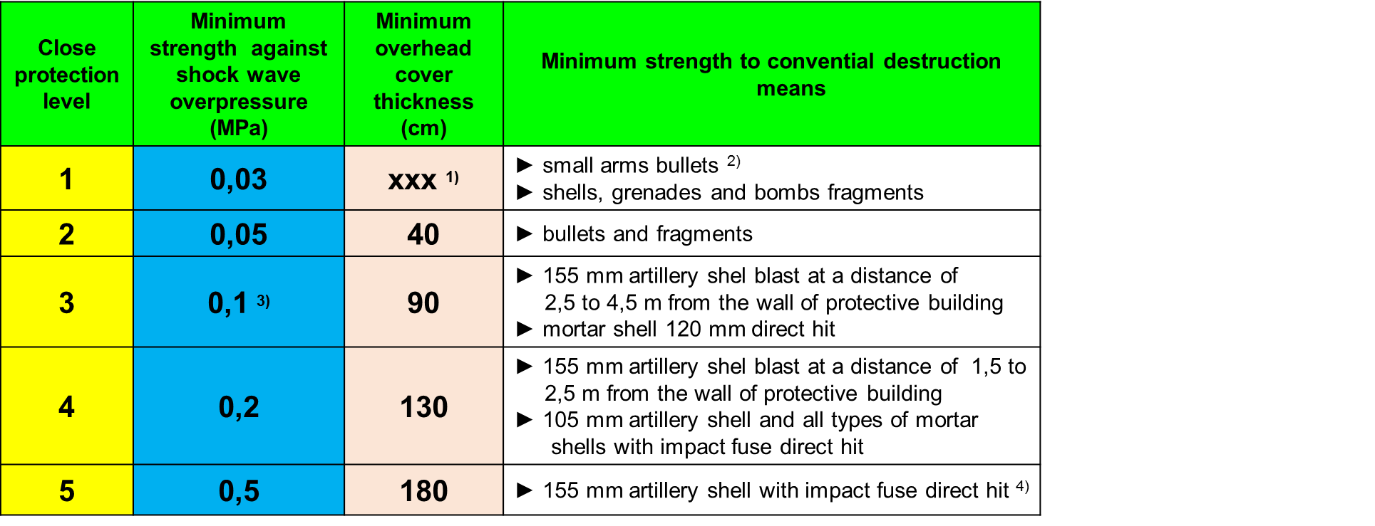
Categorization consists in close protection level and equipment class determination.

Table 2. STRENGTH REQUIREMENTS FOR CLOSE PROTECTION LEVELS

Table notes:
- Ionizing radiation protection depends on personnel position
- Personnel is protected particularly
- Protection of access has to eliminate blast wave incursion into protective structure.
- Protection against shells with delay fuse ensured by 70 cm thick initiation layer built of rubble stone
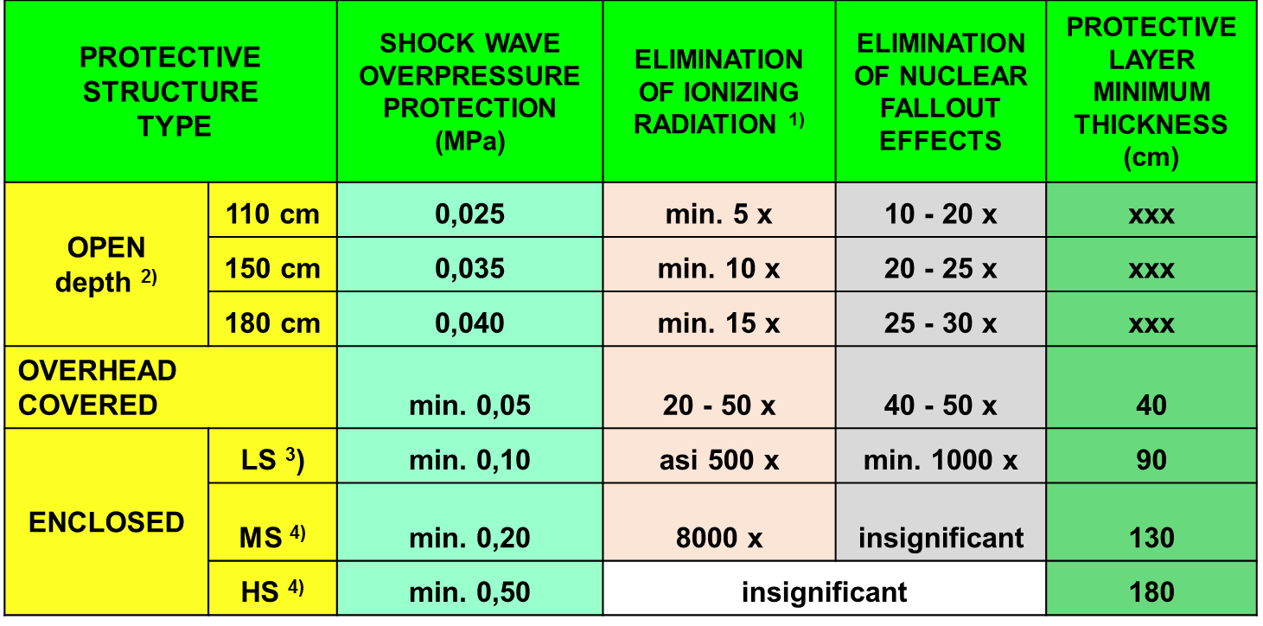

Table 3. BASIC CHARACTERISTICS OF PROTECTIVE BUILDINGS
Table notes:
- Estimated angle of ionizing radiation propagation is of 45o.
- Personnel protection depends on nuclear blast type, structure location and personnel position
- Shelter is not usually equipped with collective protection means
- Shelters usually provide collective protection
The protection level and protective structures´ strength have to be continuously increased. Open protective structures are gradually deepened, fitted with revetment, overhead covered and replaced by shelters. Higher strength of enclosed protective structures is accomplished by increasing of bearing structure ultimate load and protective layer thickness. Protective structure complexes are completed by building of structures providing higher level of protection and equipment class.
Equipment class determinates quality and quantity of protective structures including collective protection means. It create living and working conditions for personnel and equipment during it´s placement inside protective structure. Classes are marked by capital letter from A to F. Class A provides maximal comfort. Class F is almost without equipment. Field fortifications use classes F and E exceptionally D. Higher classes are used in permanent protective structures.

Class F is almost without equipment. It can provide only bench and emergency lighting. It dos not provide collective protection. In case of surroundings contamination personnel has to use gas-mask. It enable personnel to stay there for several hours.
Class E is equipped with field furniture, heating, lighting. It provides collective protection by structure insulation and filtration and ventilation equipment. It enable personnel to stay there for up to 24 hours.
Class D is equipped with field furniture, permanent lighting, water supply, emergency sanitary, air heating. It provides collective protection. It enable personnel to stay there for up to 3 days.
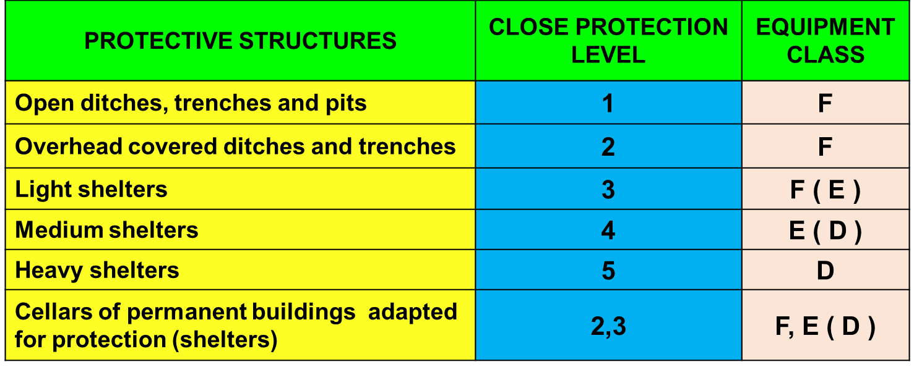

Table 4. PROTECTIVE STRUCTURES EQUIPMENT ACCORDING TO CLOSE PROTECTION LEVEL AND EQUIPMENT CLASS
PROTECTIVE STRUCTURE LAYOUT
Protective structure layout is usually based on:
- Ground plan and height dimensions
- Sections layout
- Ground level and enemy´s fire placement

Protective structure usually consist on:
- Entry section
- Functional section

FACTORS AFFECTING PROTECTIVE STRUCTURES LAYOUT DEVELOPMENT:
- Type of structure – open, overhead covered, above-ground
- Aim of structure - firing post, funk hole
- Protected property, it´s dimensions and activity conducted inside protective structure – personnel, weaponry, equipment
- Structure capacity
- Required strength and equipment class
- Construction materials
- Geological conditions, ground-water level and topography
- Other requirements – camouflage requirements, enter location etc.
It is also necessary to take into account time conditions, possible activity of enemy, number and quality of own forces and equipment useful to protective structure (complex of structures) building etc. This limits optimal shapes and dimensions of protective structure resulting to reach minimal volume of excavation. Protective structures have to be located on terrain to complete it´s protection capacity using undulations. It also results to excavation work reduction. The best enter location leads into undulation, or trench (overhead covered trench sections).

ENTRY SECTION CONSTRUCTION FUNDAMENTALS
- Entry section has to enable personnel and equipment to enter functional section. It usually consists of enter structure, parapet or overhead cover, equipment for protective structure entering (stairs, ladder) and other facilities (drainage, camouflage).
- Enter can be opened to the terrain or to other protective structure (e.g. trench). It is necessary to use terrain of proper protective and camouflage capacity.
- Enter is usually located on the opposite side to enemy´s fire. If enter is opened to the trench this must be there improved by digging deeper and overhead covered.
- Enter can be built of corridor or shaft design
- Enter is built on the narrow side with direct or broken horizontal layout
- Shaft is usually built when enter is opened directly to open terrain. Mostly it is used as emergency exit from shelter.
- Enter to pits for equipment is ramp.
Corridor type entry section is usually built on the narrow side. The horizontal layout can be direct or broken.
Direct entry section layout is basic and it is the most expedient solution from a construction point of view. Usually it is opened to other protective structure (trench, ditch, pit) or it ca be opened to open terrain (pit ramp).
Broken entry section layout is usually used if it is opened to open terrain. This layout provides better protection against convential destruction means effects (fragmentation, blast wave). It´s influence to protection against nuclear blast wave is insignificant. One bend decreases overpressure load of 2 to 5 %. Broken layout has many disadvantages – complicated work during building, higher volume of excavation, higher material demand etc.
Entry vertical layout can be level or down. Level layout is usually used for open protective structures construction. If the bottom of a protective structure´s ditch is below the bottom of a trenches ditch or terrain ground level It is necessary to overcome difference in height by:
- Stairs – gradient usually 1:1 (30/30 cm),
- Ramp (equipment enter) – gradient 1:1,5 – 1:5,
- Wall ledges ( Cuts for toe cups),
- Ladder made of pole timbers.

FUNCTIONAL SECTION CONSTRUCTION FUNDAMENTALS
Entry section is designed for function support and protection of personnel, equipment material and other property.
Horizontal and vertical entry section layout depends on:
- Aim of protective structure
- Amount of personnel (equipment, material) expected to use protective structure
- Protective structure design
- Terrain conditions in area of construction
- Combat situation (time, building equipment etc.)

