TOPIC 2/8
Engineer concealment, camouflage and deception equipment and its usage
NATURAL CAMOUFLAGE
Natural camouflage is basic, the fastest, the easiest and the cheapest type of camouflage. It is used in all situations including such measures enabling full hiding, disguising or disrupting of objects and activities by proper usage of terrain camouflage capacity, lighting and meteorological conditions. The most useful are woods, bushes, vistas, narrow-sunken roads, hallows, ravines, undulations and urban areas (barns, woodsheds, walls, fences, breezeways, sheds, narrow streets). Cast shadows are used always. Artificial camouflage is used where using of natural camouflage cannot provide sufficient protection. Artificial camouflage requires increased usage of personnel, equipment and more time.
Terrain configuration and particularities are important for camouflage. Woodland, bush land, grassy area, exposed rock, agricultural area, horticultural area, water surface, urban area or snow covered terrain have their typical surface pattern, color, configuration and emissive characteristics.
Woodland provides very good conditions for hiding of targets from ground and air surveillance and RADAR reconnaissance. Dense wood of witch treetops are in mutual contact fully hides from bevel and vertical surveillance. Thin wood hides only from bevel surveillance. Hiding of targets from vertical observation in thin wood requires additional camouflage measures. If deploying in the wood it is necessary to avoid useless woodcutting markedly disintegrating shapes of rides and fringes of forest thereby contributing to detect hidden objects. Broad-leaf woods are more useful to deter air surveillance in the summer than coniferous woods. They does not provide proper hiding from air surveillance in the winter. Dense woods with undergrowth are useful for hiding of units eliminating air and ground surveillance (ground surveillance is possible if wood depth is less than 100 m). If the unit choose an assembly area in the wood the equipment and protective structures are placed along roads and rides under dense tree tops in places limiting air surveillance conducted by enemy. This placing of units enable them quickly leaves the threatened area in case of fires and fire scars. Roads and rides hidden under tree tops are the most useful to conceal movement of units. Objects are usually hidden on northern edges of woods being covered with shadow during daytime.
Bush land is characteristic of irregular pattern and configuration created by various bush sizes. It provides advantageous conditions to hide targets from air and ground surveillance. The most useful is a shrubbery with various height of shrubs various sizes of their tops and irregular distance between them.
Grassy area is monotonous in terms of pattern and colors therefore each disturbance and footprints are visible and they have to be carefully concealed. Artificial spots can be can be easily made on grassy area surface to suit it to color of hidden object.
Terrain surface with exposed rock is advantageous to hide earthworks usually visible on the covered terrain surface. Excavated rock can be used to tone color of hidden object with color of background.
Various pattern of great spots linear shape is typical of agricultural area. Color and pattern of this terrain substantially changes during the year. Vehicles' movement and lines of trenches have to be placed next to boundary of spots.
Linear shapes of small geometrical areas are typical of horticultural areas. In comparison with agricultural area the pattern of horticultural area created by beds and furrows is markedly striped. Footprints created next to beds are less visible.
Water surface differs from other types of terrain in its mirror image. All subject placed or moving on water surface are more visible and they can be easily detected. Water surface is most advantageous for target detection with RADAR. Water surface is also very good landmark for all types of air reconnaissance due to its visibility. Sometimes it is necessary to camouflage water surface itself. It is impossible to camouflage objects placed on water surface to be fused with it. They are therefore placed next to banks concealed by masks imitating adjacent bank.
Urban area is characterized by brightly colored surface, geometric shapes of spots and cast shadows with multiple roads. It enable camouflage of object themselves and also the movement to them. Settlements, lonely places and other inhabited places create advantageous conditions for camouflage especially for RADAR and thermal observation denying. Terrain with buildings, private plots, gardens, parks, orchards is very advantageous. Personnel, equipment and protective structures are detectable there with difficulties. Cast shadows thrown by terrain objects in case of sunny weather increase the level of color variety. Combat and transportation equipment is hidden inside barns, hovels, under sheds, in ruins, orchards, in cast shadows and behind fences. If equipment is deployed in the locality for a short time it can be placed next to buildings and covered with local camouflage materials.
Terrain covered with snow is monotonous so it makes camouflage of objects harder. Various footprints are visible on snow covered surface and shadows are visible in case of sunny weather. However the snow is the most available material to conceal exposed rock, some footprints and objects.
Proper placing of object is reached by hiding it under or behind natural masks, its suiting to shape, pattern and color of background or neighborhood or by using terrain object´s shadow. Terrain bumps (elevations, gorges, banks, holes, ravines, hallows) or terrain objects (wood, bush, fence, stack of straw, settlements etc.) can be used to hide objects from ground surveillance. Object can be hidden from air surveillance by placing itself under roofs of buildings or under tops of full-grown trees.

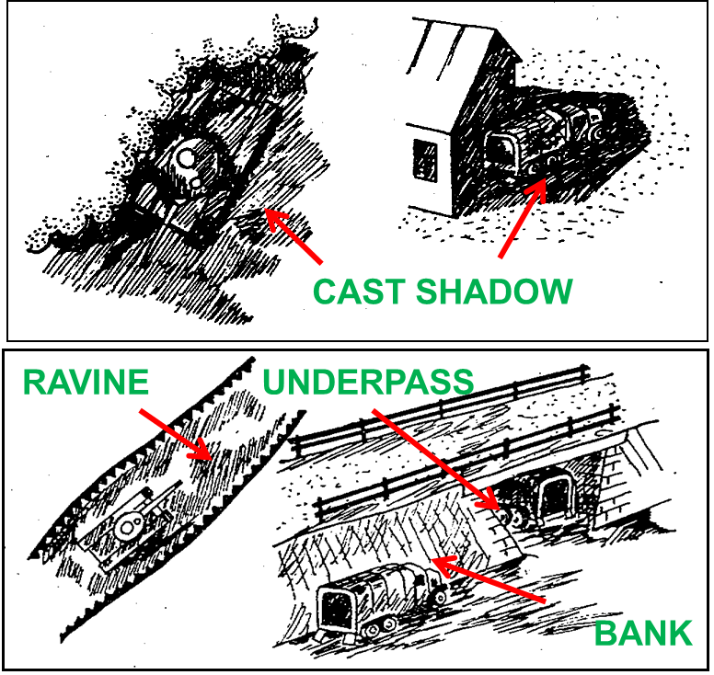

Figure1. Usage of cast shadows and undulations for equipment camouflage purpose
Usage of meteorological and light conditions can significantly facilitate a hiding of various objects therefore it is one of basic ways of camouflage in all combat situations especially in offensive operations, during movements and engineer activities. It is to be taken in account that the night, limited visibility, and bad weather conditions cannot enemy to fully disable conduct reconnaissance using optoelectronic means, acoustic reconnaissance means, RADARs, and means operating in IR specter.
Vegetation usage for camouflage purpose
The aim of vegetation usage for camouflage purpose is to reduce contrast between camouflaged object surface and neighborhood especially built-up areas, places divested of vegetable cover etc. Other purposes are to tone reflective characteristics of camouflaged object with reflective characteristics of neighborhood and improve camouflage properties of terrain.
Vegetation usage for camouflage purpose represents the using such camouflage techniques that are based on using of live or cut-off vegetation to create additional camouflage to artificial camouflage means or as camouflage means itself.
Camouflage useful properties of cut-off vegetation are gaining simplicity, easy preparing and bringing, immediate camouflage effect, easy adjustment to camouflaged object or background. Unusable properties are quick wilting and the change of color depending on weather. Using live vegetation can limit that shortages but it requires much time to achieve proper camouflage effect. Grass, tree or bush branches can be used for additional camouflage with artificial or natural camouflage screens or covers, for fitting of terrain surface parts, for concealment of combat, transportation or special equipment using distortion means.
Using of tree or bush branches is the most frequent and the easiest. The most useful woody plants are conifers. They are characterized by their durability of wilting able not fall off and to keep their color to 10 days during the summer and to 3 months during the winter. Its applicability is limited to coniferous and mixed wood. Wilting of leafy trees can cause rolling up and falling of leafs causing reduction of camouflaged area. The mask made of leafy trees branches became more transparent. Wilting can also cause the change of leafs' color (yellow and brown) and then the contrast with background and neighborhood. If used the spectrozonal photo material the mask has been early detected.
Live vegetation masks are usually used to gain long time camouflage effect. They are natural thus undetectable with color and spectrozonal photo material, they support camouflage against all reconnaissance means including RADARs and they are permanent requiring almost no maintenance. Their disadvantages are based on limited camouflage efficiency to 6 mounts a year because camouflage properties of leaf masks are limited in the winter. Grow of vegetation causes also camouflage effect delay. Much manpower is sometimes necessary to set up these masks.
Artificial made spots on terrain surface
Terrain modification for purpose of camouflage serves to improve terrain camouflage capacity and change area pattern. It improves the concealment of forces and objects. This modification is based on artificial spots making especially when the terrain surface is uniform. Spots can be made in one color or as multicolored. Spots have to be as detectable as possible in horizontal projection to disable analyze air surveillance. Each object (tank) has to be placed on extra spot only linear objects (trenches) may cross several spots.
If tanks, cars, shelters etc. are camouflaged spots are made in groups so the number of spots has to be two and more times bigger than number of camouflaged objects.
Dark spots if useful are the most advantageous for placing of objects because limiting shadows. Light spots then create additional camouflage measure. The shape of artificial made spots vary according to typical natural spots occurring in the area they are made. Before creating of spots it is necessary to conduct proper air photo reconnaissance of area.
Artificial spots making is conducted out of contact with enemy usually during camouflage making of operational objects (logistics areas, airports, storage areas, assembly areas of reserve forces etc.) because of long time consumption and greater amount of working personnel. If made in contact with enemy or on the tactical level spots created by combat are usually used (burned terrain surface after explosions).
Artificial made spots are made by unturfing, ploughing, grass cutting, snow surface disintegration, trees and bush clearing, explosive using, soil or other material scattering, vegetation burning off and camouflage colors or other chemicals spraying.
- Unturfing on great areas is conducted using dozers. Turf is usually not removed. Its bottom side is placed upward or it is cut and placed around to increase the area of spot.
- Area is ploughed if it is necessary to create narrow strip spots along roads or if fields or ditches are imitated.
- Grass cutting is useful in all cases. If the grass is high the greatest color contrast can be reached. Cut grass is usually left on side used to camouflage soil from excavation if required. It enables to gain three types of spots varying in color and brightness in visible specter and on spectrozonal and IR snapshots. The first type of strip is created by cut grass left on side and getting dry, the second type of spots is created by uncut grass and the third type of spots are created by removing of cut grass.
- Snow surface disintegration is used to camouflage footprints detectable especially on hillsides and also to improve camouflage covers made on areas of disintegrated snow surface. Snow sweepers, trucks with improvised snow plow or tops of trees can be used to this purpose.
- Explosives are used to create artificial made spots improving terrain camouflage capacity. This way is efficient especially in winter when the soil thrown by explosion create thin layered cover on the snow covered surface. It creates dark contrasting spot of irregular shape.
- Soil or other material scattering (slag, send, straw etc.) is always useful including on snow cover in winter.
- Vegetation burning off is a way to create dark spots. This way is advantageous if enough local combustible materials available (straw). This material evenly placed on the area of future spot is burn on several places from windward side.
- Camouflage colors or other chemicals spraying are useful where soil has been exposed. If making artificial spots it is possible to change color of grass. This can be sprayed with chemicals or it is fertilized. Spots are made of brown or green color. Typically used chemicals (their water solutions friendly to nature) are blue or iron vitriol, zinc chloride or potash chloride. If soil is fertilized the grass gets dark (dark green color) and grows. It usually occurs after seven to ten days. Nitrate is used as fertilizer and the grass has to be often watered.

Figure2. Artificial made spots on terrain surface
ARTIFICIAL CAMOUFLAGE
Artificial camouflage includes such measures based on usage of industrially made technical means with that army force are equipped. This camouflage means can be completed with local materials. Artificial camouflage streams realization conducting of camouflage measures including basic and additional camouflage techniques. Artificial camouflage measures are adopted where the terrain has not proper camouflage properties.
PAINTING OF SURFACE CAMOUFLAGE
Painting of surface camouflage is artificial surface color change of objects, masks and terrain parts using special colors possibly local material. It makes their identification with visual methods and optical electric reconnaissance harder in visual and IR specter.
The aim of painting of surface camouflage is to aggravate identification of shape, distort angles and edges, right vertical and horizontal lines, decrease color and brightness contrast with the background and neighborhood. The advantages of painting of surface camouflage are unlimited function of object, easy and quick practicability, the same strength as camouflaged object and low cost. It also enable to use other camouflage techniques at the same time or concealment in the proper terrain. There are three painting of surface camouflage ways:
- protective painting,
- deformation painting,
- imitation painting.
Protective painting is monochromatic coloration depending on season of the year and color of environment. The most common cast is khaki (mixture of black, brown, light green, dark green and yellow color), send or white. Protective painting is the most useful for camouflage of stationary object placed in plain environment having no sharp and accurate shapes (continuous snow layer, meadows, sand-banks etc.), small stationary objects (small weapon, radio set etc.). Protective painting is disadvantageous in case of mobile objects camouflage in the environment that is contrasting in terms of the color and the brightness.
Deformation painting is more advantageous than protective painting. It is multicolored enabling camouflaged object less detectable on various types of terrain. It is based on spots of 10 to 50 cm in width characteristic for certain season of the year. It is possible to complete it with additional color spots enabling it to conceal in specified environment. The aim of this type of painting is to make air, ground and photo reconnaissance results interpretation more difficult, to visually deform characteristic shape of object, to disrupt primary and cast shadows of objects especially of combat equipment and trucks. Deformation painting is used for mobile objects. It is conducted by crews in accordance with unified army methodic. Deformation painting principles:
- Upper surface of object has to be darker than lateral surface as a whole. It is achieved so that the width of light green spots is of 20 to 30 cm on upper surface and of 40 to 50 cm on lateral surface at the expense of dark spots.
- Spots are not ended on moulding edges on principle but they continue to adjacent surface. Imaginary axis of spots has to contain angle with edge of 30° to 60°, it has to be asymmetric and of irregular shape.
- 4 to 6 big stripes has to be seen on the silhouette of camouflaged object when observed from different sides.
- Ledges, corners, permanently shady object parts, visible loop holes etc. Have to be included in dark spots.
- Two times to three times more white spots than dark spots has to be on the surface in the winter. It depends on coherency of snow layer. More elongated spots with fissured shapes are used in the winter. The axis of spots is slightly arake.
- Dark green colored surface is of one third to one half of whole equipment surface in the summer. Color spots has to be made of round shape in case of the summer paint.

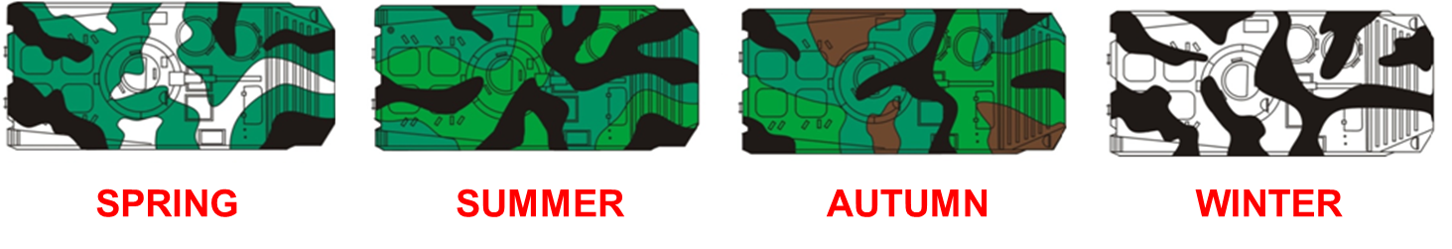

Figure3. Czech Army camouflage patterns
Imitation painting is made to bear a resemblance of camouflaged object to an environment. Imitation painting has to be made of easy spot pattern corresponding with pattern of the environment surrounding the object that is stationary as a rule. Color casts has to be modified according to seasons of the year and their typical colors.
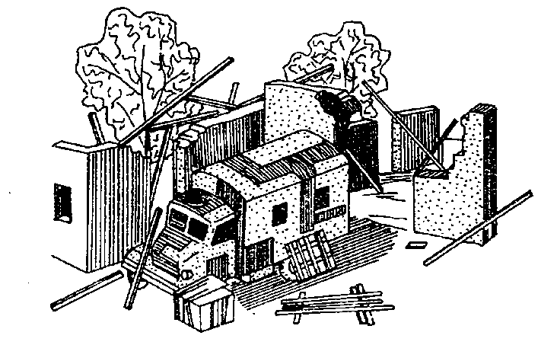

Figure4. Imitation painting
Painting of surface camouflage means
Summer and winter camouflage paint set of colors and camouflage paint equipment set are applied in Czech army to conduct painting of surface camouflage. Colors are based on casein binding agent and they are made as water-based paint. These colors are removable using brush and water. Colors are prepared in conform with manual. Used casts are white, black, light green, dark green (yellow, brown, red).
Set weight 37 kg
Color content 34 kg per 2 kg
Color dilution water 1:1
Spreading capacity about 15 m²
Preparation time 2 hours
Crew 4 person
Camouflage paint equipment set serves to apply casein colors. Set includes:
Rice brush 3 pc.
Wooden plunger 4 pc.
Knot brush 2 pc.
Silon brush 2 pc.
Flat brush 6 pc.
Screen 1 pc.
Galvanized bowl 4 pc.
Cleaning rags 4 pc.
Transportation bag 1 pc.
Longtime exploitation color set is used to make protective, deformation and imitation paintings of military equipment and objects in conditions of long time exploitation (up to 10 years). They are useful against visual-optical reconnaissance and some types are also useful against optical electronic reconnaissance in NIR specter.
Painting of surface camouflage modern trends
Multispectral colors
RADAR camouflaging colors have extensive camouflage effect in micro wave specter absorbing reflected RADAR signal. Colors useful to camouflage in IR specter are being developed too. Their effect is based on thermal radiation decrease of camouflaged object.
Digital camouflage
Digital camouflage is a type of camouflage pattern combining micro- and macro patterns, often though not necessarily with a pixelated look created with computer assistance. The function is to provide military camouflage over a range of distances, or equivalently over a range of scales, in the manner of fractals. Not all multiscale patterns are pixellated, and not all pixellated patterns work at different scales, so being pixelated does not of itself guarantee improved performance. The basis of digital camouflage are three basic principles:
- Bi- or multi scale patterns - add high spatial frequency texture components that add concealment at closer ranges,
- Dithering - the production of intermediate colors where two fields of color meet,
- Edge effect - to modify visual processing of edges.
Of the three points, the last is somewhat speculative.
Examples of digital camouflages:
- MARPAT (short for MARine PATtern) – US Marine Corps combat uniforms,
- ACUPAT (Army Combat Uniform PATtern) – US Army combat uniforms,
- SKYPAD Lighting and Thunder – Air Forces,
- Razzcam – ships and submarines.
Examples of armies using digital camouflage patterns:
- USA,
- Canada,
- Great Britain,
- China,
- Slovakia,
- Finland,
- Australia,
- Jordan,
- United Arab Emirates.

SCREENING
Screening has to limit the visibility or objects or to fully hide them. Natural masks completed with the artificial camouflage material, blending means, artificial masks, combat, transportation and special equipment decoys and phoney facilities are used for this purpose.
Blending means change the shape of camouflaged objects, their primary shadow therefore their external appearance. They are usually used to camouflage combat, transportation and special equipment. Blending can be carry out with distortion means and additions.
Distortion means are used to change geometrical shape of objects, to accommodate to irregular spots and shapes of surrounding terrain and to distort cast shadows. Cut-off tree and bush branches or artificial distortion means are usually used. This technique can be used for bigger object camouflage too. For example bush decoys are used to camouflage roads leading to important objects.
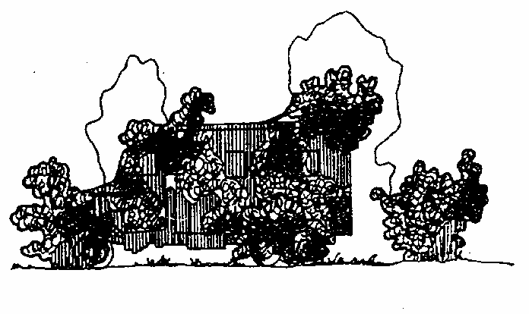

Figure5. Distortion means
Additions are designs used to imitate camouflaged object damage or to imitate another type of object. They are placed next to camouflaged object or directly on its surface.
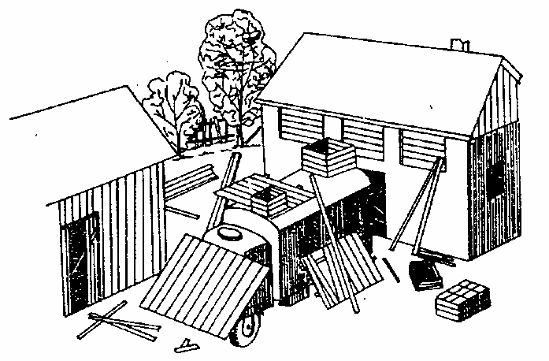

Figure6. Additions
Artificial masks are one of the main technical means of camouflage deterring ground, air and space reconnaissance. They are used when terrain camouflage capacity is not sufficient. Artificial masks may be made as vertical, horizontal and bevel camouflaging screens or as flat, convex and concave camouflaging covers. Real or dummy objects can be camouflaged with them. Dimensions and shape of masks is determined by dimensions, easy tending requirements and way of combat equipment maneuver.
- Vertical camouflaging screens are used to conceal ground reconnaissance. They are installed along the road on the side towards an enemy behind formation and water channels and where decreasing surveillance with enemy´s easy ground reconnaissance means is required.
- Horizontal camouflaging screens ere usually used as road underpass able masks. Vertical masks are installed across the road to conceal movement on the road detect by using air and cosmic reconnaissance means.
- Bevel camouflaging screens are installed of various slope to conceal ground and air surveillance of camouflaged objects.
Supporting structure of screens may be made of local material and the cover itself may be made of standard camouflage nets or local material that has to display the same spectral characteristic like camouflaged object surroundings.

Figure7. Vertical camouflaging screen
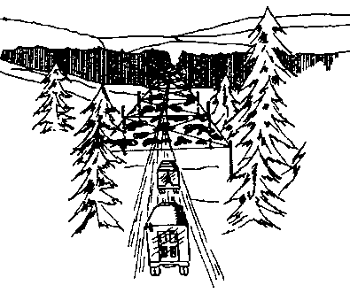

Figure8. Horizontal camouflaging screen

Figure9. Bevel camouflaging screen

Camouflaging covers are used to quick camouflage of objects if terrain camouflage capacity is not sufficient. Cover is made of standard camouflage nets completed with natural camouflage material. The installation is based on throwing of the cover over the camouflaged object and its proper shape deformation using standard or locally made supporting components. Camouflaging covers may be flat, convex or concave.
- Flat camouflage cover is used to camouflage protective structures or places with exposed rock. In this case cover is laid directly on the earth surface.
- Convex camouflage cover serves to camouflage objects overhanging the level of terrain surface. It is used in the rough terrain or among groups of bushes. Its shape has to be suited to the surroundings. Cover thrown over object is fixed to terrain, bushes trees etc. and supported with standard or locally made supporting components.
- Concave camouflage cover serves to camouflage objects placed in bowls, hallows etc. Its concavity has to be maximum 1/40 of span to deter primary shadow act as decamouflage sign.
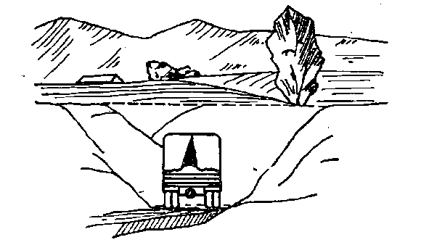

Figure10. Flat camouflage cover
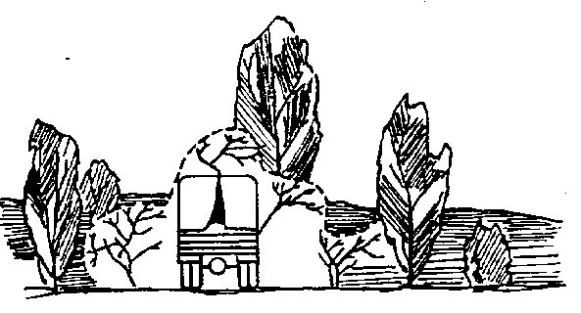

Figure11. Convex camouflage cover
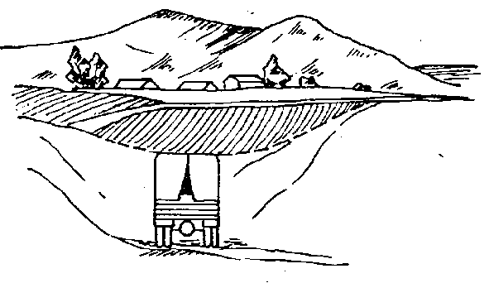

Figure12. Concave camouflage cover
Decoys serve to imitate combat and transportation equipment thereby the attention of the enemy is decoyed from real objects. It can also cause enemy fire dispersal. It is necessary to conduct on purpose demonstration on typical activities in areas where decoys and phoney facilities are used.
Phoney facilities are intended to the same purpose like decoys. The are usually used with concealment and decreasing of objects 'visibility to decoy enemy´s reconnaissance. They includes dummy protective structures, dummy roads etc. Dummy protective structures are excavated as 30 cm deep keeping horizontal dimensions. Some dark material (slag) is placed on structures 'floor to imitate depth in case of air surveillance.
Decoys and phoney facilities has to be camouflaged like real objects, combat or transportation equipment.
Screening camouflage means
Camouflage net of various dimensions „M“ is used to camouflage military equipment and special objects in visual and NIR specter. It is produced in tree modifications – old design of irregular color spots and loose fill, new design of regular geometric pattern with uniform distributed fill and winter design. The color pattern is applicable to growing season and it is effective in visible and NIR specter. Thermal radiation is dampened poorly. Working life of this mean is 2 years. Some details of decoys and phoney facilities are made of this net´s parts.
Tactical and technical data
Camouflage efficiency 0,4 - 1,2 μm
Weight 200 g/m²
Thermal durability - 40°C to +50°C
Working life 1 year
Storage life 5 years
Helicopter masks are intended to camouflage helicopters on incoherent terrain in growing and winter season. Masks are made of cover parts of irregular shape that are drawn on each rotor blade and on tail rotor. They are taut with ground rope and elastic slack adjusters. The shape of cover parts for various types of helicopters is similar to deter their mutual legibility. Cover parts are made of camouflage net M new design material.
Camouflage winter net white „MZ-B“ and color „MZ-Ba“ are intended to camouflage terrain covered with compact (MZ-B) or partial snow layer. They deter visual optical and optoelectrical reconnaissance in visible and near UV specter. This nets are modification of camouflage net M.

Tactical and technical data
Weight to 0,3 kg/m²
Working life (permanent usage) one (winter) season
Storage life 5 years
Thermal durability up to -30º C
Standard element units 6x6, 9x9, 9x12, 9x15, 12x12, 12x15, 15x18 m
M-BF-TN95 is 3D camouflage net built up of basic units of 3x6 m that are built up of three basic recurrent sub-patterns (A,B,C). If connected they have not to crate regular pattern. Units are connected with rope enabling their quick disconnecting.
Tactical and technical data
Weight 0,28 to 0,4 kg/m²
Working life 1 year at minimum
Storage life 5 years at minimum
Thermal durability +70 to -40º C
Screening modern trends
Nets of reversible camouflage pattern
This nets offer the usage in two different environments fulfilling requirements for one-sided nets.
Multispectral nets
Multispectral nets are intended to camouflage objects in terrain yearly. They disable usage of reconnaissance means and guided weapons working in microwave and IR specter. This is the reason why they are called 3D. Some of this nets are useful in UV specter. Principle of camouflage effect:
- visual specter - three-dimensional assembly of the leaf structure,
- infrared specter - reduction of thermal contrast to a background using a material with low thermal capacity and efficient assembly of the cover textile,
- microwave specter - absorption and scattering of an incident wave to a background level.
Mobile camouflage systems
This group of means is intended for camouflage of vehicles in the visible, infrared (near, medium, far) and microwave specter. The mobile camouflage is always designed for given type of vehicle and consists of elements tailored to its specific part. It can be made in various color combinations according to environment. The mobile camouflage does not hinder the maneuverability, use of weapons and access to accessories and handles. It can be easily and fast dismantled which enables standard vehicle maintenance.
Modern decoys
Inflatable decoys, decoys made of cellular material and of wood are developed to imitate object in visible, IR and microwave specter. They cam imitate situation of real equipment including the opportunity to create masks-decoys. They are usually completed with heat or radio signal sources.
RADAR CAMOUFLAGE
Anti RADAR measures use specialties and shortcomings of RADAR reconnaissance. They are based on usage of measures and available means to aggravate target RADAR detectability. Mostly the RADAR detection protection is the part of anti RADAR activity and it continues the usage of terrain camouflage capacity. If camouflaged object is not directly visible for RADAR or its reflection is the same as the reflection of the background (neighborhood) it enables conducting of anti RADAR camouflage (concealment). Many types of terrain undulations protect camouflaged objects by shielding – there is so-called field of invisibility (RADAR shadow) between localizer aerial and concealed object. Object being inside field of invisibility are not detectable with RADAR and they have not to be camouflaged against RADAR. Natural anti RADAR masks are:
- terrain obstacles, vegetation and objects (natural or man made) being on the terrain and exceeding camouflaged objects through their reflective and disperse absorptive characteristics and their height. They may be ground waves, ravines, banks, stone, concrete or brick walls, object of metal surface, wooden walls of 20 cm minimum thickness, snow berms (thickness minimum 50 cm) etc.
- densely populated and urban areas – buildings (behind or inside), stacks, vegetation etc.
Ground and air RADAR reconnaissance has the greatest impact on engineer RADAR camouflage measures taking.
Practical range and detection capability of RADAR are affected with:
- technical characteristics of RADAR itself,
- direct RADAR visibility requirements,
- reflective characteristics differences (contrast) between objects and surrounding terrain,
- detected target speed,
- reflective surface area of target.
RADAR range is markedly decreased on rough ground where RADAR shadow occurs. Reconnaissance conducted in short wavelengths ic not significantly limited by smoke rain and small cloudiness. If flat terrain or water surface is observed with RADAR from long ranges significant part of microwave radiation does not return to RADAR and there is a dark background occurring on the display of RADAR. It creates good conditions to detect targets.
Reflective properties of terrain and objects are expressed as effective reflective area. Its magnitude measured in m² depends on surface characteristics. Part of RADAR waves striking upon targets penetrates its material and it is absorbed. It causes power decreasing of reflected signal. Some examples of material decreasing power of RADAR signal:
- bricks (8 to 10 times),
- concrete (3 to 5 times),
- resinous wood (4 to 8 times).
Metal, metalized and conducting smooth surfaces reflect RADAR signal perfectly.
Radar camouflage decreasing RADAR visibility of target is based on:
- its effective reflective area decreasing,
- absorption or dispersion of energy radiated by RADAR in the area of protected target.
RADAR camouflage means
Corner reflectors used in Czech Army are of next types:
- KO-I/A, KO-I/B PKO-I/S, used for RADAR camouflage on terrain
- KO-II/A and KO-II/B used for RADAR camouflage on water surface
Difference between KO-I/A and KO-I/B – KO-II/A and KO-II/B:
A – aluminum foils plated,
B – used steel plate of thickness 0,2 and 0,3 mm.
KO – I
Made of paper. Lateral length 35 cm, weight I/A – 6 kg, I/B – 10 kg, assembly time is about 30 seconds.
Accessories: wooden stand 3,5 m with 2 steel anchor cables or textile belting with pins, hanging device (3 steel cables or belts). One person installs KO – I in 2 to 3 minutes, two persons install it in 1 minute.

KO – II
Made of paper. Lateral length 35 cm, weight 4,2 kg (6,5), assembly time is about 20 seconds.
Accessories:
- wooden floats of cross shape with 4 aluminum boxes (filled with expanded polystyrene) – universal usage
- inflatable float made of PVC foil – for standing waters.
PKO-I/S
Made of steel plate. Functionally similar to KO-I. Lateral length is 50 cm. Corner reflector is compact of 5 main sides that are of triangle shape. Corner reflector does not have the accessories. Assembly time is several seconds.
Radio absorbers
Radio absorbers are intended to decrease effective reflective area of metallic object in frequency area of 8 to 12 GHz. They decrease decamouflage signs so that the reflectance of objects´metallic surfaces approximates reflectance level of surrounding environment. This is caused so that the material contains components absorbing RADAR (microwave) radiation.
- Wide band rubber radio absorber is intended to protect military equipment (tanks, APCs etc.) against RADAR reconnaissance.
- Wide spectrum foam radio absorber is intended to absorb microwave radiation in rooms.
- Wide band radio absorber RAM – 1 is intended for military equipment and special objects protection against RADAR reconnaissance especially in stationary conditions.
RADAR camouflage modern trends
- Corner reflectors' development
- Radio absorbers' development
- Multispectral nets' development
- Development of paint matters effective in microwave specter
- Equipment antiradar coating and shapes´ modification
SPECIAL CAMOUFLAGE
Explosives and detonators are used to imitate explosions especially explosions of grenades and air bombs or explosions of engineer ammunition when earthworks are conducted. These techniques may be used in dummy areas, areas of own forces or when dummy forces action and action foot-print decamouflage signs are made. These measures are linked to engineer special knowledge thus engineer units are authorized to carry out them.
Grenade and air bomb explosions are imitated with explosive charges. Their weight is illustrated in the table on the slide. Charges are placed to craters or holes 1 m deep and then they are backfilled. Distance between charges is illustrated on the slide.
If explosions during earthworks conducting are imitated engineer ammunition is placed like during real blasting. Blasting cartridges of 400g are placed to flat hole that is then backfilled with soil. In case of fog or rain the weight of cartridge increases two or three times.
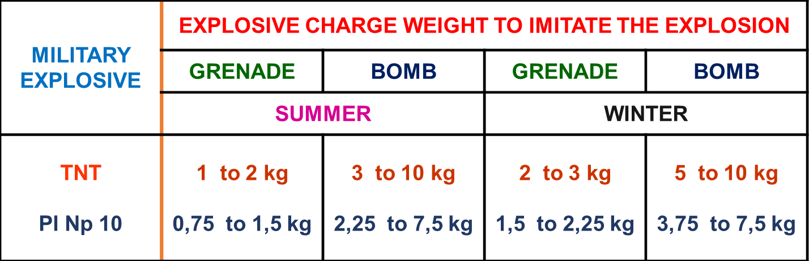

Table1. Explosive charge weight to imitate explosion
Distance between charges
- 1 to 2kg – 2 m
- 3 to 4 kg – 3m
- 4 to 10 kg – 4 to 5 m
Thermal camouflage is based on partial or full concealment of thermal decamouflage signs or their imitation in MWIR and LWIR specter. Camouflage makes detection of objects and their damage with IR guided weapons difficult. It is achieved with terrain protective characteristics, shielding and dispersion of radiated heat from object´s surface and with usage of dummy thermal targets.
In case of objects little differing from neighborhood in the temperature e. g. stored material (ammunition, provisions etc.) or equipment out of work that is cooled out it is possible to use protective characteristics of terrain (woods, buildings etc.) and cover it with tilt able to absorb heat. Then place standard camouflage net 30 to 40 cm over the tilt. Materials able to absorb heat may be:
- several layers of standard camouflage nets,
- car tilts,
- mats made of local or natural materials.
In case of object much differing from neighborhood in the temperature e. g. heated equipment when additional heat has not generated head absorbing tilts and camouflage nets have to be cooled (e. g. Using water) and thus prevent them to became source of heat.
In case of operating engines radiating heat the thermal camouflage is similar to previous cases moreover engines can cool itself with engine cooling system. In case of stationary objects radiating heat (electric power generator, compressor etc.) exhausts have to be drawn off to prevent camouflage means thawing.
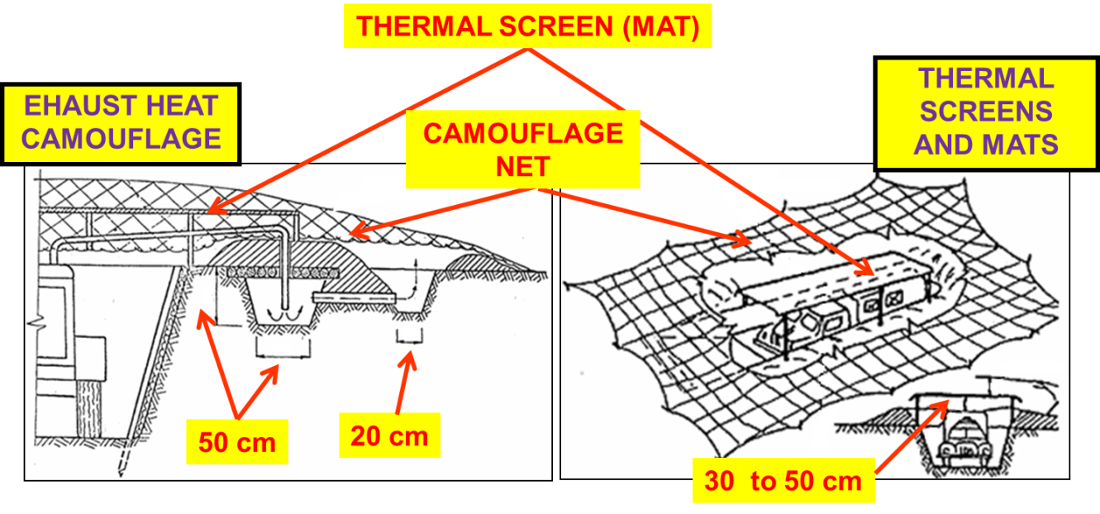

Figure13. Special camouflage techniques
Thermal camouflage means
Thermal camouflage mats and screens. They replaced improvised thermal camouflage means. Their heat resistance is 40 to 50 °C. Thermal camouflage mats are effective in UV, visible and IR specter and they are the part of equpment´s accessories.
Dummy thermal targets are made of materials with great thermal radiation coefficient. They are heated with various means (lamps, burner, electric power). They imitate parts of real objects radiating a heat or serve to create dummy target for missiles with passive homing based on heat. Head source based on flameless oxidation of petrol through the catalytic reaction in the preheated electric oven (12V) is illustrated on the slide. It was used in Soviet and East German military forces.
Special camouflage modern trends
- Multispectral nets development
- Thermal camouflage mats development
- Thermal dummy targets development
- Camouflage aerosols

