Professional Army
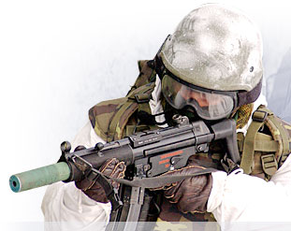
It is a decisive part of the Armed Forces of the Czech Republic (ACR), which, according to the Czech Law No. 219/1999 Coll., referred to as the Defence Law, is comprised also of the Military Office of President of the Republic and the Castle Guard.
The primary mission of ACR is to ensure the military defence of the country against aggression and to meet commitments derived from international obligations and treaties of the Czech Republic on collective defence. It is also set to fulfil tasks within peacekeeping operations in regions of instability or conflicts, and to implement rescue and humanitarian missions both on the national territory and abroad.
In its effort to become a NATO member country, the Czech Republic joined in 1994 the Partnership for Peace Programme. It enabled the Czech military to absorb NATO procedures in defence planning and implementation of force build-up, tailored to Alliance standards and overall goals. The Czech Republic successfully completed its accession talks and began a NATO member country, together with Hungary and Poland, on 12 March 1999, the day, which has been observed as the Day of Accession to NATO in the Czech Republic since.
The Czech military is engaged in the integrated NATO military structure, contributing to defence, operations and civil crisis management planning. It takes part in the procedural and organisational aspects of nuclear consultations, participates in joint exercises, and actively commits its troops for NATO-led multinational operations.
The ACR is also engaged in the EU military structure, as the Czech Republic became a EU member country on
1 May 2004. The Czech military participates in joint exercises and operations.
The supreme commander of the Armed Forces of the Czech Republic is President of the Republic Milos Zeman, while the highest military commander is Chief of the General Staff of ACR Lieutenant General Petr Pavel.
The ACR is formed by Joint Forces, and Support Forces.

Joint Forces
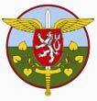
The Joint Forces of the Czech Republic are designed to establish, train, and rotate task forces/contingents that are designated to accomplish tactical or operational objectives, both inside the Czech Republic and abroad, and to perform other tasks within the Czech Republic as required by law. Their headquarters is located in the Moravian city of Olomouc.

Mailing Address
Joint Forces Command
Dobrovskeho 6
CZ 771 11 Olomouc
Czech Republic

Commander:
Major General Jan Gurnik

Structure:
- Joint Forces Command
  - Joint Forces Support Units
- Land Forces
- Air Force
- Training Command - Military Academy (www.vavyskov.cz)

Land Forces
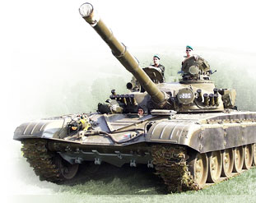
The Land Forces represent the biggest part of the Armed Forces of the Czech Republic. In coordination with other services, they are organised to defend territorial integrity and sovereignty of the Czech Republic.
Under a crisis situation and under state of war, they form the keystone of operation task force and they become part of the allied joint force. They are complemented by mobilised units and formations. The Land Forces are also pre-determined to meet obligations of international treaties.
The Land Forces cooperate with state administration authorities, with representatives of local governments and businesses, with schools, and other institutions, organisations and associations. They contribute to significant projects and events organised for the general public.
Since 1990, the Land Forces Day "BAHNA" has become the greatest presentation of the service. It is held every year at the military training ground at Strasice. Its goal is to present up-to-date military equipment, and professional skills and readiness of Land Forces' soldiers.

Deputy Joint Forces Commander - Land Forces Commander:
- Brigadier General Ladislav Jung

Structure:
4th Rapid Deployment Brigade at Zatec
- 41st Mechanised Battalion at Zatec
- 42nd Mechanised Battalion at Tabor
- 43rd Airborne Battalion at Chrudim
- 44th Light Motorised Battalion at Jindrichuv Hradec
7th Mechanised Brigade at Hranice
- 71st Mechanised Battalion at Hranice
- 72nd Mechanised Battalion at Praslavice
- 73rd Tank Battalion at Praslavice
- 74th Light Motorised Battalion at Bucovice
13th Artillery Brigade at Jince
- 131st Artillery Battalion at Jince
- 132nd Artillery Battalion at Jince

Air Force
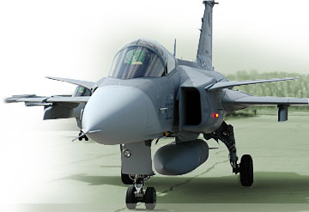
The principal task of the Air Force is to secure the integrity of the Czech Republic's airspace. This mission is fulfilled within NATO Integrated Air Defence Missile System (NATINADMS) and, if necessary, by means of the national reinforced air defence system of the CR.
In addition, the Air Force provides close air support for the Land Forces, and performs tasks associated with transportation of troops and material.

Commander:
Colonel Libor Stefanik

Structure:
Air Force
- 21st Tactical Air Force Base at Caslav
- 22nd Air Force Base at Namest nad Oslavou
- 23rd Helicopter Base at Prerov
- 24th Air Transportation Base at Prague - Kbely
- 25th Air Defence Missile Brigade at Strakonice
- 26th Air Command, Control and Surveillance Bridage at Stara Boleslav (www.bvrpz.army.cz)
- Pardubice Airport Authority

Support Forces
The Support Forces Command commenced its activities on 1 January 2009 replacing the Support and Training Forces Command.
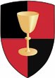
The Support Forces are designed to ensure personnel, logistic and medical support for combat forces together with other affiliated spheres of activities such as regional military commands and veterinary services. The headquarters is located at the Bohemian city of Stara Boleslav.

Mailing Address:
Support Forces HQ
Boleslavska 929
CZ 250 02 Stara Boleslav - Brandys nad Labem
Czech Republic

Commander:
Brigadier General Pavel Adam

Deputy Commander:
Colonel Rostislav Hulik

Chief of Staff:
Colonel Hynek Novak

Structure:
Support Forces
- Regional Military Commands (KVV)
- Base of Repairs at Lazne Bohdanec
- Base of Unrepaired Materiel in Brno
- Base of Repaired Materiel at Stepanov
- Base of Medical Materiel at Bystrice pod Hostynem
- Base of Ammunition at Tyniste nad Orlici
- Veterinary Base at Chotyne (Grabstejn)
- Distribution Centre at Pardubice
- Air Rescue Service Center at Line
- Central Military Veterinary Institute at Hlucin
- Regional Military Medical Facilities - 7 times (Hradec Kralove, Zatec, Bechyne, Prostejov, Vyskov, Praslavice, Prague)
- Hospital Base in Hradec Kralove
- Maintenance Support Company at Stara Boleslav
- Regional Offices of Military Transport - 3 times (Prague, Olomouc, Hradec Kralove)

