**TOPIC 2/3**

**Protective characteristics of terrain, military equipment and protective structures**

**WEAPON HAZARD EFFECTS**

**Blast.**When an explosive detonates it produces a pressure shock *wave that* moves exceptionally quickly. If placed in contact with a material, extremely high stresses are transmitted from the explosive causing it to shatter. If the explosive is surrounded by air, a blast wave is produced. Normally this pressure bubble dissipates over distance; however, confining the explosion enhances its effect. If the explosive is surrounded by earth, the shock wave propagates in a different manner and induces ground shock and may produce a crater.

**Penetration.**Weapon fragments and other projectiles are able to penetrate protective materials and cause injury.

* ***Bullets and Penetrators.***Bullets and other projectiles are designed to be aerodynamically stable in flight. Generally, they travel further and penetrate deeper into a target than fragments from a weapon casing.
* ***Shaped Charges.***Explosive charges can be pre-shaped to focus their blast effect on to a part of their container. On detonation, this section of the container is driven outwards and acts like a projectile; its extreme high speed causes it to penetrate a great depth into any material.

**Fragmentation.**As a weapon explodes, material around it is broken up and thrown outwards as fragmentation. Primary fragments are those that are formed from the weapon casing itself. They are generally very small and highly energetic, often initially travelling at several times the speed of sound. Secondary fragments are those items of debris picked up by the blast wave and thrown outwards. They are generally much slower but often far heavier.

**Flame and Thermal Pulse.**All explosions are accompanied by a fireball and thermal pulse. For most conventional weapons, the damage these cause is much less significant compared to that caused by blast and fragmentation. However, some weapons are optimised to injure using flame or thermal pulse.

**Chemical and Biological Effects.**Chemical and biological weapon agents are usually transmitted through the air or, occasionally, through water. They therefore present either a vapour or contact hazard.

**Electromagnetic and Radiation Effects.**Nuclear weapons pose both a radiological and nuclear hazard. Other weapons may also exploit the electromagnetic spectrum.

**BLAST EFFECTS**

***Pressure, Time and Impulse.*** When it detonates, an explosive turns into a hot, extremely high pressure gas. This gas bubble expands and pushes against the surrounding air. As it does so, it forms a highly compressed layer of air in front of the gas bubble, known as the ‘blast wave’. As the bubble of hot gas expands, it cools and reduces in pressure. Eventually, the gas pressure falls, momentarily, slightly below ambient air pressure before equalising. Figure shows the pressure record taken at a stationary point over which an idealised blast wave passes. The peak overpressure falls away very quickly with distance. The impulse of a blast is the area under the pressure-time curve. It is as significant as the peak overpressure when considering the damage a blast can cause. The graph shown is idealised; actual pressure records from a real explosion are invariably much more complex as they reflect from the ground or other surfaces and interact with one another. This idealised graph is known as a ‘Friedlander curve’.

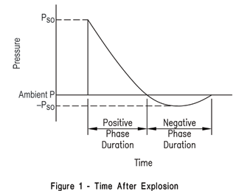

**Figure 1. Idealised Blast Wave Pressure-Time Profile**

***Reflected and Incident Pressure.***When a blast wave strikes a surface, it is reflected back. If that reflected wave is sent back into the blast wave of the expanding bubble of gas, the molecules are further compressed. In this case, the reflecting surface experiences a reflected pressure, greater than the incident pressure. The reflected pressure can be from two to eight times greater than the incident pressure. Surfaces that are face-on to a blast wave experience this reflected pressure. Only surfaces at right angles to the blast wave experience the lower, incident pressure.

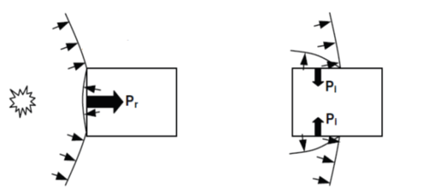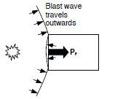

**Figure 2. Reflected and Incident Pressure**

***Internal Explosions.*** If an explosion is confined, the gas produced exerts a high pressure on the walls of the structure for a protracted period of time until it can vent to the atmosphere. This has the effect of increasing the total impulse experienced by the structure and any occupants, and accompanied by the complex reflections and enhancement of blast pressure, makes an internal explosion particularly damaging.

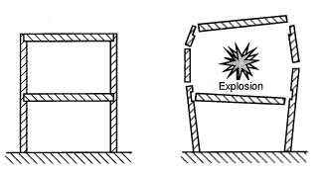

**Figure 3. Internal explosion**

***In-Contact and Close-In Explosions.*** When an explosion occurs very close to or in contact with a material, a highly destructive shock wave is sent through the material. This shattering effect is known as ‘brisance’. It is this effect that causes a breach in a concrete wall when a charge is placed in contact against it.

***Ground Shock.*** Even an above-ground explosion can produce a shock wave that travels through the ground. This shock wave can damage services, particularly gas and water mains. The way a ground shock wave causes damage to a structure is complex. However this effect is not significant unless the weapon is at least partly buried in the ground or is particularly close to a buried structure. Unless buried, most of the explosive energy goes into air blast.

**Penetration**

***Pre-formed Penetrator Projectiles.***Pre-formed penetrator projectiles, such as small arms rounds, are solid and usually inert missiles that use their high kinetic energy to penetrate. The gases produced by tracer or incendiary rounds can increase the damage they do to materials such as concrete but this is not their primary function.

***Fragmenting Munitions.***Some projectiles are designed to cause damage not through penetration but by fragmentation. Most hand grenades and artillery and mortar rounds are specially designed to cause damage with high speed fragments. There are differences in fragment size and speed but it is important to appreciate that the more damaging fragments from large mortars and artillery shells are more penetrative than most small arms (principally because of the extremely high speeds). The majority of artillery and mortar rounds are not boosted in flight, so their trajectory can be plotted with some accuracy providing their initial velocity and meteorological conditions are known.

***Projectiles with Blast Shock Effect.*** HESH rounds are not considered to be a particular penetration hazard, except to light structures. They have a soft, fairly blunt nose that allows them to flatten out in contact with a surface and then detonate, causing damage through explosive shock, not penetration. When they detonate, fragmentation is produced but this is only a secondary effect.

***Hyper-velocity Projectiles.***Some projectiles have such high impact velocities that their penetrative effect must be calculated using the principles of fluid mechanics.

***Penetrator Bombs.***Some aerially delivered bombs are specifically designed to penetrate deeply buried targets. They use a combination of high velocity and mass. They detonate once they have achieved maximum penetration.

***Shaped Charges.***The energy released by an explosion can be shaped and focused to invert a conical liner and propel it as a molten jet at extremely high velocity. These shaped charges are capable of very deep penetration as they ‘melt’ their way through the material using a combination of high temperature and pressure. However, they tend to spread-out and dissipate as they fly through the air. They are therefore only really effective if they detonate very close to, or in-contact with a material.

***Explosively-formed Projectiles.***If a flatter, ‘dished’ liner is used, a molten jet does not form. Instead, the liner remains a solid slug travelling very fast, albeit slower than a shaped charge jet. However, this explosively formed projectile (EFP) can fly far further through the air than a molten jet as it does not break up. This makes it better suited as a stand-off weapon than a shaped charge.

**FRAGMENTATION**

Fragments from the weapon casing itself are known as ‘primary fragments’. ‘Secondary fragments’ are those items of debris that are picked up and thrown either by blast or impact. Primary fragmentation is the principal hazard from most battlefield weapons. However, if an extremely large explosion occurs in a modern, urban area, secondary fragments, particularly glass, may cause most injuries. Such secondary fragments are usually less lethal but often produce many more casualties than primary fragments from large explosions. The blast hazard from a typical battlefield weapon is inconsequential when compared to its fragmentation hazard. For any battlefield weapon with less than 15 kg of explosive detonating in the open, it is recommended that no assessment is made of injury due to blast as any casualty close enough to sustain such an injury is well within the lethal fragmentation range.

**Fragment Distribution.**In almost all battlefield weapons, primary fragmentation is not uniformly distributed from the point of detonation; it is concentrated around the waist of the weapon. Fragments from this part of the weapon are more numerous and travel faster. Therefore the orientation and angle of the weapon at detonation have a considerable effect on its lethality footprint. Although certain general patterns can be identified, fragment distribution is random. Prediction methods must therefore také this into account.

**Fragment Impact.**The initial speed of most primary fragments may often be far greater than 1000 m/s. Therefore, for a close-in explosion, primary fragments are likely to have far more kinetic energy than most small arms rounds. Furthermore, they simultaneously impact over a concentrated area, increasing their ability to penetrate locally. However, unlike small arms rounds, they are generally not aerodynamically stable and so quickly slow down with distance travelled in air. Larger fragments, such as a mortar tail fin, travel at lower speeds, but their greater mass (and hence momentum) makes them harder to stop with a protective layer.

*Fragment Trajectory.* Close-in to the point of detonation (up to 6 m), the velocity of the fragment is considered to be the same as its initial velocity. Over short distances (tens of metres), primary fragments fly in a virtually straight line from the seat of the explosion. Personnel out of line-of-sight are therefore effectively shielded from fragments immediately after the detonation. However, any fragments thrown high up into the air return to Earth at some point. Although their speed is greatly reduced, they may still be lethal.

**Fragment Mass.**The majority of weapon fragments usually weigh less than 1 g. However, it is usual for weapon designers to choose a heavier, ‘design fragment’, with which to characterise the ability of the weapon to penetrate using fragmentation.

**Combined Blast and Fragmentation*.***Close to the seat of the explosion, the blast and fragmentation arrive practically simultaneously and both cause damage to any protective structure. However, the calculation of their combined effect is extremely complex and not well understood. Generally, their effects are considered separately for simplification.



**Figure 4. Typical Fragment distribution From an 81mm Mortar**

**Destructive mean´s effects on personnel, equipment and protective structures:**

* kinetic energy of small arms and mounted weapon bullets, artillery shells, air bombs and rocket warheads
* kinetic energy of fragments occurred after blast of artillery shells, air bombs, rocket warheads and IEDs,
* blast wave after an explosion of artillery shells, air bombs, rocket warheads and IEDs,
* EBW blast wave and underpressure,
* nuclear blast wave,
* nuclear weapon thermal radiation,
* thermal radiation caused by using of incendiary weapons and EBW,
* seismic effects of ground and underground nuclear blast.

**Nuclear blast wave** affects personnel, equipment, material and protective structures by overpressure and speed (dynamic effect). It causes mechanical destruction of live organism parts , destruction and turnover of equipment and degradation of material by destruction or spread. Dynamical effects of blast wave cause construction´s deformation of protective buildings or their parts, create areas of caving, conflagrations and flooding. Blast wave is the most destructive effect of nuclear blast.

Destructive effects of blast wave can be initial and residual. Residual effects are for example collapse of buildings, falling and flying objects, branches and trees, caving or conflagrations.

**EBW blast wave** is often compared with nuclear blast wave. Usage of these weapons is primarily intended for heavy fortified and underground objects destruction. Small weapons of this type can be of course used to destroy light and medium wide spread targets.

**Blastwave created by explosion of artillery shells, air bombs, rocket warheads and IEDs** works analogous to nuclear blast wave but an energy of this blast is ten millions times smaller.

**Kinetic energy of small arms and mounted weapon bullets, artillery shells, air bombs and rocket warheads as so as kinetic energy of fragments** affects personnel, equipment, material and protective constructions through the blow and penetration. Near-miss explosive charge blast may cause local break-up – craters produced by shell´s blow or explosion, cracking in walls of protective structures. Dynamic effect of blast may cause structure deformation or collapse.

**Kinetic energy of IEDs´ fragments** affects personnel, equipment, material and protective structures analogous to conventional ammunition fragments. The way of their placing and transportation to the target increase their effectiveness.

**Nuclear blast thermal radiation** affects personnel, equipment and material through the thermal pulse causing temperature raising on their surface. It causes strong heating-up of protective building´s construction materials and protective layers therefore mechanical characteristics of this material change. This may cause deformations of protective structures, loss of their stability and finally their collapse. Personnel usually suffer burns and temporary or permanent loss of sight. Residual effects are usually fires.

**Incendiary weapons thermal radiation** causes burns to personnel and flammable material ignition. Single or widespread fires affect personnel through toxic effect of carbon monoxide and other combustion gases and also oxygen reduction in air.

**Ground or underground nuclear seismic effect** propagates in geological environment causing strong shakes of object located in or on this environment's surface.

**Destructive mean´s effects on personnel:**

* nuclear blast ionizing radiation and neutron bomb neutron radiation,
* nuclear fallout radiation,
* toxic effects of toxic or biological agents,
* infection effects of biological agents,
* blast acoustic effects,
* psychological effects of destructive means using or sense of this threat.

**Nuclear blast ionizing radiation** what is gamma ray radiation and neutron flux causes pathological changes in organism. It also causes darkening of optical instruments. Gamma ray and neutron flux has great penetration ability, they travel through atmosphere at a long distance. They penetrate compact material that decreasing energy of radiation depending on material thickness. Radiation time is very short – about 10 to 12 seconds.

**Neutron radiation – effect of thermonuclear weapon blast -** is more penetrative then gamma ray. Materials appropriate to protect against gamma ray are heavy metals ( steel, lead). Light materials (polyethylene, polystyrene) and water are useful to protect against energy of neutron radiation.

**Nuclear fallout radiation** causes pathological changesin organism through radiation or through radioactive pollution invasion. Nuclear pollution is long-term effect.

**Toxic effects of toxic or biological agen**ts cause immediate disablement of organism. This agents include nerve gases (SARIN, SOMAN, TABUN,VX), blister agents (YPERIT), choking gases (FOSGEN) or blood agents (cyanogens).

**Infection effects of biological agents** cause total or long term disablement of personnel through disease. Typical examples are anthrax, dysentery or small pox.

**Blast acoustic effects** disable communication between forces through noise level increasing and acoustic organs harm.

**Psychological effects of destructive means using or sense of this threat** show itself like personnel loss of orientation and morale. This effect is based on psychical stress as an organism´s answer on noise, destructive means using consequences and sense of its using probability.

**Destructive means´effect on equipment and material:**

* nuclear blast ionizing radiation ,
* electromagnetic pulse.

**Nuclear blast electromagnetic pulse creates** inducated currents in loop circuits that are then totally or lon- term put out of service.

**Protection of personnel** and equipment has to be carry out together using protective means and objects. It also must be rationally planed and realized through means and ways of close or indirect protection.

* **Close protection** is executed by means or objects able to eliminate effects of destructive means especially blast wave, fragment penetration, thermal effects etc. Useful close protection means are protective structures but military equipment and terrain can support protection using their protective capacity.
* **Indirect protection** is executed by means, objects and measures eliminating enemy´s ability to detect target location and characteristics. These measures indirectly support decrease level of casualties after enemy´s fire attacks. Indirect protection measures include for example camouflage, dispersion or maneuver.

**PROTECTIVE CAPABILITY OF TERRAIN**

**Protective capacity of terrain** are ruggedness of landscape and ground surface characteristics. They decrease destructive means´ effects so ensuring close protection of personnel, equipment and material. Indirect protection is ensured through target concealment and camouflage.

The most useful terrain type for protection is rough ground with narrow, deep and winding valleys, gullets, ravines, washes, quarries, wood massifs and bushes or terrain with proper traffic infrastructure or water structures (roads or railways banks and cuttings, dry drainage ditches etc.). Usage planning of this type of terrain requires to take into account:

* there is great probability of fires and tree failure in woods,
* toxic and biological agents function longer in woods and hallows than on flat terrain.

**Terrain relief** affects blast wave propagation and it´s characteristics if dune steepness is bigger than **10o.** Blast wave is reflected off forward side slopes and rock walls, it bypasses elevations and get in hallows. It may change blast wall propagation direction, speed and shockwave overpressure.

**In comparison with flat terrain the shock wave overpressure increases on forward side slopes**

* when side slope is 10o to 30o 1,25 to 2 times
* when side slope is 45o up to 2,5 times

**In comparison with flat terrain the shock wave overpressure decreases on reverse side slopes**

* when side slope is 10o to 30o 1,15 to 1,2 times
* when side slope is 45o 1,5 to 2 times

**Shock wave overpressure decreases behind reverse side slope** (pressure shadow) at a distance limited by straight line with gradient of 30o to 45o from the top of the hill. Overpressure increases again in longer distance.

**Thermal radiation** effect does not act or is decreased on reverse slopes if the gradient of slope is bigger than radiation beam tilt. Nature of ground, underbrush and meteorological conditions limit thermal radiation energy power. The effect of thermal radiation is weaker on reverse sides of hills, in gullets and in the wood in comparison with flat terrain. Forward side of hills ´reflection of thermal radiation is very little. Only snow-covered terrain may be taken in account.

**Shockwave and speed surface load of ground objects depens on it´s shape and surface area on the side towards to shockwave.** Beating against the balk shockwave overpressure increases on it´s forward side to the time the blastwave is starting to bypass it. Then the overpressure decreases and the decreasing occurs untill overpressure equals atmospheric pressure.

Thermal radiation contrast with ground objects with blank walls what increases it´s effect in front of these objects. The zone of full or particular shielding is behind the object. It depends on radiation angle of arrival of course.

**Protection against thermal radiation** is provided by protective structures, undulations, surface characteristics, buildings etc. (it is necessary to take in accout residual effects of destructive means). Any opaque obstacle placed between radiatinon source and protected person may serve as basic mean of protection.

**Ionizing radiation effect may be a bit decreased by shielting behind revrse sides of hills and ground objects.**

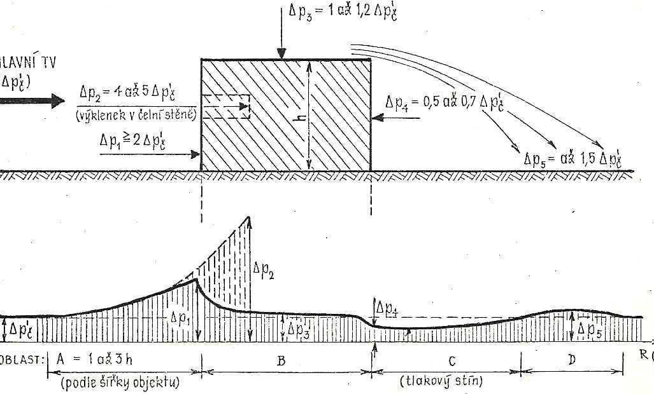

**Figure 5. Shock Wave Effect On The Building**

**Shockwave overpressure** **inside woods** increase 1,1 to 1,5 times in comparison with overpressure on the flat terrain. Speed is decreased 1,5 to 2 times. Destruction radius decreases 1,1 to 1,3 times. The more dense forest is and the more massive threes are the more big protective properties of wood area.

Thermal radiation is disabled by forest depending on type and robustness of trees and on season of the year. It can be 2 to 15 times decreased.

Woods of course presents also residual effects. Young broadleaf tree has the best protective properties.

Blast wave and thermal radiation causes area and localized sinking and fires. There is about 60% of threes destroyed in the areal sinking zone (shockwave overpressure 0,03 to 0,05 MPa) and about 30% of threes destroyed in the localized sinking zone (shockwave overpressure 0,01 to 0,03 MPa). Three uprooting, fail and displacing occurs in total wood destruction zone (shockwave overpressure bigger than 0,05 MPa).

**Urban area building density, building height and resistance and layout affect blast wave propagation.** Maximum shock wave overpressure inside urban area usually exceeds the overpressure on flat terrain. Frequent contrast of thermal radiation occurs in urban area so it is difficult to find fully protected areas outside building. Building density substantially decreases ionizing radiation by shielding.

**Blast wave and thermal radiation causes collapsing** of buildings and area fires in the areal sinking zone. Ground buildings deformations with lanes occurs in localized sinking zone . There is most of buildings in fire in area fire zone.

**Residual effects** must be take into account in urban area. They are falling ruins, debris, road obstacles made of rubble, utility lines destruction (power lines, gas pipes, water pipes etc.) and fires. Unsecured personnel is therefore safe in urban area to blast wave overpressure about 0,005 MPa (safe overpressure on flat terrain is 0,007 to 0,012 MPa). Underground objects in urban area (cellars, sewers, subway tunnels etc.) located on periphery (depending on forces' task) are usually used to ensure force protection.

**PROTECTIVE CAPABILITY OF EQUIPMENT**

**Military equipment** ensures some level of close protection against all or some destructive means effects. The most important is shape, vehicle design, material strength, special body modification or vehicle interior outfit. The most effective protection is provided by armored combat vehicles including tanks, Infantry fighting vehicles-IFV (armored personnel carriers - APC), armored howitzers etc. These vehicles are equipped with air filtering and ventilation.

**Wheeled vehicles (CARS)**

* Shock wave overpressure resistance up to 0,035 MPa.
* Speed of blast wave when overpressure is 0,035 MPa causes slight injuries to unprotected personnel.
* When overpressure is 0,035 MPa then personnel being in vehicle cabs and van bodies are injured insignificantly in comparison with personnel being on open terrain.
* Vehicles with van bodies or truck covers provide some protection level against thermal radiation direct effects, nuclear fallout, liquid toxic agents and biological agents to personnel.
* Cars decrease personnel irradiation 2 times in comparison with personnel being on open terrain.

**Tanks and Infantry fighting vehicles-IFV (Armored personnel carriers - APC)**

* Nuclear irradiation in tanks is 10 times smaller, in IFV about 7 times smaller, in APC about 4 times smaller in comparison with open terrain.
* Tank decreases neutron irradiation about 7 times, IFV 2 times, APC 1,5 times.

**ERA (Explosive Reactive Armour)**

**Reactive armour** is a type of vehicle armour that reacts in some way to the impact of a weapon to reduce the damage done to the vehicle being protected. It is most effective in protecting against shaped charges and specially hardened kinetic energy penetrators. The most common type is *explosive reactive armour* (ERA), but variants include *self-limiting explosive reactive armour* (SLERA), *non-energetic reactive armour* (NERA), *non-explosive reactive armour* (NxRA), and electric reactive armour. NERA and NxRA modules can withstand multiple hits, unlike ERA and SLERA, but a second hit in exactly the same location may potentially penetrate any of those.

Essentially all anti-tank munitions work by piercing the armour and killing the crew inside, disabling vital mechanical systems, or both. Reactive armour can be defeated with multiple hits in the same place, as by tandem-charge weapons, which fire two or more shaped charges in rapid succession. Without tandem charges, hitting the same spot twice is much more difficult. An element of explosive reactive armour is made out of a sheet or slab of high explosive sandwiched between two plates, typically metal, called the reactive or dynamic elements. On attack by a penetrating weapon, the explosive detonates, forcibly driving the metal plates apart to damage the penetrator. Against a shaped charge, the projected plates disrupt the metallic jet penetrator, effectively providing a greater path-length of material to be penetrated. Against a kinetic energy penetrator, the projected plates serve to deflect and break up the rod.

The disruption is attributed to two mechanisms. First, the moving plates change the effective velocity and angle of impact of the shaped charge jet, reducing the angle of incidence and increasing the effective jet velocity versus the plate element. Second, since the plates are angled compared to the usual impact direction of shaped charge warheads, as the plates move outwards the impact point on the plate moves over time, requiring the jet to cut through fresh plates material. This second effect significantly increases the effective plate thickness during the impact.

**Mine-Resistant Ambush Protected (MRAP)**

**Mine-Resistant Ambush Protected** (**MRAP**) is a term for military light tactical vehicles produced as part of the MRAP program that are designed specifically to withstand improvised explosive device (IED) attacks and ambushes. The United States Department of Defense MRAP program began in 2007 as a response to the increased threat of IEDs during the Iraq War. From 2007 until 2012, the MRAP program deployed more than 12,000 vehicles in the Iraq War and War in Afghanistan. Production of MRAP vehicles officially ended in 2012. This was followed by the MRAP All Terrain (M-ATV) vehicle. In 2015, Oshkosh Corporation was awarded a contract to build the Oshkosh L-ATV as the Joint Light Tactical Vehicle, a lighter mine-resistant vehicle to replace the Humvee in combat roles and supplement the M-ATV.

**SLAT armor**

**Slat armor**, also known as **bar armor**, **cage armor** and **standoff armor**, is a type of vehicle armor designed to protect against anti-tank rocket-propelled grenade (RPG) attacks. It takes the form of a rigid slatted metal grid fitted around key sections of the vehicle, which disrupts the shaped charge of the warhead by either crushing it, preventing optimal detonation from occurring, or by damaging the fuzing mechanism, preventing detonation outright. Although slat armor is effective against incoming missiles, it does not offer complete protection – as many as 50% of missile impacts are unimpeded by the slat design. Slat armor is more likely to be effective if the cage spacing is less than the diameter of the incoming RPG round, which is commonly 85 mm in diameter.

**AIM OF PROTECTIVE STRUCTURES BUILDING**

**Nuclear blast destruction radius of equipment placed in pits decreases:**

* tanks, IFVs and APCs 1,2 to 1,5 times
* wheeled vehicles about 1,4 times

**PROTECTIVE CAPABILITY OF PROTECTIVE STRUCTURES**

Protective structures ensure close protection of personnel, equipment and material against destructive means through their protective layers, bearing structure and equipment. Thus they ensure conditions in according to occupancy.

**Blast wave protection** is ensured through structure strength and back pressure adjustment of door and other apertures. This requirements are met by shelters. Other protective structures only decrease blast wave effects.

**Nuclear blast thermal radiation protection** is ensured through using of non-combustible material for structure construction or through using of non-compustible wall finish (cement or lime paste, clay layer, asbestos etc.). It is necessary to dispose combustible materials from structure's surrounding.

**Nuclear blast ionizing radiation protection** is ensured through the protective layer (overhead cover) thickness and through thickness of bearing structure. Neutron radiation protection level depends on protective layer (overhead cover) thickness and material used for it´s construction. Higher layer of soil, it´s watering or using of neutron radiation protective material is usually required.

**Nuclear fallout, toxic or biological agents protection** is ensured through proper insulation of inner area, protective layer thickness, bearing structure thickness, overpressure making inside a structure and intensive ventilation (air filtration).

**Incendiary weapons protection** is ensured through flame resistance of outside walls and prevention of incendiary agents leaking into the structure.

**Penetration and fragmentation protection** is ensured through bearing structure strength and protective layer thickness.

**Seismic effects protection** is ensured by structure strength and proper joint of all parts of structure.

**Live conditions of personnel and employment of equipment** are ensured through protective structures equipment according to their purpose.

Design of protective structure, protective layer thickness, bearing structure, layout and equipment has to take in account destructive means and their effects, structure purpose, level of protection required and it´s location on terrain. Most of protective structures include protective layer, bearing structure and equipment.

**Bearing structure** transmit the constant load of protective layer and the impose load of blast effect on foundation soil.

**Protective layer** protects against penetration (shells, grenades, bombs), eliminates blast effect and nuclear weapon using effects. Protective layer of temporary structures includes soil (rubble stone, concrete or wood can be used) and insulating layer. Soil or stone is usually used to overhead cover construction, surface structures construction, and protective layers of semi-underground and buried structures. Insulating layer obstructs water and contamined air penetration into a protective structure.