TOPIC 2/1
Force Protection Engineering Tasks, Fundamentals and Equipment

FORCE PROTECTION (FP)

Measures and means to minimize the vulnerability of personnel, facilities, equipment, materiel, operations, and activities from threats and hazards in order to preserve freedom of action and operational effectiveness thereby contributing to mission success. (AAP-6)

OPERATIONS AND JOINT FUNCTIONS (JFS):

- Mobility & Fires;
- Intelligence;
- Command & Control (C2);
- Force Protection;
- Sustainability;
- CIMIC;
- Information Operation;

Force Protection Applicability

FP is a joint function and essential to all operations. All of the joint functions need to be considered by the joint force commander (JFC) in determining the capabilities required for each operation. Nations have differing FP philosophies, policies, and priorities; however, the focus for FP is united: the protection of a national contingent itself plus supporting elements and enabling the force to conduct its mission unimpeded by the actions of an adversary. In a multinational force, differences should be reconciled, taking into consideration national caveats, and an overall combined joint FP policy should be established, along with appropriate tactics, techniques, and procedures (TTP), to facilitate unity of effort and enhance FP measures.

THE FOCUS OF FORCE PROTECTION

The protection of a national contingent itself plus supporting elements and enabling the force to conduct its mission unimpeded by the actions of an adversary.

Force Protection Coordination

Coordination is a FP fundamental during the planning and execution phases of all campaigns and operations. Vertical and horizontal coordination among strategic, operational, and tactical levels of command allows each level to take appropriate FP measures according to the mission and threat, while providing understanding of the intentions and FP capabilities of each level. Vertical coordination ensures that the higher commander’s intent with respect to the protection and conservation of assets is clearly understood, and reflected in orders and plans. Horizontal coordination assists in integrating and synchronizing the various inputs from the different staff disciplines during mission planning. Since each level of command is required to implement FP measures, tasks, and activities based on the mission and threat, the same measures, tasks, and activities may not necessarily be implemented by all units in the same theatre. Therefore, coordination across all levels should assist in providing adequate and synchronized FP. During mission execution, horizontal coordination between subordinate formations and the staff should be conducted so that FP measures, tasks and activities are integrated, synchronized, and implemented in a consistent and systematic manner. Ideally, there should be a corresponding FP staff assignment within strategic, operational, and tactical level headquarters (HQ).

Strategic Level Coordination.

At the strategic level, the Allied Command Operations J-3 provides the necessary staff structure and the J-3 operations branch coordinates FP. An officer from the J-3 staff is normally designated to provide the commander with strategic FP advice and assessments, and coordinate the input of the staff specialists. If so designated on the commander's staff, an FP officer should incorporate and integrate FP planning into all operations plans (OPLANs). Subordinate commanders may, in addition to their command responsibilities, also act as advisers to the commander in their respective specialty areas.

Operational Level Coordination.

All operational-level formations, units, and staff contribute to FP through their various disciplines and functions. Because NATO operations will be based on a comprehensive approach, synchronization of FP activities with allies, coalition partners, and other actors is essential to ensure maximum effectiveness. The J-3/J-5 staffs assist the operational commander in the coordination and planning of FP measures, tasks, and activities.

Tactical Level Coordination.

At the tactical level, the unit operations officer is normally responsible for coordinating FP, in accordance with the commander’s intent, with advice from the intelligence officer, information operations (Info Ops) officer, security officer, communication and information systems (CIS) officer, medical officer, engineers, and other key stakeholders. However, some situations may require the designation of a dedicated FP officer and staff to coordinate FP requirements.

Force protection is based on five PRINCIPLES:

- Measured Assessment of the Threat. A threat assessment (TA) based on accurate and timely all-source intelligence serves as the basis for the selection of the proper NATO security alert state and associated FP measures. FP allows the commander to focus resources on the protection of assets that are critical to mission success. A continuous evaluation of threats and hazards is required to enable commanders to adjust force posture and protective measures, while maintaining economy of effort. The TA also provides the JFC with situational awareness (SA) that reduces the probability of surprise, enhances decision making, and enables effective management of the operational environment (OE) thus enhancing the overall effectiveness of the force. It requires the fusion of information and intelligence from a variety of sources, both military and civilian.
- Risk Management. FP should be based on risk management, not risk elimination. Casualties, deliberate or accidental, are a reality of military operations, and the desire to avoid them totally may impact adversely on the accomplishment of the mission. This requires a balance between risk mitigation and mission accomplishment, resulting in risk acceptance known to the joint force and contributing nations’ commanders. The willingness to accept risk is scenario-dependant. The risks from threats, hazards, and other vulnerabilities should be continuously re-evaluated to ensure appropriate FP at all times. Effective FP planning requires integrated hazard and threat identification, risk analysis, and risk management. Although it is not possible to protect every asset against every threat all of the time, those assets previously identified as “critical to the mission” must be protected.
- Joint and Multinational Interoperability. FP embraces all force components, including civilian support, within and outside the joint operations area (JOA), and addresses all aspects of the threat. FP preserves interoperability and considers the concepts, policies, doctrine, and procedures of Allies, coalition partners, and the host nation (HN) to ensure interoperability.
- Prioritisation. FP balances the conflicting priorities of the need to preserve force capability while maximizing operational freedom of movement. It is unlikely that the capability will exist to protect all force elements to the same degree. Priority should be given to the protection of friendly force centres of gravity, both tangible, such as lines of communications (LOCs), and intangible, such as operational cohesion or political will as influenced by public opinion. FP requires the application of measures that need to be prioritized, based on the mission and the threat.
- Flexibility. FP policy and measures should be developed with the capability to respond to a rapidly changing threat, within resource limitations. The aim of FP is to counter and mitigate the effects from threats and hazards. To be effective, FP requires a core policy that has the flexibility to allow the operational forces to develop standards and procedures to meet individual, specific needs.

Force Protection Coordination Areas

The FP coordination areas are active, passive, and recuperation.
- Active. The active coordination area involves measures, tasks, and activities to deter, prevent, nullify, or reduce the effectiveness of an enemy attack and to counter hazards. These are primarily proactive in nature with the core functions to provide a defence against a perceived or actual threat, and when necessary, find, fix, and strike threats and hazards before they are realized, with the intention to further exploit the situation wherever possible. The employment of individual FP fundamental elements should be in accordance with the mission mandate, Rules of engagement (ROE), and standing operating procedures (SOPs). It is about taking the battle to the aggressor and either deterring hostile intent or neutralizing the ability to attack or pose a viable threat.
- Passive. The passive area involves measures, tasks, and activities to negate or minimize the effects of enemy attacks and hazards on NATO assets by making them more survivable. Passive measures, tasks, and activities should be proactively employed prior to any attack or hazard materializing. They are designed to protect the force from the operational, tactical, and physiological consequences arising from the use of both conventional and chemical, biological, radiological, and nuclear (CBRN) weapons and devices or the release of toxic industrial material (TIM). A force's ability to survive the effects of such weapons or devices should be enhanced by the anticipation of their use. Furthermore, effective passive defense preparation will be likely to reduce an aggressor’s incentive to use such measures.
- Recuperation. FP should include an overall plan for NATO-led forces and installations to resume their primary operational roles following the effects of attack, hazards, or disasters. Recuperation covers those measures, tasks, and activities necessary for the force to recover, restore essential capabilities, and enable operations to continue, with the minimum of disruption and in the minimum possible time. Measures are therefore pre-planned responses that are reactively employed post-incident.

Force Protection Fundamental Elements.

FP comprises a number of distinct but inter-related fundamental elements, which may contribute to the overall FP function. While some are focused on only one of the coordination areas discussed above, many can potentially provide FP measures, tasks, or activities in any of the three coordination areas. The contribution of these fundamental elements will be determined by the OE, for instance, by the threat, scale of the operation, climate, civil environment, the composition of the NATO-led force, and the availability of host-nation support (HNS) or support of local security forces.

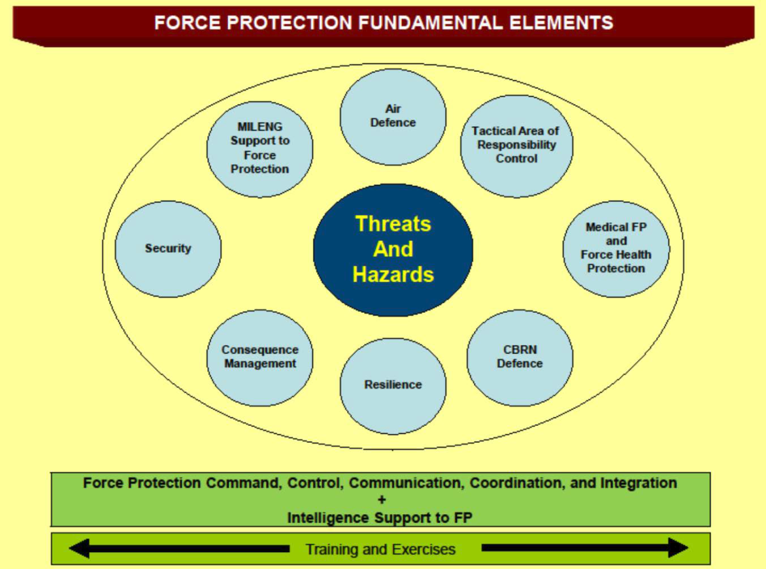

Figure 1 : FORCE PROTECTION FUNDAMENTAL ELEMENTS

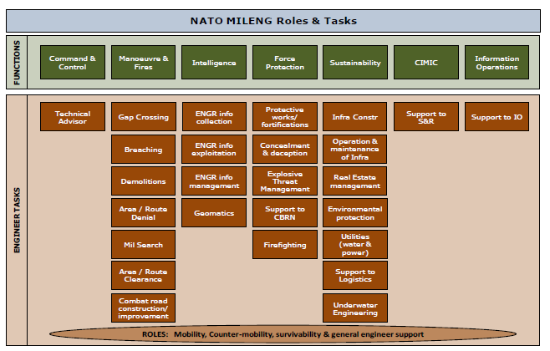

Figure 2 : FRAMEWORK OF MILENG ROLES AND TASKS

SURVIVABILITY SUPPORT

THE CONCEPT. All arms/branches are responsible for their own immediate survivability requirements. Engineers will augment and enhance unit survivability measures within the limits of available resources and the priorities of the commander. Engineer effort will be concentrated on tasks requiring specialist skills or equipment. Survivability measures begin with the use of all available concealment and cover, followed by digging and constructing fighting and protection positions.

Main Tasks

The main engineer survivability tasks are:
- Assistance in the preparation and construction of field fortifications.
- Assistance in the hardening and construction of protective infrastructure works. This includes collective protection against the CBRN threat.
- Assistance with camouflage, concealment and deception.
- Assistance in the clearance of fields of fire.
- Explosive threat Management. Those are tasks related to minimizing the threat posed by all kinds of explosive devices, both manufactured and improvised, to friendly forces. This includes all actions from providing advice and engineer intelligence to deliberate actions such as disposal, search and support to EOD/IEDD/C-IED tasks. Note that this task is not exclusively.
- Executed as a survivability task, it is often conducted as a mobility task when the explosive threat hinders FOM of friendly forces.
FORCE PROTECTION ENGINEERING

Force Protection Engineering (FPE) is defined as “the aggregate of those engineering activities whose intended effect is the minimization of the risks to a force’s assets posed by operational threats, occupational and environmental hazards that require technical and engineering skills”. The Military Engineers, as technical experts, develop and maintain FP Engineering SOP and best practices, enabling pre-incident vulnerability analysis, post incident response and restoration capabilities.
Effective protection does not rely on a single technique or action but comes from a balanced combination of active and passive measures into a coherent, flexible system. This systematic approach to integrated survivability seeks first to prevent an attack. Should an attack take place, its effect should be reduced if not, nullified. If an effect is felt, the protected asset should have the robustness to maintain operational capability. Moreover flexible plans are to set up in advanced in order provide rapidly restoration of destroyed capabilities and ensure the survivability of the attacked base. It is essential that this systematic approach is applied from outside the asset and works towards it.

FORCE PROTECTION ENGINEER TASKS

- Protective works/ Fortifications
- Concealment & Deception
- Explosive Threat Management
- Support to CBRN
- Firefighting

Protective works

Engineers may augment existing structures or facilities with enhancements or protective materials to increase the protective properties or resistance to damage or attack. Although not as extensive as in the field fortifications in the defense, protective emplacements are used primarily for personnel infrastructure, unit locations and logistic concentrations. Commanders may require hardening of key command and control facilities, especially those with a detectable electronic signature. Engineers provide protective works mainly in the form of constructed barriers and screens such as:
- Chicanes or route access control points;
- Fences, screens, or bunkers surrounding a facility or vehicle, equipment or troop concentration;
- Preparation of sites for tactical air and aviation units;
- Advice/assistance with the construction of protective barriers;
- Perimeter protection systems;
- Support to CBRN Collective Protection (COLPRO).

Field Fortifications. The preparation of (field) fortifications is an all arms/branches responsibility. When time is short or the nature of the terrain requires special techniques, such as the use of earthmoving equipment or explosives, engineers may provide support in accordance with the commander’s priorities. Possible engineer tasks include:
- SME’s advice on the construction of field fortifications;
- Construction of command posts;
- Construction of artillery gun positions, tank scrapes and weapon pits;
- Preparation of alternate positions;
- Preparation of sites for tactical air and aviation units;
- Strengthening field fortifications and building reinforcement.

Critical Infrastructure Protection. Critical infrastructure should be protected against spectrum of threats. The types of protection built will depend upon the terrain and soil type as well as on the availability of existing buildings and natural cover and Host nation Support. Engineer advises the commander on the selection of the most suitable measures to protect both military and host nation critical infrastructure.

CONCEALMENT, DECEPTION AND CAMOUFLAGE

Although camouflage and concealment is and all arms task one of the main engineer survivability tasks associated with force protection is “Assistance with camouflage, concealment and deception.” This includes the MILENG Expertise in planning, designing, construction and maintenance of concealment and deception in support to tactical Commanders Measures taken by engineers might include the construction of fighting positions, the installation of dummy equipment and the emplacement of phoney minefields to support formation and unit deception plans.

Camouflage and Concealment. In general, all units are responsible for their own concealment and local camouflage. Major positions, facilities, and operational sites, may, however, require special camouflage stores and measures. The tactical commander may then require engineers to undertake such tasks, as advised by his engineer commander. Efforts must be made to mitigate the distinctive signatures that engineer work in preparing battle positions can create. Apart from the use of camouflage nets and natural camouflage material, special camouflage measures often require the employment of engineer equipment and devices. This is especially true for large scale camouflage requirements.

Deception. Deception is designed deliberately to give the adversant a false and misleading picture of the true tactical and operational situation thus conferring potential benefit to own forces. Deception measures often include camouflage, although construction work should expend as little time and materiel as possible. It is an engineer responsibility to provide advice on deception to the all arms/branches commander.
  - Deception must always be coordinated at the highest practical level and with all the units involved.
  - Special engineer deception measures can include construction of dummy positions, phoney obstacles, including minefields, decoys and the simulated employment of construction equipment. For the construction of dummy positions and decoys, camouflage and deception material will be used and engineer equipment may be employed to excavate soil. Damaged or captured materiel can also be used to create deception. Dummy positions and decoys must be carefully planned and coordinated within the framework of the tactical plan and genuine positions.

EXPLOSIVE THREAT MANAGEMENT

Threats
- Improvised Explosive Devices (IEDs),
- Unexploded Explosive Ordnance (UXOs, including mines),
- Abandoned Explosive Devices (AXOs),
- CBRN Explosive Ordnance (CBRN EO, including Toxic Industrial Materials (TIM) and Petrol/Oil/Lubricants (POL))

IEDs are devices placed or fabricated in an improvised manner incorporating destructive, lethal, noxious, pyrotechnic or incendiary chemicals and designed to destroy, incapacitate, harass or distract. IEDs may incorporate military stores, but are normally devised from non-military components.
UXOs are all munitions containing explosives, nuclear fission or fusion materials and biological and chemical agents. Mines are explosive munitions designed to be placed under, on or near the ground or other surface area and to be actuated by the presence, proximity or contact of a person, land vehicle, aircraft or boat, including landing craft. Mines are considered military stores and come in two types: anti-vehicle and anti-personnel. Although anti-personnel mines are prohibited by the OTTAWA treaty which is signed by many countries, they still are a common threat all over the world.
AXOs are abandoned ammunitions, ammunition that has not seen a weapon system and is abandoned in the terrain or in storage. CBRN EO is an explosive device containing a CBRN element. Although a CBRN element is normally not explosive by itself, it can be so due to an external threat, such as fire or a detonation, and then even may cause a disaster.

Explosive ordnance disposal main tasks:
- Explosive Ordnance Reconnaissance (EOR)
- Explosive Ordnance Clearance (EOC)
- Conventional Munitions Disposal (CMD)
- IED Disposal (IEDD)
- Chemical, Biological, Radiological and Nuclear Explosive Ordnance Disposal (CBRN EOD)

Other Engineer explosive management tasks:
- Explosive Threat Manager,
- Military Search assistance,
- Support to Intelligence.

Explosive Threat Manager: This is normally the role for the principal EOD Staff Officer of the Joint Force. The Explosive Threat Manager is the Subject Matter Expert and coordinates all tasks related to the Explosive Threat. He operates the Multi National EOD Coordination Cell (MNEODCC). He reports directly to the Joint Force Engineer and to the (MN/CJ)EODC(C) of the higher command. The JF Engineer is the principal MILENG advisor of the JF Commander and has the coordinating and technical authority over the employment of all MILENG assets throughout the Joint Force. As there are rarely sufficient MILENG recourses to meet all demands, coordinating and task-organizing available MILENG assets in support of Explosive Threat Management is an essential role for the JF Engineer, in which the Explosive Threat Manager is his principal advisor and SME.
Military Search is executed by military engineers and/or EOD units and is used to find explosive threats when executing Breaching and/or Area/Route Clearance tasks.
Support to Intelligence builds understanding of all aspects concerning the physical operational environment. Explosive Threats are a fundamental risk for the JF in that physical operating environment.
The MILENG Support to Intelligence task directs the information requirements, collects all information, processes it to be used in planning processes and procedures, and disseminates it to all relevant users. Support to Intelligence builds the Explosive Threat database and is operated in the environment cell of the Joint Force.

SUPPORT TO CBRN

Engineers must implement the general rules for defense against the CBRN threat which are common to all arms/branches. National engineers may have specific CBRN responsibilities allocated to them; these vary from nation to nation and are not considered further in this publication. Whatever special responsibilities are allocated to them nationally, engineers are very likely to be involved in the following tasks because of their generic capabilities and organization:
  - Assistance with Survivability. With construction capabilities, engineers are well placed to advise and assist other arms/branches in the provision of field fortifications and other shelters against CBRN attack including improvised collective protection (COLPRO) against chemical attack; these measures are termed “Survive to Operate”.
  - Mobility through or Around Areas Affected by CBRN Strikes. As part of their normal task of route opening and maintenance, engineers are likely to be tasked to clear routes blocked by the effects of CBRN strikes, or to open routes to by-pass.
  - Decontamination. Engineers may be called upon to construct traffic circuits and facilities in a decontamination point. In some armies, they may operate the point or provide water for it. Area decontamination may also be an engineer task.
  - Release Other Than Attack (ROTA) and Toxic Industrial Materials (TIM). In built up or urban areas, there is considerable potential for engineers to have to deal with the effects of ROTA and TIMH. Industrial areas, power stations and even hospitals offer a range of options for potential enemies to exploit.

FIREFIGHTING

Fire Protection. Fire Protection includes the design and construction of fire prevention and suppression systems within infrastructure. It includes the development, implementation and monitoring of a fire safety program within a camp, including training, exercises and the evaluation of the Fire protection plans adopted by the military units/bases.
Fire Prevention. Fire Protection Services are a key safety-related component which must be an integral part of every deployment. Within NATO this responsibility falls under different elements within various Troop contributing Nations (TCNs). However regardless of who is responsible the requirement to establish fire protection support needs to be identified within the deployed NATO force. Employment of fire fighters in a theatre of operations is outlined as essential for force protection but can easily be translated into any fire support service from a TCN. Fire can have many causes ranging from poor housekeeping discipline, inadequately designed electrical services, improper handling of fuel or as a result of an attack by adversant forces. Unless fires are quickly contained, controlled and extinguished, the resultant effects can hamper the Commander’s ability to project combat power and achieve his mission. It is the FEngr’s responsibility to advise the Commander on the proper level of fire protection and prevention services within the theatre of operations. The scope of the advice will include incorporation of fire protection requirements within the Force, selection of camp location, design of the accommodation and facilities, and even mundane TF daily routine to prevent the risk of fires due to poor housekeeping and practices.

CZECH ARMY ENGINEER MEANS USED TO BUILD PROTECTIVE STRUCTURES

- ENGINEER TOOLS
  - Hand-carried engineer tools
    - Trenching tool
    - Short axe 49 type
    - Packing trenching tools
  - Vehicle-carried engineer tools
    - Engineer shovel
    - Saw
    - Engineer pick
    - Long axe
    - Steel and wooden mallet
    - Lever
    - Wire-cutter
- ENGINEER EQUIPMENT
  - Excavation equipment
    - Dozers
    - Mounted bulldozer equipment
    - Loaders
    - Excavators
    - Drilling machines and air picks
  - Logging and woodworking equipment
    - Power saws
    - Timber making saws
    - Mobil woodworking workshops
- ENGINEER CONSTRUCTIONS
  - Reusable industry-made constructions
  - Non-reusable industry-made constructions

CZECH ARMY DECEPTION (CAMOUFLAGE) ENGINEER MEANS

- CAMOUFLAGE PAINTS
- DECORATION CAMOUFLAGE MEANS
- ANTI-RADAR CAMOUFLGE MEANS
- SPECIAL CAMOUFLAGE MEANS

