Gradable
Many adjectives describe qualities that can be measured in degrees, such as size, beauty, age, etc.
These adjectives are often called gradable adjectives, because they can be used in comparative or superlative forms, or with grading adverbs such as very or extremely, to show that a person or thing has more or less of a particular quality.
Examples:
- Don’t talk to Jenny, she is very angry.
- Sorry, I can’t stop, I am extremely busy.
- I am worried about Tom, he is dreadfully unhappy.
- This is a very important matter.
- That slice of cake is rather big.

Non-gradable
Non-gradable adjectives are adjectives like ‘married’ or ‘wooden’. You can’t be very married or a bit married.
Non-gradable adjectives do not have different degrees.
They describe qualities that are completely present or completely absent. They do not occur in comparative and superlative forms, and cannot be used with adverbs such as very or extremely.
Adjectives like ‘terrifying’, ‘freezing’ ‘amazing’ are also non-gradable adjectives. They already contain the idea of ‘very’ in their definitions.
- freezing’ means ‘very cold’ etc.
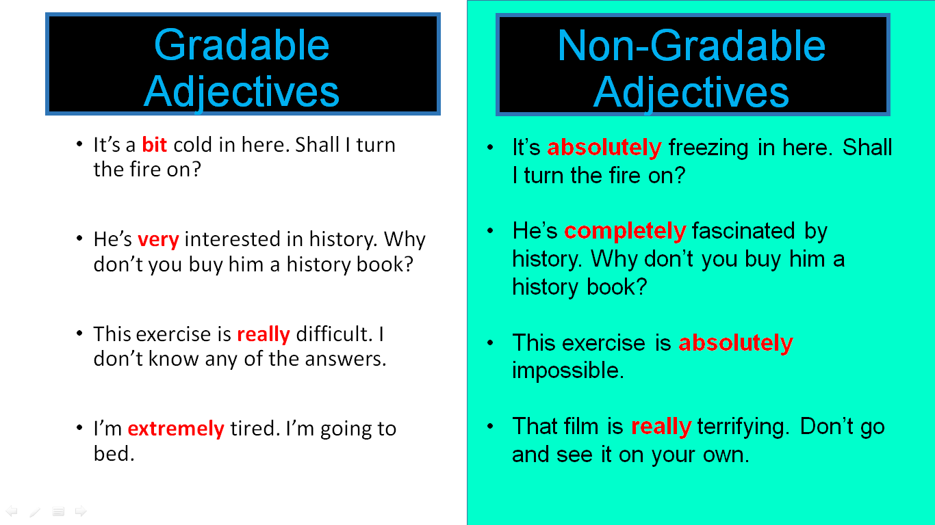

Strong adjectives
- gorgeous = very beautiful
- huge = very big
Base Adjectives | Strong Adjectives
beautiful | gorgeous
ugly | awful
dirty | filthy
good | superb, great, fantastic
bad | terrible
happy | thrilled
angry | furious
hungry | starving
tired | exhausted
funny | hilarious
big | huge, enormous
small | tiny
fat | obese
scared | terrified
cold | freezing
hot | boiling

Very, absolutely and really are used differently according whether the adjective is a base or a strong one:
 | very | absolutely | really
Base adjectives
Strong adjectives
Examples:
- He was very happy; he was absolutely thrilled.
- He was really happy/thrilled.
Excercise:
https://www.myenglishpages.com/english/vocabulary-exercise-base-strong-adjectives.php
https://www.tolearnenglish.com/exercises/exercise-english-2/exercise-english-84300.php
https://www.tinyteflteacher.co.uk/learn-english/grammar-practice/adjectives/strong-weak-adjectives-practice

BBC Learning English Quiznet Absolutely + adjective
Quiznet © BBC Learning English
bbclearningenglish.com
Quiz topic: Absolutely
1. It's so cold in here - can you put the heating on? I'm absolutely _____________!
a) chilly
b) boiling
c) cool
d) freezing
2. I'm a nurse, so sometimes I have to work night shifts. I find them so tiring, honestly,
I'm usually absolutely ___________!
a) exhausted
b) tired
c) sleepy
d) all of the above answers
3. Have you been on that enormous rollercoaster? It's so high and so fast, I was
absolutely ______________!
a) frightened
b) scared
c) terrified
d) afraid
4. We just got back from our holidays in Spain; can you believe it was too hot? Everyday
it was 100 degrees or more - honestly, it was absolutely _____________!
a) boiling
b) scorching
c) baking
d) all of the above answers
5. Wow - flowers! I love them, thanks - they're absolutely ______________!
a) stunning
b) gorgeous
c) beautiful
d) all of the above answers
6. It's done nothing but rain for 2 days. This weather is absolutely ____________!
a) wet
b) foul
c) rainy
d) raining
ANSWERS
Quiz topic: Absolutely
1. It's so cold in here - can you put the heating on? I'm absolutely _____________!
a) chilly
b) boiling
c) cool
d) freezing
a) If a place is 'chilly', it's a little bit cold, e.g. 'It's a bit chilly out; put your coat on.' But which is correct - 'absolutely chilly' or 'very chilly'? We use 'absolutely' with an extreme (strong) adjective but we usually use 'very' with a base (weak) adjective. What kind of adjective is 'chilly'?
b) This means it's very, very hot. We use 'absolutely' with an extreme (strong) adjective but most often 'very' with a base (weak) adjective. What kind of
adjective is 'boiling'?
c) If something is cool, it's not hot - but in a good way, e.g. 'Oh, let's go inside, it's lovely and cool in there.' But which is correct - 'absolutely cool' or 'very cool'? We use 'absolutely' with an extreme (strong) adjective but we usually use 'very' with a base (weak) adjective. What kind of adjective is 'cool'?
d) Well done! This means it's very, very cold. Notice how we use 'absolutely' +
an extreme (strong) adjective – in this case 'absolutely freezing'. The others are
all base (weak) adjectives which are usually used with 'very'.
2. I'm a nurse, so sometimes I have to work night shifts. I find them so tiring - honestly,
I'm usually absolutely ___________!
a) exhausted
b) tired
c) sleepy
d) all of the above answers
a) Correct! This means very, very tired. Notice how we use 'absolutely' + an
extreme (strong) adjective – in this case 'absolutely exhausted'.
b) If you use 'absolutely', you must follow it with a strong adjective, e.g. 'absolutely
exhausted' or alternatively, you can say 'very tired'. Is 'tired' an extreme (strong) or a base (weak) adjective?
c) If you use 'absolutely', you must follow it with a strong adjective, e.g. 'absolutely
exhausted' or alternatively, you can say 'very sleepy'. Is 'sleepy' an extreme
(strong) or a base (weak) adjective?
d) Only one of the answers can be used with 'absolutely'.
3. Have you been on that enormous rollercoaster? It's so high and so fast, I was
absolutely ______________!
a) frightened
b) scared
c) terrified
d) afraid
a) If you use 'absolutely', you must follow it with a strong adjective, e.g. 'terrified'.
Alternatively, you can say 'very frightened' or even 'so frightened' but is 'frightened' an extreme (strong) or a base (weak) adjective?
b) If you use 'absolutely', you must follow it with a strong adjective, e.g. 'terrified'.
Alternatively, you can say 'very scared' or even 'so scared' but is 'frightened' an extreme (strong) or a base (weak) adjective?
c) That's right! If you use 'absolutely', you must follow it with a strong adjective
- in this case 'absolutely terrified'.
d) If you use 'absolutely', you must follow it with a strong adjective, e.g. 'terrified'.
Alternatively, you can say 'really afraid' or even 'so afraid' but is 'afraid' an extreme (strong) or a base (weak) adjective?
4. We just got back from our holidays in Spain; can you believe it was too hot for us? Everyday it was 100 degrees or more - honestly, it was absolutely _____________!
a) boiling
b) scorching
c) baking
d) all of the above answers
a) This means it's very, very hot. Notice how we use 'absolutely' + an extreme (strong) adjective - in this case 'boiling'. But are there any other extreme adjectives to choose from?
b) This means it's very, very hot. Notice how we use 'absolutely' + an extreme (strong) adjective - in this case 'scorching'. But are there any other extreme adjectives to choose from?
c) This means it's very, very hot. Notice how we use 'absolutely' + an extreme (strong) adjective - in this case 'baking'. But are there any other extreme adjectives to choose from?
d) Correct! All the above adjectives are correct because they are all extreme
(strong) adjectives.
5. Wow - flowers! I love them, thanks - they're absolutely ______________!
a) stunning
b) gorgeous
c) beautiful
d) all of the above answers
a) This means they are very, very nice/attractive. Notice how we use 'absolutely' + an extreme (strong) adjective - in this case 'stunning'. But are all the others base (weak) adjectives?
b) This means they are very, very nice/attractive. Notice how we use 'absolutely' + an extreme (strong) adjective - in this case 'gorgeous'. But are all the others base (weak) adjectives?
c) This means they are very, very nice/attractive - notice how we use 'absolutely' + an extreme (strong) adjective - in this case 'beautiful'. But are all the others base (weak) adjectives?
d) All the above adjectives are correct; notice how we use 'absolutely' + an
extreme (strong) adjective.
6. It's done nothing but rain for 2 days. This weather is absolutely ____________!
a) wet
b) foul
c) rainy
d) damp
a) You can say 'it's very wet' but if we say 'absolutely' we need to use an extreme
(strong) adjective. Which adjective is stronger than the others?
b) That's right! This means it is very, very wet/horrible outside. Notice how we
use 'absolutely' + an extreme (strong) adjective - in this case 'absolutely foul'.
c) You can say 'it's very rainy' but if we say 'absolutely' we need to use an extreme adjective. Which adjective is stronger than the others?
d) You can say 'it's very damp' but if we say 'absolutely' we need to use an extreme (strong) adjective. Which adjective is stronger than the others?

