English has 3,000 words for being drunk
By Susie Dent
31 January 2017
Dry January is almost over, and temporary teetotallers everywhere will soon be back on the booze. That word ‘booze’ tends to conjure up a certain amount of slurring, with perhaps a swig of decadence thrown in. It also sounds distinctly modern. It is, in fact, over five centuries old, having slipped into English from the Dutch word buizen, to drink to excess. It gets an early mention in the Elizabethan play Jack Drum’s Entertainmentand the pithy statement ‘You must needs bouze’ - a sentiment with which few of January’s hydropots (one term for water-drinkers) would disagree.
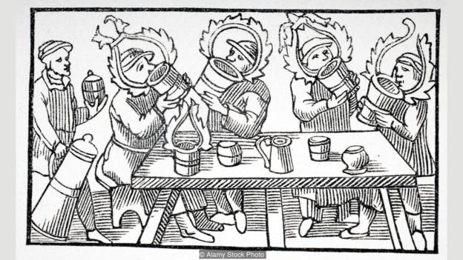

The English word ‘booze’ is over 500 years old, coming from the Dutch word buizen (Credit: Alamy Stock
Photo)

‘Booze’ was once a popular term in the slang or ‘cant’ of the criminal underworld, which may explain its rebellious overtones today. But whether formally or informally, when it comes to alcohol, English has been hard at work for centuries. ‘Alcohol’ itself is 800 years old, taken from the Spanish Arabic al-kuḥul which meant ‘the kohl’, linking it with the same black eye cosmetic you’ll find on any modern make-up counter. The term was originally applied to powders or essences obtained by alchemists through the process of distillation. This included both unguents for the face as well as liquid spirits of the intoxicating kind.
The only subjects that fill the pages of English slang more are money and sex
The heady result has been with us ever since. Purveyors of the strong stuff have invited hundreds of epithets over a millennium or more. Drinkers of the past would happily visit ‘the Lushington crib’, ‘shicker shop’, or ‘fuddle-caps hall’ (ie the local pub) to sample the offerings of the landlord - aka the jolly ‘knight of the spigot’.
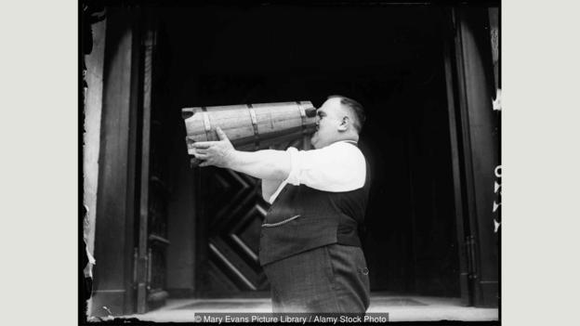

‘Booze’ was once a popular term from the slang or ‘cant’ of the criminal underworld (Credit: Mary Evans Picture Library /
Alamy Stock Photo)

The concoctions those knights dispensed fill an even richer lexicon, veering from the euphemistic ‘tiger’s milk’ to the blatant invitation of ‘strip-me-naked’. Add those to the 3,000 words English currently holds for the state of being drunk (including ‘ramsquaddled’, ‘obfusticated’, ‘tight as a tick’, and the curious ‘been too free with Sir Richard’) and you’ll find that the only subjects that fill the pages of English slang more are money and sex.
Such a lush lexicon makes it all the harder to forsake alcohol for a whole month. Those who’ve made it, however, can console themselves with the fact that they have enjoyed weeks without the unpleasantness of feeling ‘crapulent’, ‘cropsick’, or ‘wamble-cropped’: three beautifully expressive words for the dreaded hangover.
In days gone by, drinkers opted for extreme cure-alls for the morning after the night before, from the ashes of a crab to the drinking of vinegar, although the wealthier might have preferred dropping an amethyst into their glass before imbibing. ‘Amethyst’ itself came to the language from the Ancient Greek amethustos, which means ‘not drunken’, because the stone was once believed to hold magical properties that prevented intoxication.
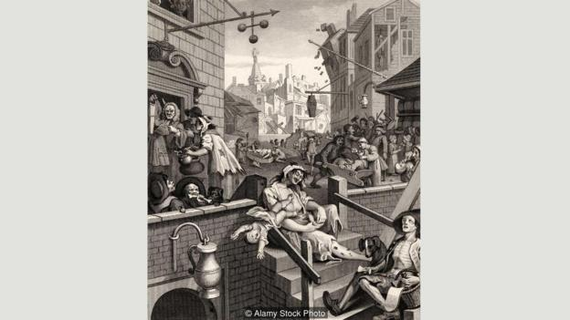

Some of the 3,000 words that English has for being drunk include ramsquaddled and obfusticated (Credit: Alamy Stock Photo)

Meanwhile, the idea of having a ‘hair of the dog (that bit you)’ was once entirely literal. In the Middle Ages, anyone bitten by a stray dog would run after the offending animal in an attempt to pluck out one of its hairs: a poultice with that hair was believed to greatly ease the post-drinking blues (what in German they call a Katzenjammer, in which the drinker’s moans are compared to the wailing of a very miserable cat). It is probably entirely appropriate that the word ‘poison’ is rooted in the Latin potare, to drink.
‘Drunk as a thrush’
Those on the wagon can afford a smug smile over shenanigans like these. The wagon in question originally carried water around small town America during the temperance movement, when citizens were urged to embrace ‘tee-totallism’, in which the ‘tee’ was there simply to give emphasis to the first letter of Total.
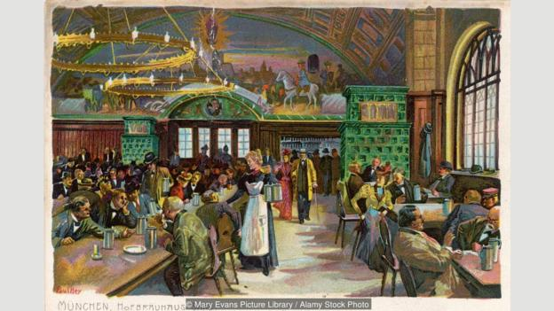

The post-drinking blues is called Katzenjammer in German, comparing the person’s hungover moans to a mournful cat (Credit: Mary Evans Picture Library / Alamy Stock Photo)
The idea soon crossed to Britain, where abstinence battled with the thrill of being ‘drunk as a lord’, an expression from the 17th Century that’s curiously linked to the swear-word ‘bloody’. The expletive is thought to have begun with the ‘bloods’ or aristocratic rowdies of the same period, when to be ‘bloody drunk’ was to be as ‘drunk as a blood’ – in other words, as sloshed as a posh hooligan. There was, it seems, nothing these bloods liked more than painting the town red, another phrase in the drinking arsenal that the town of Melton Mowbray near Leicester in the East Midlands of England has claimed for its own, thanks to a night when the Marquis of Waterford and a group of friends ran riot with pots of scarlet paint.
The adjective ‘bridal’ began as ‘bride-ale’, and was used of a wedding feast that featured plenty of the strong stuff
For all that partakers in dry January have avoided such results of befuddlement directly, it would be hard to do so with their more metaphorical tongues, for drinking is behind a surprising number of words that have since hidden their tipsy history. The adjective ‘bridal’ began as ‘bride-ale’, and was used of a wedding feast that featured plenty of the strong stuff. ‘Small beer’, on the other hand, was a heavily watered-down version of the original, enjoyed by both children and adults when drinking water could prove a lot more perilous than ale.
While we like nothing better than lampooning politicians on social media these days, that word too has its roots in guzzling. ‘Lampons!’, for the French, meant ‘let us drink!’, and was an exhortation to merry revellers to pick up their glasses and sing a song or two. As those songs tended to be mocking and satirical, so our modern sense of ridicule crept in. Lampooning and carousing went together – appropriately enough given that ‘carouse’ is from the German gar aus trinken, meaning ‘drink to the bottom of the glass’.

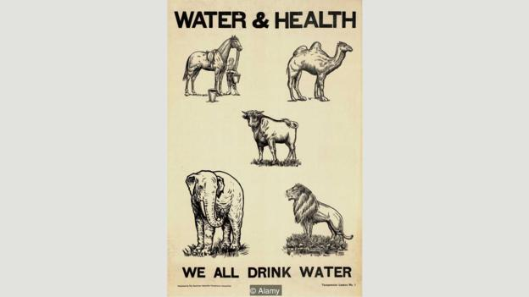

During the US temperance movement, citizens were encouraged
to embrace ‘tee-totallism’ (Credit: Alamy)
There’s an even more surprising word to add to this list. We may be ‘pissed as a newt’ these days, but for the Romans the image of choice would be ‘drunk as a thrush’, an allusion it seems to the bird’s merry tottering around vineyards after feasting on fermented grapes. Bizarrely, our English word ‘sturdy’ may go back to the Latin turdus, thrush. Anyone described as ‘sturdy’ in the 1200s was wilfully reckless and possibly as immovable as a sozzled bird.
Birds do it, newts do it, even educated lords do it: the pull of getting groggy seems hard to resist. Especially if you’re a sailor, whose associations with rum are legendary. Fittingly, ‘groggy’ itself was born on the high seas thanks to the English naval officer Admiral Edward Vernon, nicknamed Old Grog on account of his thick coat made of coarse grogram cloth. It was Vernon who gave the unhappy order that his sailors’ rations of rum should be diluted with water. He surely would not, then, have approved of two expressions that emerged in the sailors’ slang of his day.
An Admiral of the Narrow Seas is defined in Francis Grose’s 1785 Classical Dictionary of the Vulgar Tongueas “one who from drunkenness vomits into the lap of the person sitting opposite him”. (Worse still, a Vice-Admiral of those same seas is ‘a drunken man that pisses under the table into his companion’s shoes’.) Not for nothing, perhaps, were those who liked to throw back their mug of beer and drink its contents with relish known as ‘tosspots’ from the start.
Tosspot or hydropot, English has lessons for us all. And if a pint of foaming ale or glass of tantalizing red is beckoning from the hands of February, cheers. And don’t forget your amethyst.
If you would like to comment on this story or anything else you have seen on BBC Culture, head over to our Facebook page or message us on Twitter.
And if you liked this story, sign up for the weekly bbc.com features newsletter, called “If You Only Read 6 Things This Week”. A handpicked selection of stories from BBC Future, Earth, Culture, Capital, Travel and Autos, delivered to your inbox every Friday.

