TOPIC 2/5
Protective structures building on various types of operations and conditions

OPEN AND OVERHEAD COVERED PROTECTIVE STRUCTURES
Open protective structures are the simplest structures. Depending on possibilities they are gradually developed by building of revetment, overhead cover and some structures are replaced by shelters. They can be built as:
- Foxholes (ditches for small arms fire)
- Fighting pits for equipment (IFV, tank, APC artillery weapon)
- Trenches and structures built in trenches
- Protective pits for equipment and material
If overhead covered the close protection level will increase. Usual types of overhead covered buildings:
- Overhead covered ditches for personnel (funk holes, tactical command posts, observation posts)
- Overhead covered sections of trenches (usually two sections 10 m length in squad defensive position or sections in front of shelter´s entry)
- Other (pits for material)
PROTECTIVE STRUCTURES FOR PERSONNEL
Foxholes (ditches) provide protection of marksmen against adversary´s destructive means and make small arms handling advantageous. To facilitate manual work and camouflage it is better to place this structures to the terrain using it´s undulations (gullets, hallows, caves, craters etc.), features (water channels, fences etc.) and natural camouflaging covers (vegetation). Small obstacles hindering fire (branches, grass, stones) are removed.
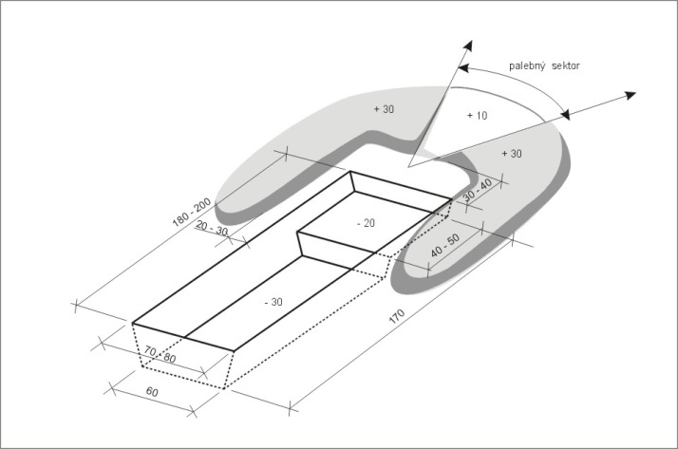

Figure1. Foxhole
Observation ditches are assigned to ensure continual observation, processing and sending of information. They are built as detached or connected to trenches, shelters or other protective structures. Layout and design depends on number on personnel occupying structure, their action and used equipment. These protective structures are usually equipped with optical means for day/night observation, special observation and signal equipment.
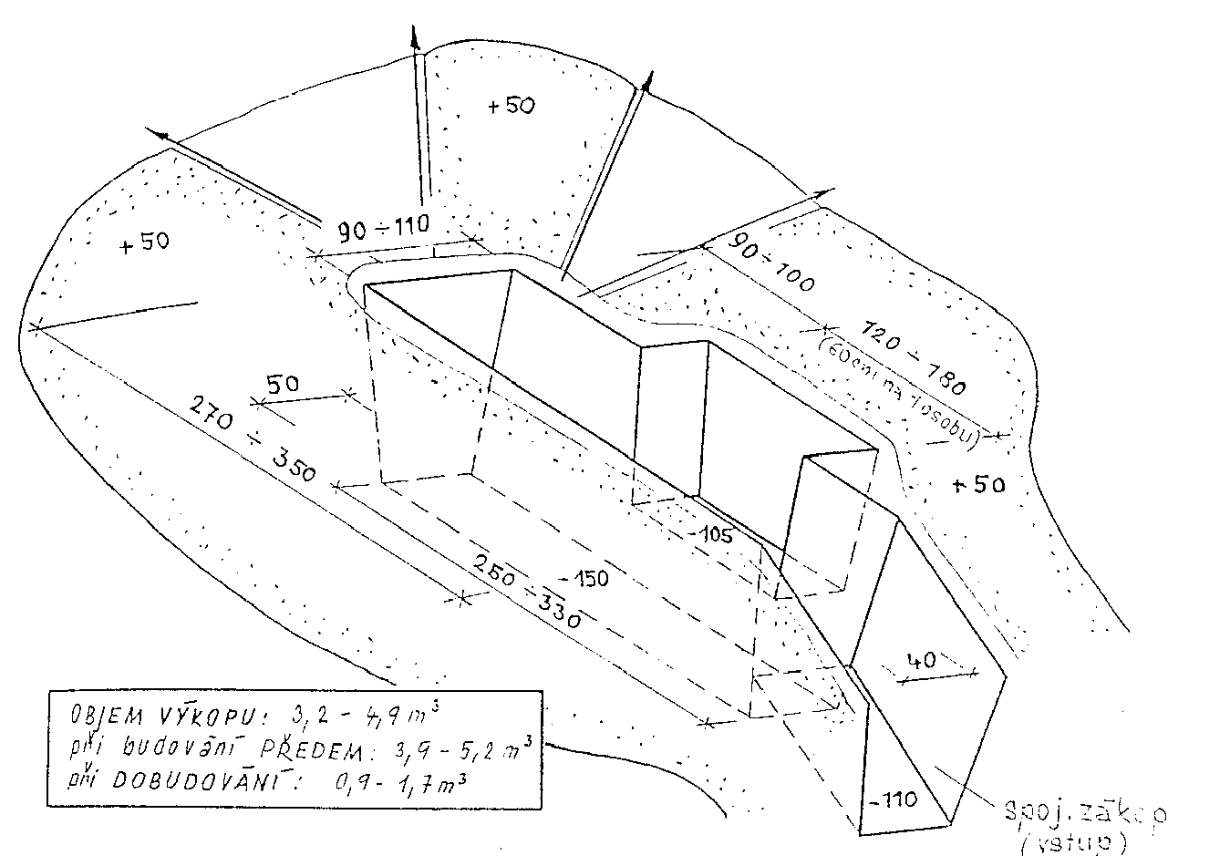

Figure2. Observation ditch
Working ditches are mostly assigned to protection of commanding personnel, immediately leading and organizing combat activity of units and formations if shelters are not built. Working ditches are placed on terrain to ensure necessary working condition (observation ability, liaison, command etc.) and to ensure concealed approach into them. They are build as detached or connected to trenches. It is practical to build it on areas hard-to-get-a-place for tanks and other armored vehicles. Working ditches can be also build to protection of logistic and medical elements and units (supply point, aid station etc.). Layout and design of working ditches depends on number of personnel, type of their activity and used equipment.

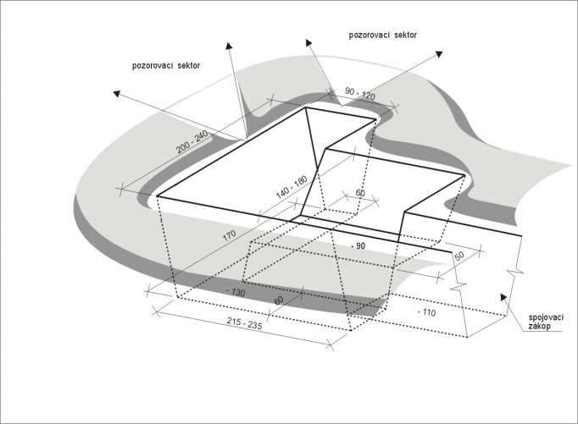

Figure3. Working ditch

Funk holes are assigned to protect personnel against combined effects of enemy´s destructive means and to deny observation. They are occupied usually for short time of increasing fire aactivity of enemy. They are usually overhead covered to increase level of protection against destructive means' effects and climatic influences. They are usually build in unit defense positions, strong points, artillery firing positions, command posts, logistic assembly areas, first aid points etc. The aim is to achieve as the highest level of mass-protection as possible in very short time. Layout vary depending on usage aim but it has to enable gradual increasing of strength. Funk holes are usually built for unit (crew, squad) but also for one person or platoon. They are built in frontal wall of trench or separately (assembly area) as open or overhead covered excavations deep at least 150 cm. Floor-to-roof clearance is usually 120 cm, floor width 60 cm and length 50 cm per person. Bearing structure is laid directly on level of terrain. If placed on rough surface stringers can be embedded and supported by thresholds on their ends (made of timber or deal).
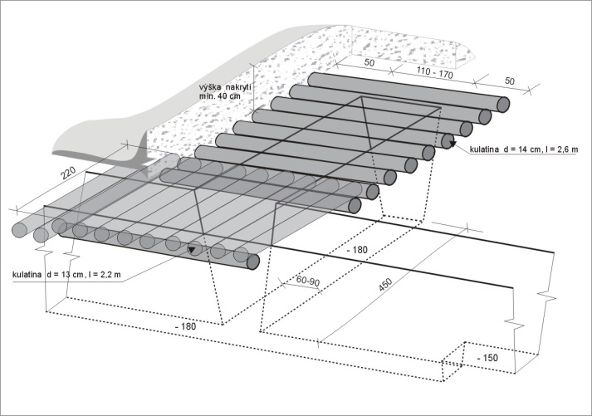

Figure4. Funk hole
Trenches provide close protection against destructive means' effects, improve conditions for application of fire, enable hidden action thereby they improve conditions for battle procedure. They are built as narrow, long ditches with parapets made of excavated soil on both sides. Profiles of trenches and ways of their building depend on combat situation, time, units´ equipment, terrain and type of soil. Trenches can be built as:
- Crawl trenches – enable small arm fire in a kneeling position and hidden moving by stalk.
- Crouching trenches – enable fire in a standing position and hidden moving of bent personnel.
- Standard trenches - enable fire in a standing position using banquette and hidden moving of upright personnel
- Deepened trenches – build usually if sections are overhead covered or in entrances to funk holes or shelters. Walls must be revetted.
- Dummy trenches
Width of trench on the terrain ground level is 90 to 120 cm, on the floor it is 40 to 60 cm. This depends on necessary wall slope that depends of soil type. Parapet high is usually 30 to 60 cm and width 1,5 to 3 m depending on excavated soil capacity.
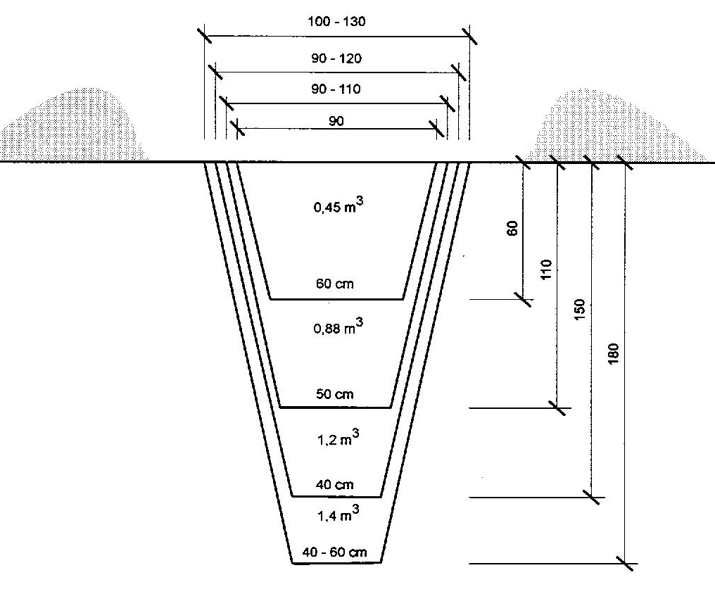

Figure5. Trenches
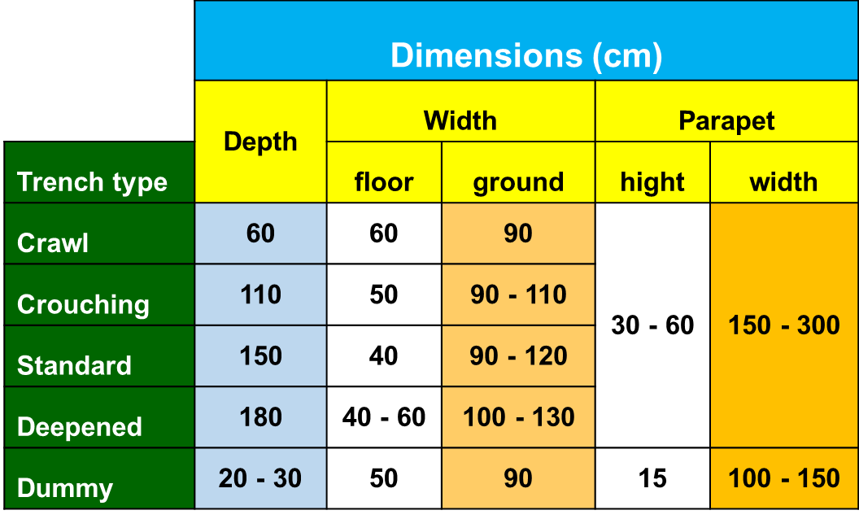

Table1. Trenches dimensions

Placement of trenches on terrain depends on terrain conditions, combat situation and their purpose. Straight stretches length of manually built trenches dos not have to overreach 15 to 20 m, built by ditching machine 25 m. Angle of refraction has to be obtuse 100º to 150º. If it is necessary to build straight stretches longer irregular grades are build every 15 to 20 m.
Approach trenches are similar to basic trenches. Constructions necessary for live of forces (funk holes, working and rest ditches, medical facilities, supply points, trench latrines etc.) are built alongside them. Line of approach trenches must be carefully hidden and camouflaged using terrain capacity and overhead cover building.
Facilities built in trenches system:
- Combat facilities
  - Clinked or released firing positions of small and AT weapons (main and reserve)
  - Observation posts
  - Funk holes
  - Cavities for weaponry and ammunition
  - First aid posts and command facilities
- Logistic facilities
  - Supply points
  - Cavities for supplies (storage)
  - Aid stations and places for stretchers
  - Trench latrines
  - A facility for improvement of operations in trenches – entrance facilities, crossings and turnouts, dead spurs drainage etc.
FIGHTING PITS BUILT FOR COMBAT EQUIPMENT
Pits for equipment and material are usually built by excavation equipment, mounted bulldozer equipment or explosives due to huge capacity of excavated soil. About 10 to 25 % of excavation mustt be finished by hand. Pits are usually build for protection of combat, transport and special vehicles, crews and material against destruction means. They are built as:
- Fighting pits for self - propelled armored equipment
  - Tanks, IFV, APC and weapon mounted on this chassis
  - Self-propelled howitzers and mortars
- Fighting pits for vehicle tracked howitzers and mortars
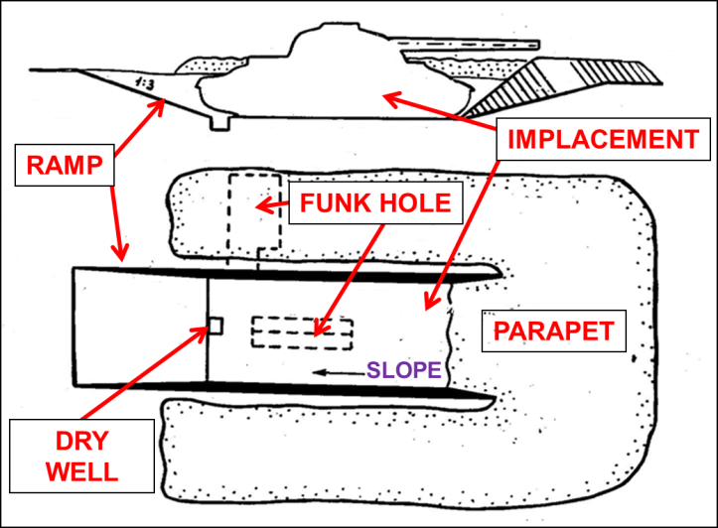
Pits for self-propelled armored equipment (tracked or wheeled) are composed of implacement (functional section), parapets and ramp. If enough time is available funk hole for crew is build. It can be built under vehicle (vehicle acts as overhead cover) or (mostly) in side wall of pit.

Figure6. Fighting pit for self-propelled combat vehicle
Parts of firing pits for vehicle tracked howitzers and mortars:
- implacement,
- funk hole for crew,
- cavities or ammunition,
- ramp,
- protective pit for howitzer (mortar).
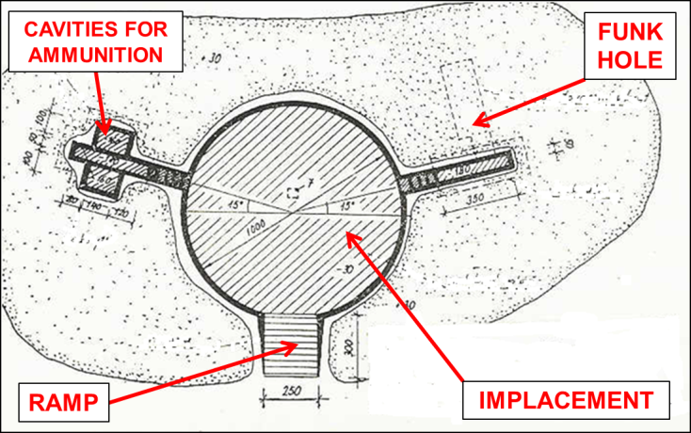

Figure7. Fighting pit for vehicle tracked howitzer or mortar
PROTECTIVE PITS BUILT FOR EQUIPMENT material
Protective pits are similar to fighting pits, but they are not assigned for application of fire thus they provide increased protection. They are built in staging areas, assembly areas, waiting positions, logistic assembly areas, command posts, aid stations etc. Protective pits are built for individual vehicles or as group protective pits. They are also build as drive – through (two ramps) or non-drive – through (one ramp). Protective pits may be built in conjunction with fighting pits in case of building for fighting equipment. Funk holes are built for protection of crews.
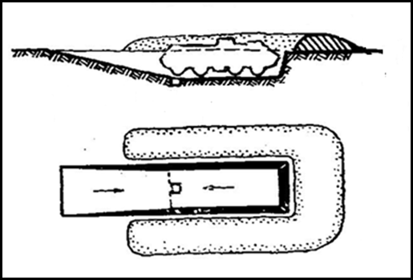

Figure8. Non-drive – through individual protective pit
Pits for material are built for critical material protection against destructive means 'effects. This material includes ammunition, fuels and lubricants, provisions etc. Special attention is paid to potable water resources. Pits are built as long ditch. Dimensions may correspond to protected material package dimensions multiple. Pits may be built as overhead covered. Protective layer has to be at least 40 cm thick. Common material for building of protective layer is soil. In case of necessity protected material has to be insulated to prevent it´s contact with moisture (food, ammunition).
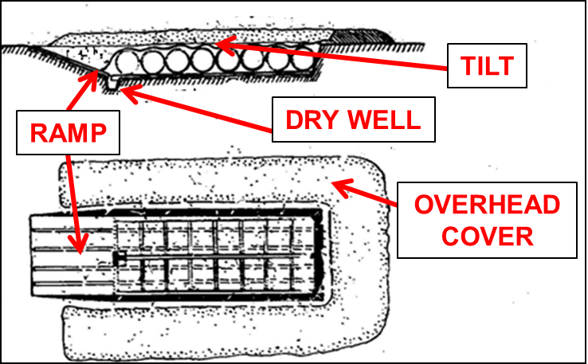

Figure9. Pit for P&L barrels
ENCLOSEED PROTECTIVE STRUCTURES
Enclosed protective structures (shelters) provide a high-quality protection against all destruction means. They prevent direct impact of destruction means effects on protected personnel or property, direct hit of grenades (bombs) and all destructive effects of nuclear weaponry and incendiary weapons.
Inner space of shelters is fully protected, the entry section is provided with back-pressure closure. Shelters are usually built as buried (singularly mined) protective structures providing collective protection against toxic and biological agents if they are perfectly sealed and equipped with filtering and ventilation device.
Shelters are build using local materials or industrially-made parts. The building requires time, trained manpower and proper equipment therefore it is difficult task.
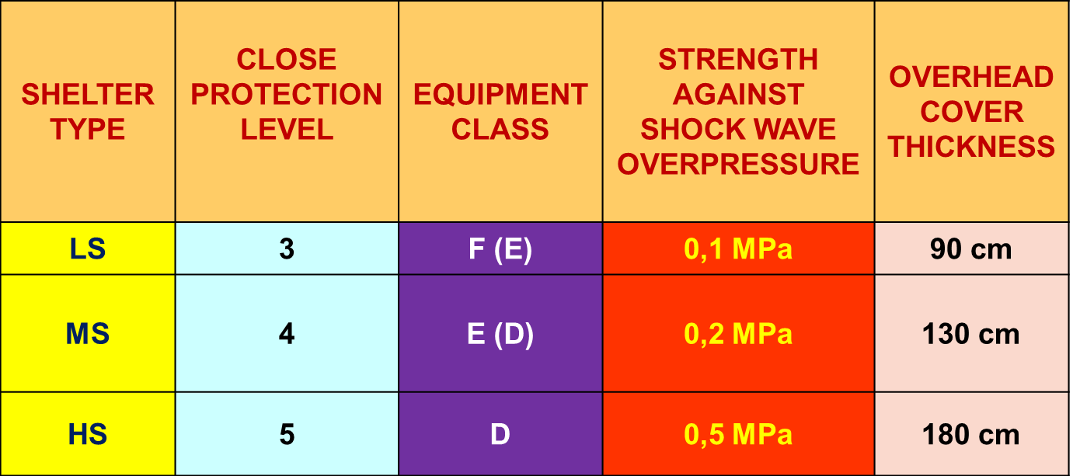

Table2. Protective properties classification of shelters
Crashproof areas located in buildings especially cellars may be adapted to provide 2th or 3th close protection level therefore they can be used as light shelters. Light and medium shelters are usually used for field fortification purpose. Building of shelters providing higher level of close protections is more difficult therefore it does not belong in field works.
Light shelters provide 3th close protection level and equipment class F. They may be built as fire, observation, funk-hole, occasionally rest or storage structures. Their design has to ensure nuclear wave protection to the overpressure of 0,1 MPa and the protective layer has to be 90 cm thick at least. These shelters are built of local materials usually of wood. Entry section has to ensure blast wave protection of functional section by back-pressure closure (back-pressure door, shield). If shelter is equipped with filtering and ventilation device it can provide collective protection.
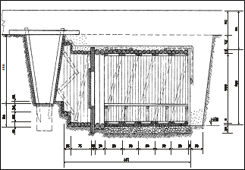

Figure10. Light shelter
Medium shelters provide 4th close protection level and equipment class E or D. They are equipped with filtering and ventilation device therefore they provide collective protection. They may be built as observation, working and rest structures. Their design has to ensure nuclear wave protection to the overpressure of 0,2 MPa and the protective layer has to be 130 cm thick at least. They are built of local materials or industrially-made parts are used. Entry section includes back –pressure closure and two gas-tight partitions and walls and ceiling are perfectly insulated to detach inner space from surrounding atmosphere.
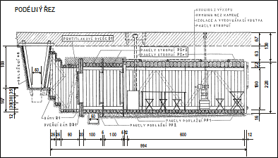

Figure11. Medium shelter

SHELTER ENTRY SECTION
Aim. Enabling to enter and to quit a shelter in any case without personnel and material being in endangering or destruction of structure or it´s parts.
Characteristics. Entry section especially it´s opening to the terrain (trench, ditch) is the most vulnerable part of the shelter. Entry section is usually open to the trench or overhead covered entry ditch.
Strength of entry section has to be the same as the strength of functional section. It has to protect functional section against blast wave overpressure intrusion and against contamined air intrusion (if collective protection is required) when personnel is entering the structure.
Because entry section may be destroyed by destructive means, therefore shelter may be permanently or partially disabled, emergency exit or hatchway is built as a part of medium shelters (if more than 10 persons are using it) or heavy shelters. The part of this shelters´ equipment is salvage tools to help personnel to rescue themselves. In case of shelters using the same or similar type of main and emergency exit parts of these exits have to be conformable or similar.
Entry section parts:
- Entry bearing structure and protective layer
- Entry equipment (stairs, ramp, ladder)
- Back-pressure and gas protection structure
- Equipment (decontamination means, lighting, salvage tools, dry closed etc.)
- Other (drainage, insulation, camouflage etc.)
Entry section dimensions
- Depend on structure´s purpose, length of entry section and power of people leaving the structure in case of need
- Clear width: 70 to 80 cm for LS, 80 to 100 cm for MS
- Clear height: 160 to 180 cm for LS, 190 cm for MS
- Minimal width 70 cm is used in case of building short corridors for small structures (fire, observations)
- Entry sections of width 110 cm are built for aid station
- If building funk-hole shelters or structures where level of activity is low the height of entry section is 160 cm
- Minimum height has not be less than 140 cm
- The height of the shelter may not be the same as the height of functional section. It is usually lower
- Dimensions of shaft entry section: min. 60 x 80 cm, max. 80 x 100 cm
Entry section location
- Every entry section is open either on terrain or into some structure (e. c. trench). In regard of destructive means' effects it is necessary to open entry section to such area where these effects are limited by other protective structures or protective capacity of terrain.
- The most usual arrangement is based on the opening of entry section into the trench that is overhead covered at 5 m and deepened to 1,8m. If build deeper in battle formation shelters´ entry sections may be opened to terrain of natural protective capacity e. c. reverse slope, narrows, ravines etc. In this case narrow ditch with stairs is build.
- Enter has be located on the opposite side to enemy´s fire. Emergency exit is built as far as possible off main entry section.
Difference in height between bottom of trench (terrain ground level) and floor of the shelter is usually overcome by stairs, ramp or ladder. If difference is small It is sometimes advantageous to deepen the part of trench in front of the entry section (it also make drainage easier).
The upper surface of the first entry section frame has to be placed by 10 cm in excess of trench floor to prevent surface water and incendiary agents leaking into the entry section. Corridor floor has to equal the functional section floor in high.
Emergency exits (if build) ere designed like main entry sections. They are build of minimum dimensions.
Hatchway is built as a shaft on the end opposite to main entry section. Shaft is closed by shield on the level of shelter´s ceiling and fills up. Hatchway is not built in the case of light shelters.
SHELTER FUNCTIONAL SECTION
Functional section serves to concealment of personnel, their activities and material. It has to ensure close protection against destructive means' effects through a bearing structure and a protective layer. Layout of the functional section and it´s equipment has to enable life and activity of personnel including technical means' usage (telephone, radio station, distribution of electric power etc.).
Functional section horizontal and vertical layout (determined in accordance with expected usage and equipment)
Calculated per person:
- Funk hole shelters 0,35 to 0,8 m² floor space 0,7 to 1,5 m³ air volume
- Rest shelters 0,8 to 1,3 m² floor space 1,5 to 2,5 m³ air volume
- Working shelters 1,3 to 2 m² floor space 2,5 to 3,8 m³ air volume
- Observation shelters 1,0 to 1,8 m² floor space 1,9 to 3,4 m³ air volume
Functional section dimensions
- Clear width : 90 to 120 cm for LS, 190 cm for MS
- Clear height : 160 to 180 cm for LS, 190 cm for MS
- Functional section length is determined in accordance with required activity of personnel and it conforms to required floor space and air volume
Drainage of functional section is ensured by floor slope of minimal 0,5 % to entry section and by:
- drainage placed under the floor and flowing in dry well built in entry section (in case of medium shelters dry well is built in the 1st air lock) or
- spray drain, build along shelter´s perimeter and filled with gravel (dry well is not built in case of light shelters but drainage is build bigger and it is filled with gravel)
- dry well in front of the gas proof door or in front of the entry into shelter (it ensures drainage of whole shelter)
Ceiling insulation against water is made of insulating foil or cardboard. Watered clay layer of 10 cm may be used singularly.
SHELTER EQUIPMENT
Shelters´ equipment necessary to fulfil their purpose
- Overpressure protection means
  - Overpressure protection of entry sections
  - Overpressure protection of openings
- NBC protection means
  - Collective protection means
- Equipment
  - Furniture
  - Heating installation
  - Lighting
  - Sanitary
  - Particular- decontaminating means
  - Potable water supply
  - Salvage tools
  - Other e. c. liaison means, observation means etc.
Equipment class determinates quality and quantity of protective structures including collective protection means. It creates living and working conditions for personnel and equipment during its placement inside protective structure.
Shelters´ overpressure protection
Shelters´ overpressure protection is based on protection of entry sections and openings (air duct, smoke flue, field of view etc.) against blast wave intrusion inside. OVERPRESSURE PROTECTION ACHIEVMENT CONDITIONS:
- Proper location and layout design of shelter
- Bearing structure earthing (under level of surrounding terrain)
- Proper solidity and structural rigidity
- Usage of means for closing of all openings (entries, hatchways, smoke flues, air ducts, fields of view, loop holes etc.)
Overpressure protection equipment is usually located:
- at entry sections,
- at functional sections,
- on structure surface,
- on functional section walls surface.
Every entry sections have to be protected against blast wave with back-pressure door mounted on back-pressure partition. This door has to be fitted with rubber hose around it´s perimeter or with other rubber sealing. Door itself as so as partition have to be made as gas proof. It creates back-pressure and gas proof isolation in the entry section. Door has to be outside open able. Back-pressure partition (door partition) bears against reinforced part of bearing structure. Back-pressure door is provided with door hinges and locks (one lock for LS, two locks for MS). Lock has to enable two closing positions:
- first position with gap of 1 cm between door and partition to enable ventilation,
- second position – door is hermetically sealed.
Opening overpressure protection is designed as back-pressure closers, weather-strips, shields etc.
Back-pressure closers protect air duct of filtering and ventilation device and smoke flue of heating installation against blast wave intrusion into the shelter. Back-pressure closers are usually parts of filtering and ventilation device. Air passes through openings to the filtering and ventilation device. In case of blast wave intrusion to the closure It is closed by membrane-spring system. In case of industrially made closers shortage it is possible to use improvised closers (box with grate filled with gravel, needles etc. – packing is compressed by blast wave overpressure) dampening blast wave overpressure.
Shelters´ NBC protection
NBC protection in light shelters is ensured by personnel NBC protective means. Medium and heavy shelters provide collective protection. It is ensured by:
- perfect insulation of shelter and it´s maintenance during usage of shelter,
- shelter´s equipment with filtering and ventilation device supplying clean air, making overpressure inside the shelter and removing harmful pollutants arised from human activity,
- equipment placed into air lock in entry section enabling personnel passage from contamined environment and improving entry insulation.
Entry section of shelters providing collective protection is protected against contamined air diffusing with two gas proof partitions and gas proof door. Together with back-pressure door they create two air locks. Outside dimensions of gas proof partition have to be greater than structure perimeter of entry section. This prevents air diffusing around the bearing structure. Air lock length is min. 100 cm (medical shelters min. 250 cm).
Shelter stemming is necessary to prevent contamined air and toxic agents diffusion or inrush of water into the functional section. It is also important to create air overpressure inside the shelter (up to 50 % of intake air is forced out of bearing structure through it´s leaks into surrounding soil). Stemming is ensured by:
- shelter´s cladding stemming especially of joints in bearing structure – most commonly with wetted and beaten clay (layer thickness of 10 cm). Cement slurry may be used too (beating structures made of reinforced concrete),
- over bearing structure insulation - insulation layer has to encroach upon natural soil of excavation wall. Side wall insulation may be also used - insulating foil, underfelt, wetted and shaped clay layer build of slope from the middle of a ceiling to sides (insulating layer must not be damaged during the backfilling,
- careful soil ramming next to bearing structure walls during excavation backfilling.
Filtering and ventilation device is fundamentally placed to back side of shelter and connected to air duct that must be provided with back-pressure closer and gas proof valve. Air flows due to air overpressure from rear panel of the shelter through inner space to entry section flushing it and it is forced out of the shelter through an overflow valve in gas proof door and through gap in back-pressure door and partition. Air locks are then flushed too.
Shelters´ EQUIPMENT
Shelters are equipped in line with their aim, strength and close protection level. Field shelters of higher strength destined for work, rest or other special functions are equipped to be more comfortable. Equipment class determinates minimal mandatory equipment. This equipment is a part of shelter. Additional equipment has to be brought by shelter crew.
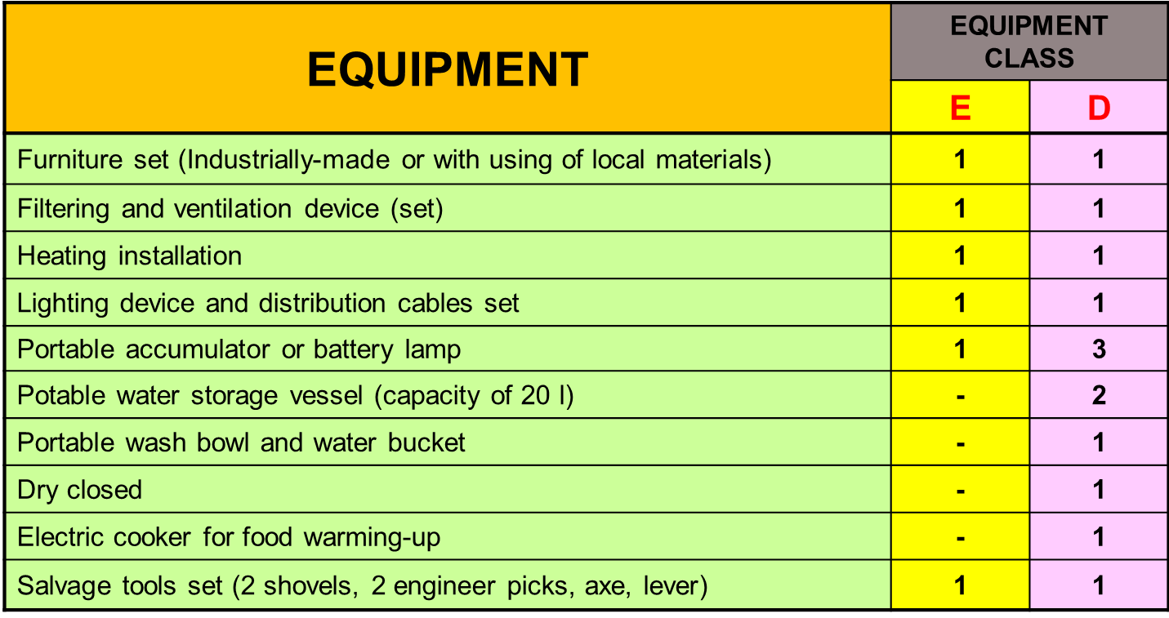

Table3. Medium shelters equipment
Heating of shelter depends on its aim, occupation and season of the year. The optimal temperature in working shelters is 22 ºC to 26 ºC in summer 18 ºC to 22 ºC in winter. Temperature in rest shelters is about 4 ºC lower. Heating is provided with solid and fluid fuel heating set. Smoke flue has to be protected with back-pressure closer and equipped with gas proof sleeve valve enabling a hermetic closing. To protect against fire walls next to heating installation are revetted with insulating material (bricks, metal plate, asbestos etc.). Heating set is usually placed in front side of shelter next to door. If filtering and ventilation device is not working heating is prohibited. In case of great shelters hot air is conveyed over the inner space with pipe.
Portable accumulator or battery lamps or lighting devices and distribution cables sets powered with generators or electric network ensure lighting of shelters. It is prohibited to use candles, kerosene lamps etc. to light a shelter.
Salvage tools set is placed into shelter space.
Potable water may be in hay-boxes, rubber water bags etc. Sanitary water is used to washing and equipment cleaning purpose.
Shelters may be equipped also with other means supporting their proper usage. They are for example means for fire choking in heating installation (bowls of send and water), first aid means, decontamination equipment etc.

OBSERVATION POSTS (OP) AND CHECK POINTS (CP) BUILDING
The observation post (OP) is a manned military position established to monitor and observe a certain area, object or event. An OP can be permanent or temporary.
The Checkpoint (CP) is a manned military position established to check, inspect and control the movement of traffic and personnel in to, or out from, a certain area or object, or an event. A CP can be permanent or temporary (CPT). Depending on the nature of the operation and task of the PSF either CP’s or CPT’s are to be preferred.
The purpose of an OP is to:
- Increase the safety in the operations area by showing a presence of the PSF to all parties and the population in the area.
- Survey all activity in the specific area.
- Monitor for example; airspace, coastal areas, airfields, CFL boundaries and borders.
- Count special traffic, such as military vehicles, tanks, APC´s, artillery, etc.
- Monitor activities of parties involved in the conflict and all other unknown and abnormal activities.
- Report all activities in the observation area upwards through the command chain.
The purpose of a CP is to increase the safety in the operations area by:
- Showing a presence of the PSF to all parties and the population in the area.
- Preventing smuggling of weapons, ammunition, explosives and other illegal material or items.
- Confiscating illegal items and apprehending the persons carrying them.
- Prevent Para-militaries and other illegal armed personnel to pass through the CP.
- Survey activity in the specific area.
- On specific order, to be able to close the flow of movement through the CP and block the roads.
- If needed, carry out the duties of an OP.
OBSERVATION POSTS (OP) are to be established as early as possible in a new mission. Initially, tomporary observation posts (OPT) should be set up. When being familiar with the situation in the area, planning of the permanent OP´s can start in order to cover the most critical areas. Start the construction of permanent OP´s when you are absolutely sure of the right place for them. Location:
- When choosing the site of an OP terrain and different climatic effects due to seasons have to be taken into consideration.
- The location of an OP is chosen to fulfill the needs of the PSO and the tasks given to the unit.
- In some missions the Status of Forces Agreements (SOFA) Peace Support Force (PSF) puts restrictions on the location of OP’s.
- For observing at long range, the OP should if possible be located on high terrain.
- To observe possible infiltration, the OP should be set up so it can oversee possible infiltration routes.
- Sometimes it is advisable to put an OP close to or inside a village to show a presence and to monitor possible hotspots.
Temporary Observation Posts
OPT’s generally have the same function as OP’s but are not allocated on fixed positions. The deployment of OPT’s is time restricted to usually cover from a few hours to a few days. OPT’s may be manned by foot patrols, vehicle patrols or AFV’s or otherwise deployed troops. AFV’s if available are very suitable for the task due to their optical equipment and shelter. The amount of equipment is determined by the patrols capacity to carry equipment. The minimum equipment for an OPT is observation- and communications equipment and an observation log. OPT’s are constantly used to cover areas and occurrences of a temporary nature that cannot be covered from fixed OP’s, and therefore belong to the routine duties of the units on the ground. Therefore the setting up and managing of OPT’s should be included in the training program of the PSF.
CHECKPOINTS (CP) are to be established as early as possible in a new mission. Initially, Temporary Checkpoints (CPT) should be set up. After establishing the situation in the area, planning of the permanent CP’s can start. Start the construction of permanent CP’s when you are sure of the right place for them. Location:
- When choosing the site of a CP terrain and different climatic effects due to seasons have to be taken into consideration.
- The location of a CP is chosen to fulfi l the tactical demands of the PSO and the tasks given to the unit.
- In some missions the SOFA of the PSF puts restrictions on the location of CP’s.
Temporary Checkpoints
CPT’s generally have the same function as CP’s but are not allocated on fixed positions. The deployment of CPT’s is time restricted to usually cover from a few hours to a few days. CPT’s may be manned by foot patrols; vehicle patrols or AFV’s or otherwise deployed troops. AFV’s if available are very suitable for the task due to their armament and shelter. The amount of equipment is determined by the patrols capacity to carry equipment. The minimum equipment for a CPT is equipment for checking people and vehicles and communications equipment. CPT’s are constantly used to cover areas and occurrences of a temporary nature that cannot be covered from fixed CP’s, and therefore belong to the routine duties of the units on the ground. Therefore the setting up and managing of CPT’s should be included in the training program of the PSF.
BUILDING OF OBSERVATION POSTS
Building and improving
- The OP tower is built.
- The area is fenced off with barbed wire at a distance of 40– 50 meters from the defense positions if possible (out of range of hand grenades).
- Building of the defense positions and shelters.
- Connection of electric power.
- Warning systems are set up around the OP.
- Manuals, photos of the observation area, etc. are produced and improved.
- The infrastructure (housing, sanitation etc.) is set up.
Other considerations when establishing an Observation Post
- A PSF OP is regarded as a PSF installation and should also be able to defend itself if necessary. Proper defense positions and shelters have to be built.
- The night vision capability of some armored vehicles makes them extremely efficient for observation by night. Therefore such vehicles could reinforce OP´s from time to time.
- The use of available sensors is to be taken into consideration for covering possible blind spots.
- Acoustic senses should not be overseen when establishing OP’s. Tanks, APC´s and airplanes, for example, will often be heard a long time before you are actually able to see them.
- Have a Helipad in the vicinity of, or inside, the OP.
- Have an UXO pit prepared in the vicinity of the OP site.
- How to build a compound with necessary facilities.
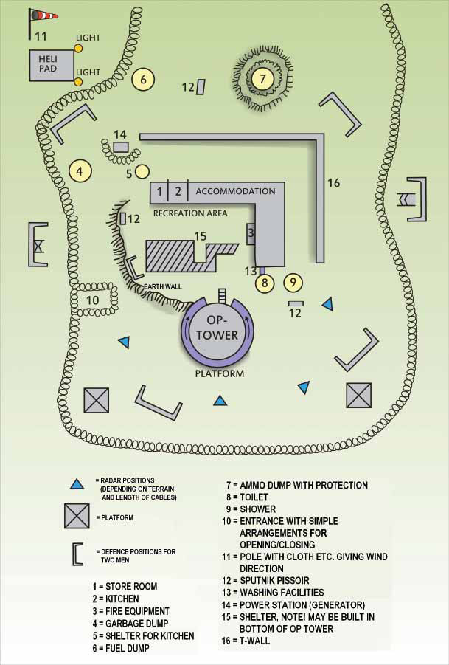

Figure12. Observation post layout
BUILDING OF CHECKPOINTS
Building and improving
- The gates and spiders or concrete blocks are placed on the road.
- The area is fenced off with barbed wire at a distance of 40 – 50 meters from the defense positions if possible (out of range of hand grenades).
- Building of the defense positions and shelters.
- Connection of electric power.
- Setting up of floodlights.
- The CP house is built.
- Warning systems are set up around the CP.
- The equipment, manuals and photos are produced and improved.
- The infrastructure (housing, sanitation etc.) is set up.
Considerations when establishing a Checkpoint
- A CP is regarded as a PSF installation and should also be able to defend itself if necessary. Proper defense positions and shelters have to be built.
- The CP must be built at least 15–30 meters from the road. The distance must not exceed talking distance between the securer and the soldier examining the car.
- The CP is constructed to be bullet proof up to caliber .50 (12.7 mm).
- Small openings are made for defense in all directions, but of course with emphasis towards the road.
- The entrance to the CP must be secured against hand grenades.
- Chicken wire covering all openings to safeguard against grenades.
- Possibilities for own personnel to observe and fire through the chicken wire.
- Barbed wire or concertina is put up around the CP with only a narrow entry leading to the CP. The entry must be in the direction of observation for the light machinegun or rifle. The barbed wire must be lower than the line of sight.
- Barbed wire/concertina along the road and around the CP (outer perimeter) to prevent hostile personnel from operating inside the CP compound.
- One of the gates should be a large, heavy one that can be closed quickly to make the traffic stop.
- Barbed wire between the waiting lane (for cars) and the road.
- Big, heavy concrete blocks, at least three in each direction.
- Defense position for a squad has to be built in the CP compound. Half covered positions for one or two armored vehicles.
- Positions for recoilless rifle.
- Bumps for speed reduction.
- Nail mats that can be easily towed across the road.
- Floodlights must be placed so that they do not blind own personnel.
- The PSF controlled area is clearly marked with signs.
- Trip flares and other warning systems.
- Cut down vegetation to prevent infiltrators or others from moving up to or passing the CP without being discovered (remember the danger of mines).
- The armament of armored vehicles makes them extremely efficient for showing force. Therefore such vehicles could reinforce CP’s from time to time.
- Have a Helipad in the vicinity of the CP.
- Have an Unexploded Ordnance pit prepared in the vicinity of the CP site.
- How to build a CP with necessary facilities.

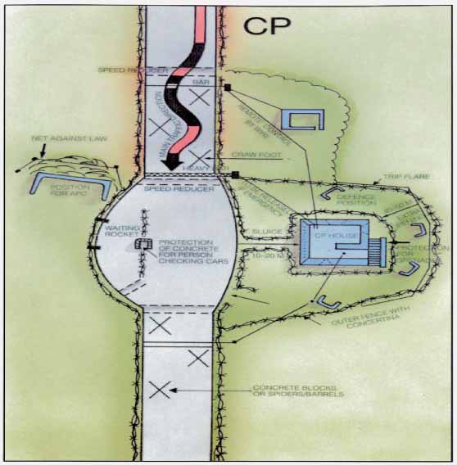

Figure13. Check point layout
BASE CAMPS BUILDING
Base camps. A base camp is an evolving military facility that supports the military operations of a deployed unit and provides the necessary support and services for sustained operations. Base camps are typically designed to be used for short- to mid-term periods, generally from a few months to a few years. They have a limited number of fixed facilities constructed and typically have a well-defined perimeter and controlled access. These facilities include various types of housing; sanitation; command and control (C2); morale, welfare, and recreation (MWR); and supporting logistics infrastructure. These facilities may include new or prefabricated construction and make maximum use of any existing structures (with and without repair or modification). They are usually established to support a specific mission or operation for an extended period of time and are closed at the conclusion of that operation. These missions may include offensive, defensive, stability, or civil support. Base camps are subject to a broad range of construction, facility, and environmental standards, depending on the camp’s anticipated life span, population, function, governing documents, location, and the tactical and political situation. A base is a locality from which operations are projected or supported. At the base level, the component in command of the base has overall responsibility for the security of everything within the base boundary. Tenant units normally secure their own facilities within the base, but selected forces will be made available by tenant units and the base commander will exercise tactical control (TACON) over those forces for the purpose of base defense. This should be proportionate to the organic capabilities and the local threat.
MAJOR BASE CAMPS, occupied by a battalion task force or larger unit, (500 population or more) are continuously operated camps with command, staff, and logistic functions.
FORWARD OPERATING BASES are normally occupied by company-sized units and operated on a continuous basis.
OUTPOSTS are normally used for short term, operationally defined missions (examples checkpoints and observation posts), platoon or squad sized, and will have limited services.
TEMPORARY BASES. Designed and constructed on an expedient basis, with finishes, materials, and systems selected with energy efficiency, maintenance, and lifecycle costs being secondary considerations and with a life expectancy of five years or less.
SEMI – PERMANENT BASES. Designed and constructed with finishes, materials, and systems selected for moderate energy efficiency, maintenance, and life cycle cost and with a life expectancy of more than five but less that 25 years.
PERMANENT BASES. Designed and constructed with finishes, materials, and systems selected for energy efficiency, low maintenance, and low life cycle cost and with a life expectancy of 25 years or more.
BASE CAMP FACILITIES
ROADS. Primary roads identified by commanders on base camp master plans are authorized for paving with asphalt. Primary roads are considered to be the major camp arteries that support the majority of vehicle traffic through the camp. Concrete turning pads are authorized to prevent damage to asphalt roads. Secondary and perimeter patrol roads are to be surfaced with gravel.
HOUSING. It provides electric heat, lighting, and fixed duplex electrical outlets. All living units are equipped with hard-wired smoke detectors and fire extinguishers. Furniture authorized for deployed soldiers and civilians: one bed, bunk/single, one mattress single foam rubber with non plastic shell, one foot locker, nail boards on walls of living areas, locally built shelves made of plywood.
SURGE HOUSING. All base camps maintain the ability at all times to house 10% of total population as transients and surges. This is usually ensured by tents with plywood floor panels. This tents can be equipped with plywood panel sidewalls, raised insulated flooring, electric light outlets, electrical outlets and space heaters.
TOILETS AND SHOWER FACILITIES. Toilet and shower facilities are lighted, heated and equipped with hot and cold water. A shower head/population ratio of 1:10 is the goal for all base camps. A Toilet/population ratio of 1:10 is the goal for all base camps.
The size of the HEADQUARTERS is situation dependent, based on the standards . The headquarters should include, but is not limited to chain-link security fence with barbed wire top, gravel parking lots, exterior security lighting, Secure Compartmentalized Information Facility (SCIF), a facility to house the Tactical Operations Center (TOC) operation, SEAhut style buildings for primary staff offices, communications platforms and shelters, command bunkers and guard shacks.
AVIATION FACILITIES include helicopter pads, vehicle parking area , lighted landing pad , forward area refuel point (FARP), control tower, aviation maintenance, aviation ground vehicle maintenance.
MEDICAL FACILITIES. All plans for health clinics, dental clinics, and hospitals will be developed in coordination with the supporting Health Facility Planning Office or through the Health Facility Planning Agency. They are aid stations, clinics and hospitals.
MOTOR POOL FACILITIES include maintenance facilities, maintenance administration, maintenance pads, fuel truck parking, wash rack, hazardous waste collection points, parking lots.
KENNELS. Military working dogs are authorized a lighted, climate controlled kennel, and an exercise yard. Kennels will have individual stalls (dog run) for each animal, and a sealed concrete floor for health reasons and ease of cleaning. Kennel floor drains should be connected to a sewer system.
MORGUE. Privacy screen is authorized around the entire facility.
WAREHOUSES are authorized wherever a 2 year pay back or less can be shown using the criteria of reduced lease cost, reduction of weather damage, increased shelf life, and other relevant factors. Warehouses are preferred over MILVANS for long-term storage.
DRMO. One recycling facility per task force is authorized at a size of 0,1 m² per soldier. Should have concrete or asphalt floor capable of handling forklifts.
BASE CAMP UTILITIES
ELECTRIC POWER. Where economically supportable and practicable, base camp power grids will be connected to commercial power. Smaller or remote base camps that cannot be economically connected to the commercial power grid are authorized to construct central power plants capable to support 125% of camp maximum demand load, or use distributed generators of sufficient capacity to support maximum demand loads.
HEATING, VENTILATION & AIR CONDITIONING (HVAC). Heating/cooling will be provided to office spaces, admin areas, and soldier living spaces in temporary standard structures such as SEAHuts. Camps will utilize installed central heating/cooling systems where already existing or as economically feasible. Tents will be provided with heating only. Storage areas will only be provided heating/cooling services as needed to address specific storage requirements. Temporary facilities such as SEAHuts will utilize individual environmental control units (ECUs) sized to ensure delivery of heating cooling as follows: standards for maximum indoor temperatures in winter are 20 °C and minimum indoor temperature in summer is 25 °C.
WATER. For main operations bases the order of execution for water is as such
- Contractation to tie into local municipalities if it is economically feasible, and meets Army health and force protection standards. The installation of a water purifying station such as a UV-2000 should be considered in the start up cost on this project.
- Installation of wells for potable water. A minimum of 2 wells per camp, one primary and one for back up are authorized.
- Potable water trucking and/or bottle water.
WASTEWATER TREATMENT PLANT. The initial assessment for a base camp should have a design for the installation of a wastewater plant based on projected size of the camp to include allied forces and local nationals. Upgrades to existing sewage treatment plants are authorized to allow for effective treatment of waste being generated on that facility. Connection to local waste treatment facilities should be made only if the facilities meet Army standards.
FUEL STORAGE. Above ground fuel tanks are authorized for the storage of bulk fuels. Fuel storage bladders will be phased out as the above ground storage tanks become available. Tanks will be constructed IAW existing environmental regulations and installed per manufacturer recommendations.
AMMUNITION HOLDING AREAS (AHA). Ammunition holding areas will have containment berms, a fenced and lighted perimeter, graveled access roads and lightning protection for the entire area. Ammunition will be stored in protective structures (MILVANs) that are out of contact with the ground (on wooden sleepers or on concrete foundations).
SOLDIER SUPPORT ON BASECAMPS
The concept for upgrading SOLDIER SUPPORT FACILITIES is to increase the ability to provide support services to TF soldiers and to provide a safer working environment. It includes dining facilities, chapels , education centers, DLA & MOS library, postal facility, mail rooms, supply support activity (SSA), finance, barber/beauty/alteration/pressing facilities, post exchange (PX), food /service concessions stands, laundry collection/distribution point, fire protection, morale, welfare and recreation – MWR (fitness facilities, field house, athletic fields, community activity center - communication (cyber cafe) center, phone center, common area, library, and TV room, theater, warehouse/maintenance facility).
BASE CAMP PROTECTION
Anti-terrorism force protection and physical security in the expeditionary environment presents unique challenges to planners, engineers, and security forces. As is the case for fixed facilities, the type and severity of the threat along with the desired level of protection will be the primary considerations in the selection of the anti-terrorism force protection and physical security measures. These considerations will affect decisions on various issues such as the types of vulnerability reduction measures and the physical layout of facilities, facility groups, and infrastructure. Important factors in planning security measures in the expeditionary environment include the availability of existing facilities, the type of structures in which people live and work, existing natural or man-made features, type and quantity of indigenous construction materials, available real estate and layout of utilities and other base infrastructure.
ENTRY CONTROL POINTS (ECPS) and facilities must remain functional and an essential aspect of the FOB access control system regardless of the level of threat. The type of access provided at the ECP should be a principal factor in the design of the ECP. Numerous factors should be considered when commanders are determining the type of access at a base camp, including threat, base camp mission, base camp operations, and available security personnel. The preferred type of access for an ECP is one that limits all pedestrian and vehicle access to mission-essential personnel only. The ECP design should anticipate increased traffic volume and should support the employment of required force protection condition (FPCON) measures and random antiterrorism measures (RAMs). The total number of ECPs should be kept to a minimum. An entry control point should be subdivided into FUNCTIONAL ZONES, each encompassing specific functions and operations.
Approach zone. The approach zone is the initial interface between the off-site road network (public highways) and the base camp. The length of the approach zone should be based on available land, distance required for queuing and performing traffic sorting, and the space required for additional lanes of traffic to prevent traffic from backing up excessively onto adjacent public highways. Space may also be required to support additional speed management techniques to mitigate high-speed threats. The approach zone should include design elements that accomplish the following functions and operations:
- Reduce the speed of incoming vehicles.
- Sort traffic by vehicle type.
- Allow for verification of authorized access of personnel and vehicles.
- Provide adequate stacking distance for vehicles waiting for entry.
- Provide the first opportunity for early warning to identify potential threat personnel/vehicles, including those attempting entry through the outbound lanes of traffic.
Access control zone.The access control zone is the main body of the ECP. It includes guard facilities, vehicle and personnel inspection areas, and traffic management equipment used by the security forces. The design of the access control zone should be flexible enough to ensure the infrastructure can support future inspection demands, access control equipment, and technologies. The access control zone should include design elements that support the following functions and operations:
- Verification of personnel identification.
- Random or 100-percent inspection of personnel and vehicles.
- Visitor control (issue of visitor/vehicle passes).
- Overwatch for approach zone.
- Maintenance of vehicle speed management/reduction techniques.
Response zone. The response zone is the area extending from the end of the access-control zone to the final denial barrier or gate to the FOB. This zone defines the end of the ECP. The response zone should be designed so security personnel can carry out the following functions:
- Provide time to react to a threat, operate the final denial barriers, and close the gate, if necessary.
- Monitor overwatch for the entire entry control facility.
- Define the FOB perimeter.
Safety zone. The safety zone extends from the passive and active barriers in all directions to protect site personnel from an explosion at the ECP. Acceptable standoff distance, or safety zone, must be determined by an assessment of the threat (specifically, expected weight of the explosive charge) and the base camp or asset to be protected. If an adequate safety zone or standoff distance cannot be achieved to produce acceptable damage and injury levels, other alternatives must be evaluated or a decision made to accept additional risk.

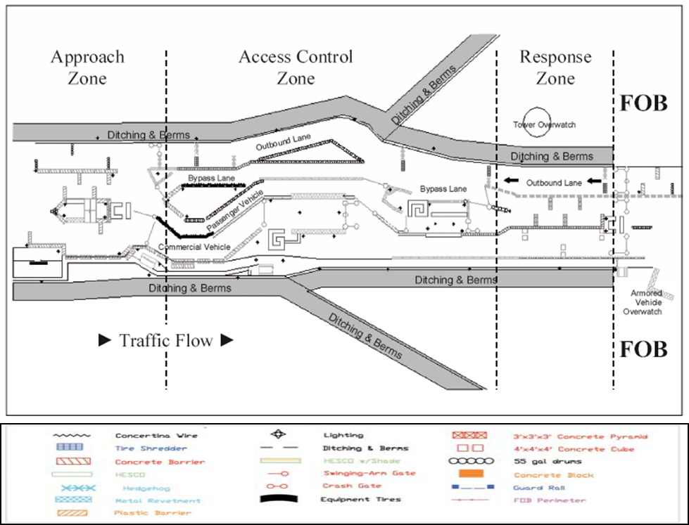

Figure14. Entry control point (ECP) layout
FACILITY PROTECTION
Site characteristics
- Maintain good housekeeping by keeping areas within 9-meters of shelters or structures free of items other than those items that are part of the infrastructure.
- When possible, position exterior doors so they cannot be easily targeted from the installation perimeter or uncontrolled vantage points.
Facility standoff/separation
- Maintain a minimum standoff distance of 20-meters from inhabited transportable structures to installation perimeter.
- Clearly delineate the installation perimeter. Options include, but are not limited to, fencing, concertina wire, barricades, counter-mobility barriers, ditches, police tape, or warning signs.
- Maintain a minimum separation of 18-meters between billeting groups.
- Maintain a minimum separation of 3.5-meters between billets in a row.
- Maintain a minimum separation of 9-meters between rows of billets.
- Limit unprotected glazing to 5% or less of the wall area.
- Locate mail and supply handling areas at least 20-meters from inhabited transportable structures.

Generators
- Wood or chain link fence will be installed around all generator locations. Enclosing generators in wooden buildings is not authorized.
Bunkers (shelters)
- Sand bag bunkers will have the sand bags protected from solar radiation and the wooden core protected from rot. Design factor is 110% of camp population for bunkers and fighting positions. Normal planning factor is that 50% of the population will be on the perimeter, with 50 % in bunkers.
Guard towers
- Guard towers will be placed so every tower is visible to the immediate towers on the right and left and so there is no dead space on the perimeter. Towers will have heat and light. Towers will be hardened against small arms and mortar fire.
Fighting positions
- Overhead cover design on fighting positions must be approved by the task force engineer. Fighting positions must be inspected regularly for deterioration.
Theaters and similar multipurpose facilities
- These facilities will have a barrier to minimize a car bomb threat. Barrier can be a berm, Hesco bastions, Jersey barriers, or other method capable of stopping a car or truck. Air conditioning will be fenced to reduce terrorist threat of gas introduced into the duct systems.
Water plant
- Water plants, wells, storage tanks, and bladders will be fenced.
PERIMETER PROTECTION
- Fences, either chain link or concertina, are authorized around the camp perimeter. Berms and sniper screens are authorized to block vision. Perimeter lights are authorized. A gravel perimeter road is authorized inside the berm. Culverts underneath the perimeter fence will be caged to prevent persons from crawling through.
PROTECTIVE STRUCTURES BUILD ON OBSERVATION POSTS CACKPOINTS AND BASECAMPS
One of the elements in an integrated, layered, defense-in-depth plan for the base camp is the use of structures that are designed to protect personnel and other assets from the effects of threat weapons. Protection from VBIEDs and RAMs should be considered during the base camp planning/layout stage rather than trying to include it after the base camp is occupied. However, this may not be practical due to constraints on available resources (lack of time, manpower, materials, equipment, funds, etc.). If the desired level of protection from VBIEDs and RAMs cannot be provided during the expeditionary and initial stage of the JFOB, at a minimum, a plan should be established for implementing and increasing levels of protection as the base camp evolves. To the extent plausible, locations in which personnel routinely work eat, or sleep should be hardened. In addition, hardened positions such as bunkers and foxholes with overhead cover should be provided in immediate proximity to all unprotected areas in which personnel must work or transit within the base camp. The axiom, continue to improve the position for as long as it is occupied, remains valid. Commanders of all units must know their requirements for protection. They must also understand the principles of fighting positions and protective positions, as well as the level of protection needed, given limited engineer assistance.
PROTECTIVE STRUCTURES MAY BE GROUPED AS FOLLOWS:
- Sidewall Protection and Revetments. Walls or barriers designed to stop fragments and reduce blast effects from near-miss impacts of RAM rounds. Revetments are used to provide full-height sidewall protection and to form a wall around open stores of critical equipment or material assets. Some revetment designs can also function as vehicle barriers.
- Compartmentalization. A series of interconnected walls designed to divide large areas of high occupancy into smaller protected areas so as to limit casualties from impacts of RAM rounds.
- Overhead Cover. A structure designed to provide protection from the direct impact of incoming RAMs. The concept consists of a pre-detonation layer that activates the incoming round’s fuse, causing it to detonate, and a shielding layer that stops the fragments and reduces the blast effects.
- Personnel and Equipment Bunkers (Shelters). Purpose-built structures designed to withstand both near miss and direct hits of RAMs.
- Hardened Fighting and Observation Positions. Similar to personnel and equipment bunkers except they have apertures for returning or initiating fire.
- Use of Existing Structures. Depending on construction type and standoff, existing structures can provide protection against VBIEDS and RAMs. If required, there are retrofit construction techniques for increasing protection.

