TOPIC 2/7
Concealment, camouflage and deception fundamentals, tasks and procedures
Although camouflage and concealment is and all arms task one of the main engineer survivability tasks associated with force protection is “Assistance with camouflage, concealment and deception.” This includes the MILENG Expertise in planning, designing, construction and maintenance of concealment and deception in support to tactical Commanders Measures taken by engineers might include the construction of fighting positions, the installation of dummy equipment and the emplacement of phoney minefields to support formation and unit deception plans.
Camouflage and Concealment. In general, all units are responsible for their own concealment and local camouflage. Major positions, facilities, and operational sites, may, however, require special camouflage stores and measures. The tactical commander may then require engineers to undertake such tasks, as advised by his engineer commander. Efforts must be made to mitigate the distinctive signatures that engineer work in preparing battle positions can create. Apart from the use of camouflage nets and natural camouflage material, special camouflage measures often require the employment of engineer equipment and devices. This is especially true for large scale camouflage requirements.
Deception. Deception is designed deliberately to give the adversant a false and misleading picture of the true tactical and operational situation thus conferring potential benefit to own forces. Deception measures often include camouflage, although construction work should expend as little time and materiel as possible. It is an engineer responsibility to provide advice on deception to the all arms/branches commander.
- Deception must always be coordinated at the highest practical level and with all the units involved.
- Special engineer deception measures can include construction of dummy positions, phoney obstacles, including minefields, decoys and the simulated employment of construction equipment. For the construction of dummy positions and decoys, camouflage and deception material will be used and engineer equipment may be employed to excavate soil. Damaged or captured materiel can also be used to create deception. Dummy positions and decoys must be carefully planned and coordinated within the framework of the tactical plan and genuine positions.

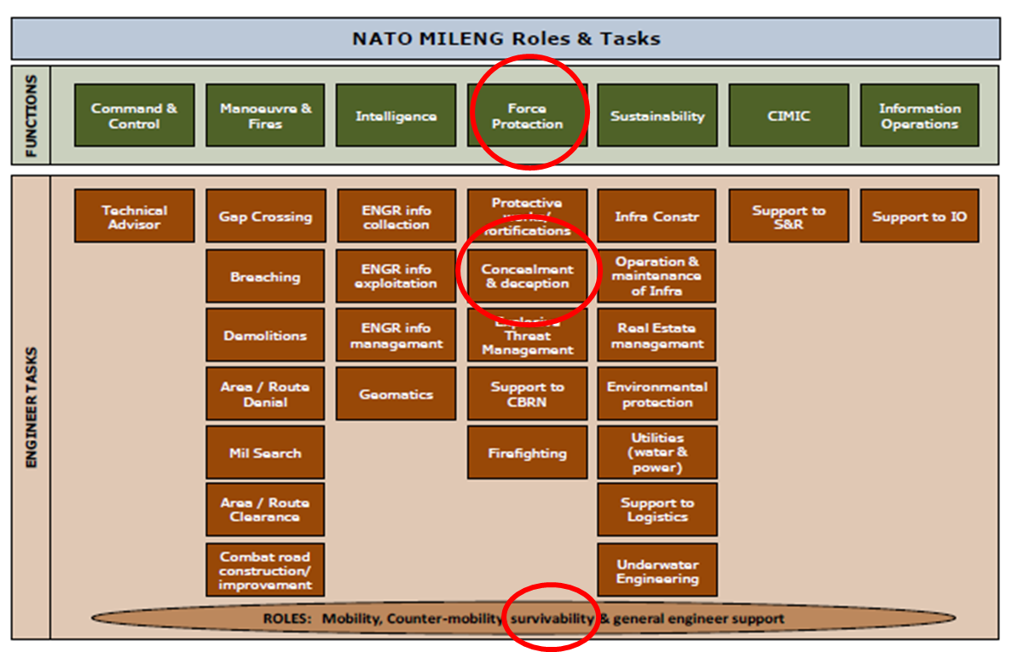

Figure1. Framework of camouflage and concealment within NATO MILENG roles and tasks

NATO CC&D APPROACH
Denial and Deception (D&D) - is the overarching defensive and offensive philosophy of using resources and procedures to control the knowledge and situational awareness in an operational scenario for friendly use, while denying all information on friendly plans, deployments, operations, etc. to an opponent(s). The measures, tools and resources of CC&D are the executive aspects and the practical plans and measures of the D&D philosophy. CC&D includes the operational and tactical measures, materials and procedures used to achieve the goals of the D&D philosophy.
CC&D - Camouflage, Concealment, and Deception
Camouflage - the use of natural or artificial materiel on personnel, objects or tactical positions with the aim of confusing, misleading or evading the enemy.
Concealment - the protection from (enemy) observation or surveillance. Sometimes referred to as Blending.
Deception - those measures designed to mislead the enemy by manipulation, distortion, or falsification of evidence to induce him to react in a manner prejudicial to his interests.

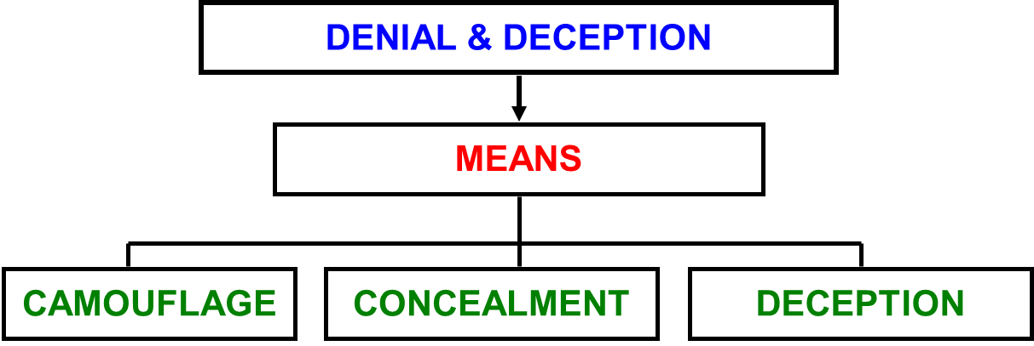

Figure2. NATO CC&D approach

CZECH CAMOUFLAGE APPROACH
Concealment is used usually on the tactical level. It acts as passive way of camouflage based on denial of creation, removal and suppression of signatures. It is realized by:
- Hiding is using of terrain, lighting and meteorological conditions,
- Disguising is a creation of natural or artificial masks,
- Disrupting is a deformation of object characteristic outward appearance.
Concealment is continuously and independently planed and lead by commanders of all levels without special orders using all available means.
Decoying is deploying a false or simulated target(s) within a target’s scene or in a position where the enemy might conclude that it has found the correct target(s). Decoys generally draw fire away from real targets. Depending on their fidelity and deployment, decoys will greatly enhance survivability.
On Purpose Demonstration is based on dummy activities of real units in dummy areas during movements, marshalling and battle procedure.
Decoying and On Purpose Demonstration are conducted by detached units and based on order of higher command level.
Natural camouflage is basic, the fastest, the most easy and the cheapest type of camouflage. It is used in all situations including such measures enabling full hiding, disguising or disrupting of objects and activities by proper usage of terrain camouflage capacity, lighting and meteorological conditions. The most useful are woods, bushes, vistas, narrow-sunken roads, hallows, ravines, undulations and urban areas (barns, woodsheds, walls, fences, breezeways, sheds, narrow streets). Cast shadows are used always. Artificial camouflage is used where using of natural camouflage cannot provide sufficient protection. Artifical camouflage requires increased usage of personnel, equipment and more time.
Artificial camouflage includes such measures that require a usage of technical means made and delivered to army forces for this purpose. It include:
- Painting of surface camouflage,
- Screening,
- Radar camouflage,
- Special camouflage.
Painting of surface is artificial change of objects´, masks' or terrain parts' surface by using of colors or local materials. It makes their identification or surveillance harder in visual and near infrared spectrum (visual, optoelectronic and photo reconnaissance).
Screening decreases visibility of objects or it conceals it completely. Natural masks with artificial camouflage material, blending means, artificial masks, decoys or phoney facilities are used for this purpose.
Radar camouflage is assigned to reduce or disable ground target identification with radar. It decreases radar visibility of target by its radar cross section (RCS) reduction or by absorption or dispersion of energy emitted by radar.
Special camouflage is conducted by technical means requiring special training for its usage. Engineer special camouflage measures include:
- Explosives and detonators – used to imitate explosions of grenades, air bombs or engineer ammunition explosions during protective building. This measures are adopted to decoy dummy areas or phoney facilities and to carry out On Purpose Demonstration there.
- Thermal camouflage – partial or full concealment of thermal signs respectively their imitation in Medium Wave Infrared (MWIR) and Long Wave Infrared (LWIR) spectrum.
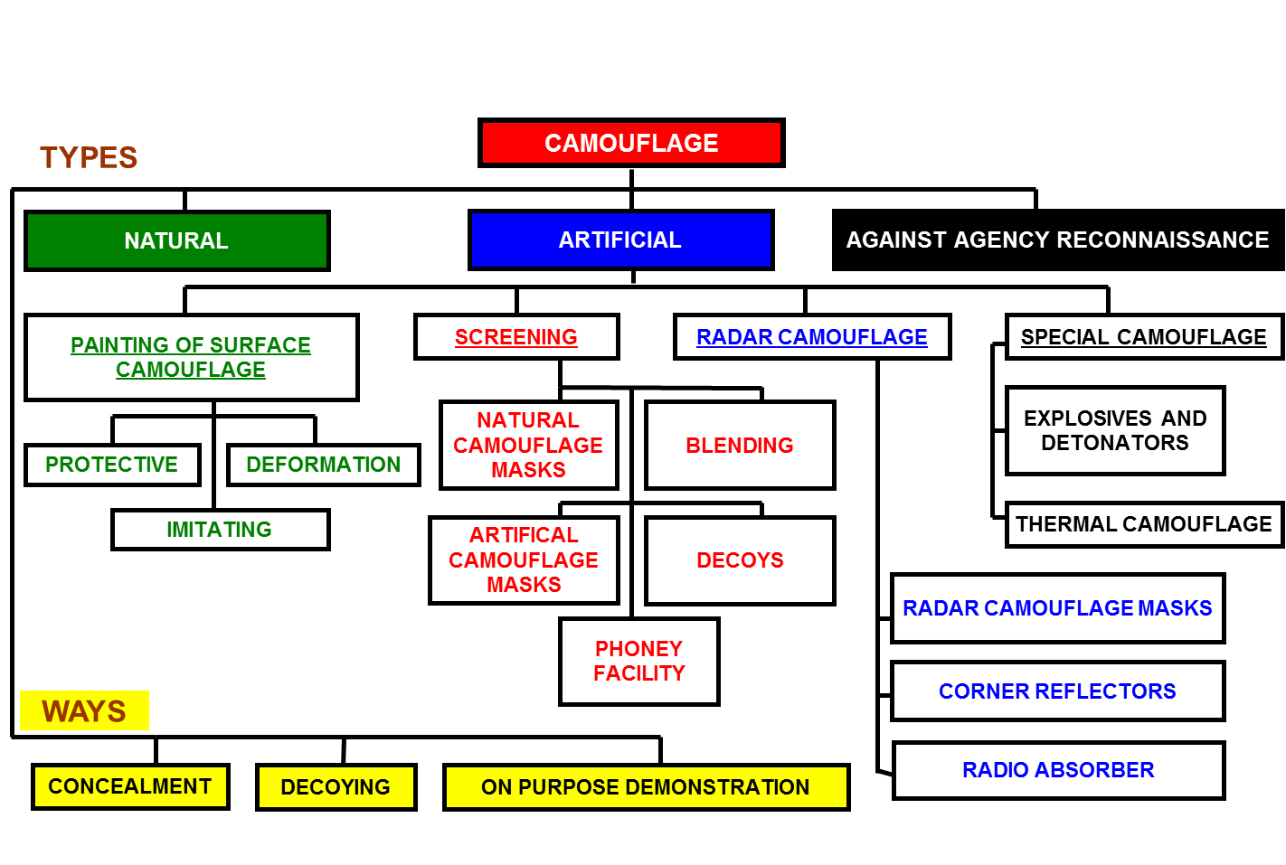

Figure3. Czech camouflage approach

Camouflage fundamentals
Color tone, color purity and luminosity is assessed during visual specifying of color surface. It depends on reflective characteristics, texture and color of object surface and its illumination, on reconnaissance means capability and on observed object distance.
Surface texture and illumination impact on color surface perception is characterized by lightening or darkening of this surface. It is caused by its ability more or less reflect incident light energy. Amount of reflected light energy depends on light ray incidence course and on observing angle.
The level of detectability depends on background or surroundings on that subject is projected. This dependence shows itself as luminance, color and energy (thermal, electromagnetic) contrast.
Color luminosity is the most important characteristics of color for the purpose of camouflage. With increasing distance of observer from observed object the the luminosity of dark blotches increases and the luminosity of white and light blotches decreases.
Depth perception of object´s shape is determined by ability to observe an object with both eyes. This ability enable to see object as aerial image for certain distance and to be able to specify configuration of particular object in space. With increasing moving away from observed object observer perceives it as surface.
Object perceiving by shadows is possible when sunny weather or well illumination, when the shadow is a clear camouflage sign enabling to determine dimensions and the shape of subject. The shadow may occur as primary shadow or cast shadow. As light and smooth the surface of shady neighborhood (background) is the darker cast shadow seems.
Limit of visibility is a distance of observed object from an observer from which this object is getting invisible for given type of reconnaissance. This limit depends on decamouflage signs of visual appearance (color, dimensions, shape and shadow), observation conditions (daytime, illumination, observation distance), type of surveillance mean and its range, contrast of object and background, atmospheric conditions limiting light transmission (dust, smoke, aerosol..) and the ability of observer.
Object perceiving by typical noise is limited by the way of a sound propagation and its audibility in the atmosphere. It depends on configuration of terrain and meteorological conditions (for example the audibility of noise decreases when hot and sunny weather or when rainy or fogy weather, or when snow is falling). The wind direction can speed up or slow down the sound wave motion. When strong wind many strong noises occur disabling to detect dim sounds.
Camouflage measures efficiency and expedience basic preconditions
- Forces' ability to conduct camouflage tasks and consistent adherence to camouflage discipline
- Proper camouflage preparation and organization
- Objects and operations decamouflage signs knowledge and their detection potential
- Preferential usage of natural camouflage measures
- Usage of proper prefabricated or local technical means to camouflage against visual, IR and RADAR reconnaissance
- Cogency, continuity, diversity and mutual relationship of camouflage measures

Camouflage measures choice limiting factors
- Distance from enemy
- Enemy´s technical reconnaissance means range and resolution
- Camouflage capacity of terrain
- Camouflaged object types and their usage conditions
- Meteorological conditions, season and daytime
- Available time, personnel and camouflage equipment
Cogency of camouflage depends on credibility of measures and their accordance with potential situation of own forces with rigorous complying with all potentials of enemy´s reconnaissance types and means.
Camouflage continuity is achieved with continuous execution of necessary camouflage measures in any situations during all military operations (combat, movement etc.).
Camouflage diversity requires non-maneristic organization and execution of camouflage measures, systematic searching and usage of new means and ways of camouflage.
DECAMOUFLAGE SIGNS
Decamouflage signs are characteristics of objects, forces and their actions by which they vary and differ from background and environment. They are classified as
- Outward appearance signs,
- Action and action foot-print signs,
- Place and location signs.
Outward appearance signs include:
- Color, luminance, dimensions and shape contrast,
- Primary and cast shadow,
- Objects' ability to reflect or emit radiation in invisible part of spectrum enabling enemy detect it using ways and means of reconnaissance.
Action and action foot-print signs occur as a necessary effect of forces' presence and activity or they are caused by camouflage discipline breaching. They may include:
- Personnel and equipment movement and activity (training, maintenance, reconnaissance, resupply etc.),
- Combat equipment foot-prints ( blowing dust, light during the night, engine noise etc.),
- Engineer bridging and road works, excavations, wood cutting etc.,
- Anti-aircraft fire,
- Liaison means operating,
- Direct combat activity,
- Material remains, waste,
- Excessive pathways creation,
- Rumpled grass.

Place and location signs are created with layout of objects, their place in battle formation and with mutual relationship of particular objects in any complex ensuring its readiness for action.
ISTAR
ISTAR - Intelligence, Surveillance, Target Acquisition and Reconnaissance
Intelligence. Encompasses three elements: a product, a process and an organization.
Surveillance. Systematic surveillance of the battle space provides for the collection of information via optical sensors, electronic detection devices, thermal imagery, satellites, UAVs, attended and unattended ground sensors and other means. It also cues reconnaissance and target acquisition resources.
Target Acquisition (TA). TA provides detailed information about enemy forces and locates them with sufficient accuracy to permit continued monitoring, other sensor cues or target designation and engagement.
Reconnaissance (Recce). Reconnaissance is active in nature. Recce assets are assigned missions to obtain information about the adversary or terrain
Electromagnetic energy may be reflected or dispersed. Two objects reflecting similar energy content of the same wavelength interval may in other interval reflect different energy content. Reflected and dispersed energy content is influenced with surface chemical and physical characteristics (temperature, water content, surface roughness etc.). Surfaces reflection properties form so-called SPECTRAL BEHAVIOUR. Here are bands of electromagnetic (EM) spectrum created by so-called „Atmospheric windows“ that are used to conduct reconnaissance using sensors detecting any types of EM radiation.
ULTRAVIOLET
The UV area is the part of the EM spectrum immediately below visible light. UV sensors are more important in snow-covered areas, because snow reflects UV energy well and most white paints and manmade objects do not reflect UV energy very well. Photographic intelligence systems with simple UV filters highlight military targets as dark areas against snow-covered backgrounds. These backgrounds require specially designed camouflage that provides a high UV reflectance
VISUAL
Visual sensors work in the parts of the EM spectrum that are visible to the human eye. Enemy soldiers’ eyes are the principle sensors on a battlefield. They may be aided by binoculars, telescopic sights, and image intensifiers. Civilian populations, enemy agents, recon teams, and patrols are visual-sensor systems from the enemy’s intelligence viewpoint. Three types of enemy visual sensors are—
- Image intensifiers. Image intensifiers are passive night-observation devices. They amplify the low-level light that is present on even the darkest nights. These devices are used for surveillance and as weapon sights on small arms and vehicles. Airborne platforms are also capable of supporting image intensifiers.
- Low-light television (LLTV). LLTV combines image intensification with television technology, and it is usually mounted on airborne platforms.
- Aerial recon, remote sensing, and imagery. Aerial photography, satellite imagery, and video imagery allow image analysts to record and study visual information. These analysts then produce target nomination lists that are, in effect, priority lists of targets in a given target scene. Since analysts often have to make subjective determinations of the identity and/or importance of a given target, the ranking of targets provides the defender with an opportunity to use CCD to impact an enemy’s target-prioritization process. Video systems allow transmission of visual images to the ground while the manned aircraft, satellite, or unmanned aerial vehicle (UAV) is still in flight.
NEAR INFRARED
NIR sensors operate at a wavelength immediately above the visible light wavelength of the EM spectrum. NIR energy reflects well from live vegetation but reflects better from dead vegetation and most man-made materials. NIR sensors, such as sights and periscopes, allow the human eye to detect targets based on differences in their reflection of NIR energy. NIR sensors are partially blocked by fog, mist, and smoke operations, although not as completely as visual sensors. An enemy’s combat vehicles use active NIR sensors that employ searchlights, scopes, and sights; but these sensors are rapidly being replaced with image intensifiers and thermal gun sights.
INFRARED
IR sensors detect the contrasts in heat energy that targets radiate on the battlefield and display the contrasts as different colors or shades. Because longer wavelength IR radiation is more susceptible to atmospheric absorption than NIR radiation, IR sensors are less affected by typical concentrations of fog or conventional smoke.
Differences in thermal mass and surface properties (reflectivity) of man-made and natural materials result in target-to-background contrasts. These contrast levels change dramatically over a daily cycle. For example, operating vehicles and generators, heated buildings and tents, and soldiers are usually hotter than their background. Also, equipment exposed to direct sunlight appears hotter than most natural backgrounds.
At night, however, equipment might appear cooler than its background if it is treated with special emissivity coatings. In other words, military equipment, particularly metallic equipment, generally heats up and cools off more quickly than its background.
Sophisticated, passive IR sensors (such as the Forward-Looking Infrared System [FLIRS]) can be mounted on aircraft. FLIRS sensors provide aircrews and enemy ground forces with real-time IR imagery that is displayed on video monitors.
Recon aircraft often employ special IR films to record temperature differences. Due to film processing, however, these systems are subject to time delays in obtaining the data. Newer versions of this sensor produce non-film-based images.
RADAR
Radar uses high-frequency radio waves to penetrate atmospheric impediments such as fog, mist, and smoke. Radar works by transmitting a very strong burst of radio waves and then receiving and processing the reflected waves. In general, metal objects reflect radar waves well, while radar waves are either weakly reflected by or pass through most other objects. The shape and size of a metal object determine the strength of the reflected signal. A large, metal object generally reflects more signal than a small object. Therefore, large, metal objects can be detected from greater distances. The method by which the received radio wave is processed determines the type of radar. Radar systems commonly used against ground forces on the battlefield include—
- Moving-target indicators (MTIs). When an EM wave hits a moving target, the wave is reflected and changes frequency. The faster the target moves, the larger the changes in frequency. The simplest and most common battlefield radar detects this frequency change. Threat forces use MTIs for target acquisition. More sophisticated developmental radar systems, such as the Joint Surveillance Target Attack Radar System (JSTARS), use airborne surveillance platforms that downlink captured data to ground-station modules in near real time. Ground-based operators are then able to manipulate the data and gain heightened situational information, which is forwarded to command-and-control (C2) nodes to enhance tactical decision-making.
- Imaging radar. An imaging radar’s receiver and processor are so sensitive that an image of the detected target is displayed on a scope. Imaging radar, such as side-looking airborne radar (SLAR), is generally used on airborne or space-borne platforms. Imaging radar typically does not provide the same resolution as the FLIRS and is less likely to be used for terminal target acquisition.
- Countermortar (CM) and counterbattery (CB) radar. CM and CB radar usually transmit two beams of energy that sweep above the horizon. An artillery or mortar round or a rocket passing through the beams reflects two signals that are received and plotted to determine the origin of the round.
Reconnaissance can be performed via many techniques:
- Ground reconnaissance is conducted with surveillance, listening, photography, night vision devices, TV cameras, RADARs, IR cameras etc.
- Surveillance is conducted with sight upgraded with optical or optoelectronic devices.
- Listening is conducted with pure hearing or with technical means (acoustic intelligence devices, monitoring devices, radio direction finder). This devices are used usually during the night when proper atmospheric conditions enable better sound audibility.
- Photographic reconnaissance (ground and air) is conducted with cameras equipped with tele objective, light optical filters etc. Cameras of big focal distance are able take photos at great distances and detect details. Panchromatic, color, infrared or spectrozonal film or chip is used. Direct surveillance conducted from aircraft is limited but aerial photography is the most widespread and reliable mean of reconnaissance.
- Night vision devices reconnaissance enables surveillance of enemy´s objects and operations. If IR floodlight is paced out of observer´s post he is undetectable.
- IR cameras and thermal weapon sights can detect all objects emitting thermal energy. This energy has to be as strong as to create contrast with background.
- UV binoculars enable detect contrast between natural or artificial white surface. They are used usually during the winter if terrain surface is covered with snow. Range of these devices is up to 400 meters and it depends on water vapor content in atmosphere.
- TV reconnaissance devices enable fast data and combat situation formations transfer to great distances.
- Air reconnaissance is conducted with surveillance, photography, TV cameras, RADARs, IR cameras etc. It serves usually to detect special combat equipment, command posts, headquarters, forces in assembly areas, movement of units etc.
- Agency reconnaissance is conducted with intelligence personnel.
- Space reconnaissance is conducted with satellites.

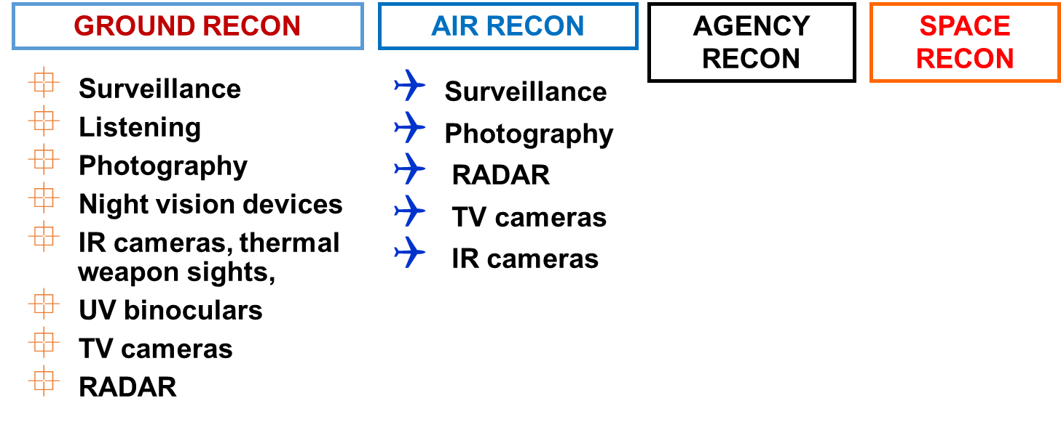

Figure4. Reconnaissance techniques

IR RECONNAISSANCE DEVICES
- Active first generation of surveillance means using optoelectronic image converter with IR floodlight. LASER target acquisition and designation system, LASER Rangefinder.
- Semi-active Night vision devices, image Intensifier of 1st and 2nd generation, Low Light Level Television (LLLTV) camera with very sensitive CCD(Charge Coupled Devices) detector and IR or spectrozonal photo cameras.
- Passive IR cameras and surveillance devices
A night vision device (NVD) is an optical instrument that allows images to be produced in levels of light approaching total darkness. Its function is based on residual light intensify. NVD may be the part of equipment or can be made as a personal device. It works in wavelengths of 700 to 1000 nm intensifying radiation to visible band of the electromagnetic spectrum. The image is usually displayed on green screen. User then sees it as monochromatic green image. Modern NVDs can display tactical data on screen (for example maps, GPS coordinates etc.).
IR binoculars are used with combat equipment to enable it to fire and to support orientation during the night. The range of IR binoculars is of 300 to 1200m.
IR sighting devices, IR detectors and IR cameras detect all objects emitting thermal energy contrasting with background.

RADAR RECONNAISSANCE
RADAR reconnaissance enables to detect subjects when visibility is decreased for example during the night or during bad meteorological conditions. The type of reconnaissance uses the ability of objects' surfaces to reflect incident electromagnetic energy. The basic condition for usage of RADAR is direct Line-of-Sight from RADAR position to target. The principle of RADARs is emission, reflection and interception of electromagnetic waves pulses. They are caught, processed and displayed as for example light spots on scope. Each RADAR has its typical characteristics. Some of them are significant:
- RADAR range,
- beamwidth,
- pulse length,
- wavelength,
- range resolution.
Objects scanned with RADAR are displayed as follows:
- concrete, bituminous and water surfaces – dark spots (contrast depends on surrounding terrain),
- buildings especially with metal parts, bridges etc. – light points or spots.
Reflection contrast is greater during summer.
AIR AND SPACE RECONNAISSANCE
Air reconnaissance is conducted with surveillance, photography, TV cameras, RADARs, IR cameras etc. It serves usually to detect special combat equipment, command posts, headquarters, forces in assembly areas, movement of units etc. It can be for example detected using aircrafts:
- sharp contour objects from the height of 400 to 500 m during dark night,
- great forces, tanks or trucks movement from the height of 600 to 1000 m during the light moonlit night,
- airports, roads, forces movements and engineer terrain works from the height of 2000 to 3000 m when properly illuminated.
Space reconnaissance is conducted with satellites. Resolving power of space photo reconnaissance equals the resolving power of air reconnaissance from the height of 3000m.
GUIDED WEAPONS
In every Go-Onto-Target system there are three subsystems:
- Target tracker
- Missile tracker
- Guidance computer
The way these three subsystems are distributed between the missile and the launcher result in two different categories:
- Remote Control Guidance: The guidance computer is on the launcher. The target tracker is also placed on the launching platform.
- Homing Guidance: The guidance computers are in the missile and in the target tracker.
HOMING GUIDANCE
Active homing
Active homing uses a radar system on the missile to provide a guidance signal. Typically electronics in the missile keep the radar pointed directly at the target, and the missile then looks at this "angle" of its own centerline to guide itself. Radar resolution is based on the size of the antenna, so in a smaller missile these systems are useful for attacking only large targets, ships or large bombers for instance. Active radar systems remain in widespread use in anti-shipping missiles, and in „fire-and-forget" air-to-air missile systems.
Semi-active homing
Semi-active homing systems combine a passive radar receiver on the missile with a separate targeting radar that "illuminates" the target. Since the missile is typically being launched after the target was detected using a powerful radar system, it makes sense to use that same radar system to track the target, thereby avoiding problems with resolution or power, and reducing the weight of the missile. Semi-active radar homing (SARH) is by far the most common "all weather" guidance solution for anti-aircraft systems, both ground- and air-launched.
It has the disadvantage for air-launched systems that the launch aircraft must keep moving towards the target in order to maintain radar and guidance lock. This has the potential to bring it within range of shorter-ranged IR-guided missile systems. It is an important consideration now that "all aspect" IR missiles are capable of "kills" from head on, something which did not prevail in the early days of guided missiles. For ships and mobile or fixed ground-based systems, this is irrelevant as the speed (and often size) of the launch platform precludes "running away" from the target or opening the range so as to make the enemy attack fail.
SALH is similar to SARH but uses a laser as a signal. Another difference is that most laser-guided weapons employ a turret-mounted laser designator which increases the launching aircraft's ability to maneuver after launch. How much maneuvering can be done by the guiding aircraft, will depend on the turret field of view and the systems ability to maintain a lock-on while maneuvering. As most air-launched, laser-guided munitions are employed against surface targets the designator providing the guidance to the missile need not be the launching aircraft; designation can be provided by another aircraft or by a completely separate source (frequently troops on the ground equipped with the appropriate laser designator).
Passive homing
Infrared homing is a passive system in which heat generated by the target is detected and homed on. Typically used in the anti-aircraft role to track the heat of jet engines, it has also been used in the anti-vehicle role with some success. This means of guidance is sometimes also referred to as "heat seeking“.
Contrast seekers use a television camera, typically black and white, to image a field of view in front of the missile, which is presented to the operator. When launched, the electronics in the missile look for the spot on the image where the contrast changes the fastest, both vertically and horizontally, and then attempts to keep that spot at a constant location in its view. Contrast seekers have been used for air-to-ground missiles, because most ground targets can be distinguished only by visual means. However they rely on there being strong contrast changes to track, and even traditional camouflage can render them unable to "lock on".

