Child victim of racist firebomb attack released from hospital after miracle recovery
12/03/2009

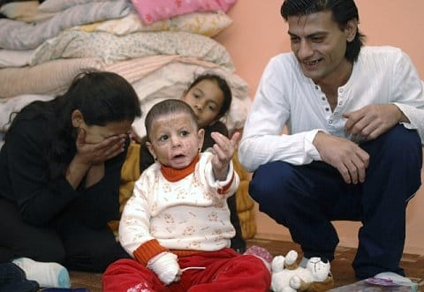
Many in the Czech Republic were shocked and outraged when neo-Nazis firebombed the home of a Romany family in north Moravia earlier this year. The family’s youngest daughter Natálka suffered horrific burns in the attack, and was not expected to survive. So there were scenes of joy on Wednesday when the two-year-old was released from hospital after eight months of intensive treatment.
Natálka laughed happily in the comfort of her family’s new home on Wednesday, a sight many did not expect to see when she was rushed to hospital with severe burns on 80 percent of her body. In the early hours of April 19 this year, the family’s small house in Vítkov, north Moravia was the target of a racist firebomb attack that also left both of her parents suffering from burns.
Over the last eight months, Natálka has undergone around 20 major operations. She was given a general anesthetic some 100 times to allow nurses at the intensive care unit of the children’s department at Ostrava hospital’s intensive care unit to change the dressing on her wounds. Three times doctors believed she was close to death, and the fact she has recovered enough to finally go home has been described as a miracle.
Though Natálka is now at home and playing once again with her three older sisters, her medical treatment is a long way from over. In fact, she will bear the consequences of April’s attack for the rest of her life.
Her parents will also have a lot to do, as Natálka will need to have ointment applied to her skin three times a day to prevent it drying and cracking. She will require a lot of exercise. What’s more, unlike most children of her age she has not yet learnt to walk, after her eight-month stay in hospital interrupted her normal development. Doctors say she is unlikely to remember anything other than her hospital bed.
The four neo-Nazis charged with firebombing Natálka’s family’s home are unlikely to appear in court before next spring. Three have confessed.
The medical insurer who has covered the cost of the child’s treatment says it will seek financial compensation from the perpetrators, as well as money to fund what is likely to be many years of medical care.
Author: Ian Willoughby

Latest development
Václav Cojocaru and Ivo Müller were to serve 20 years in prison for an arson attack on a Roma house in Vítkov in the Opava region, during which little Natálka and her family almost burned to death. However, the Šumperk court decided on their conditional release which became a reality on Tuesday and both men left the gates of Mírov prison. The court's decision shocked the government commissioner for the affairs of the Roma minority, Lucia Fuková, and even President Petr Pavel did not have much sympathy for it.

