- Numbers filling in: https://www.focus.olsztyn.pl/en-ordinal-and-cardinal-numbers-in-english.html
- https://english.lingolia.com/en/vocabulary/numbers-dates-time/ordinal-numbers/exercises
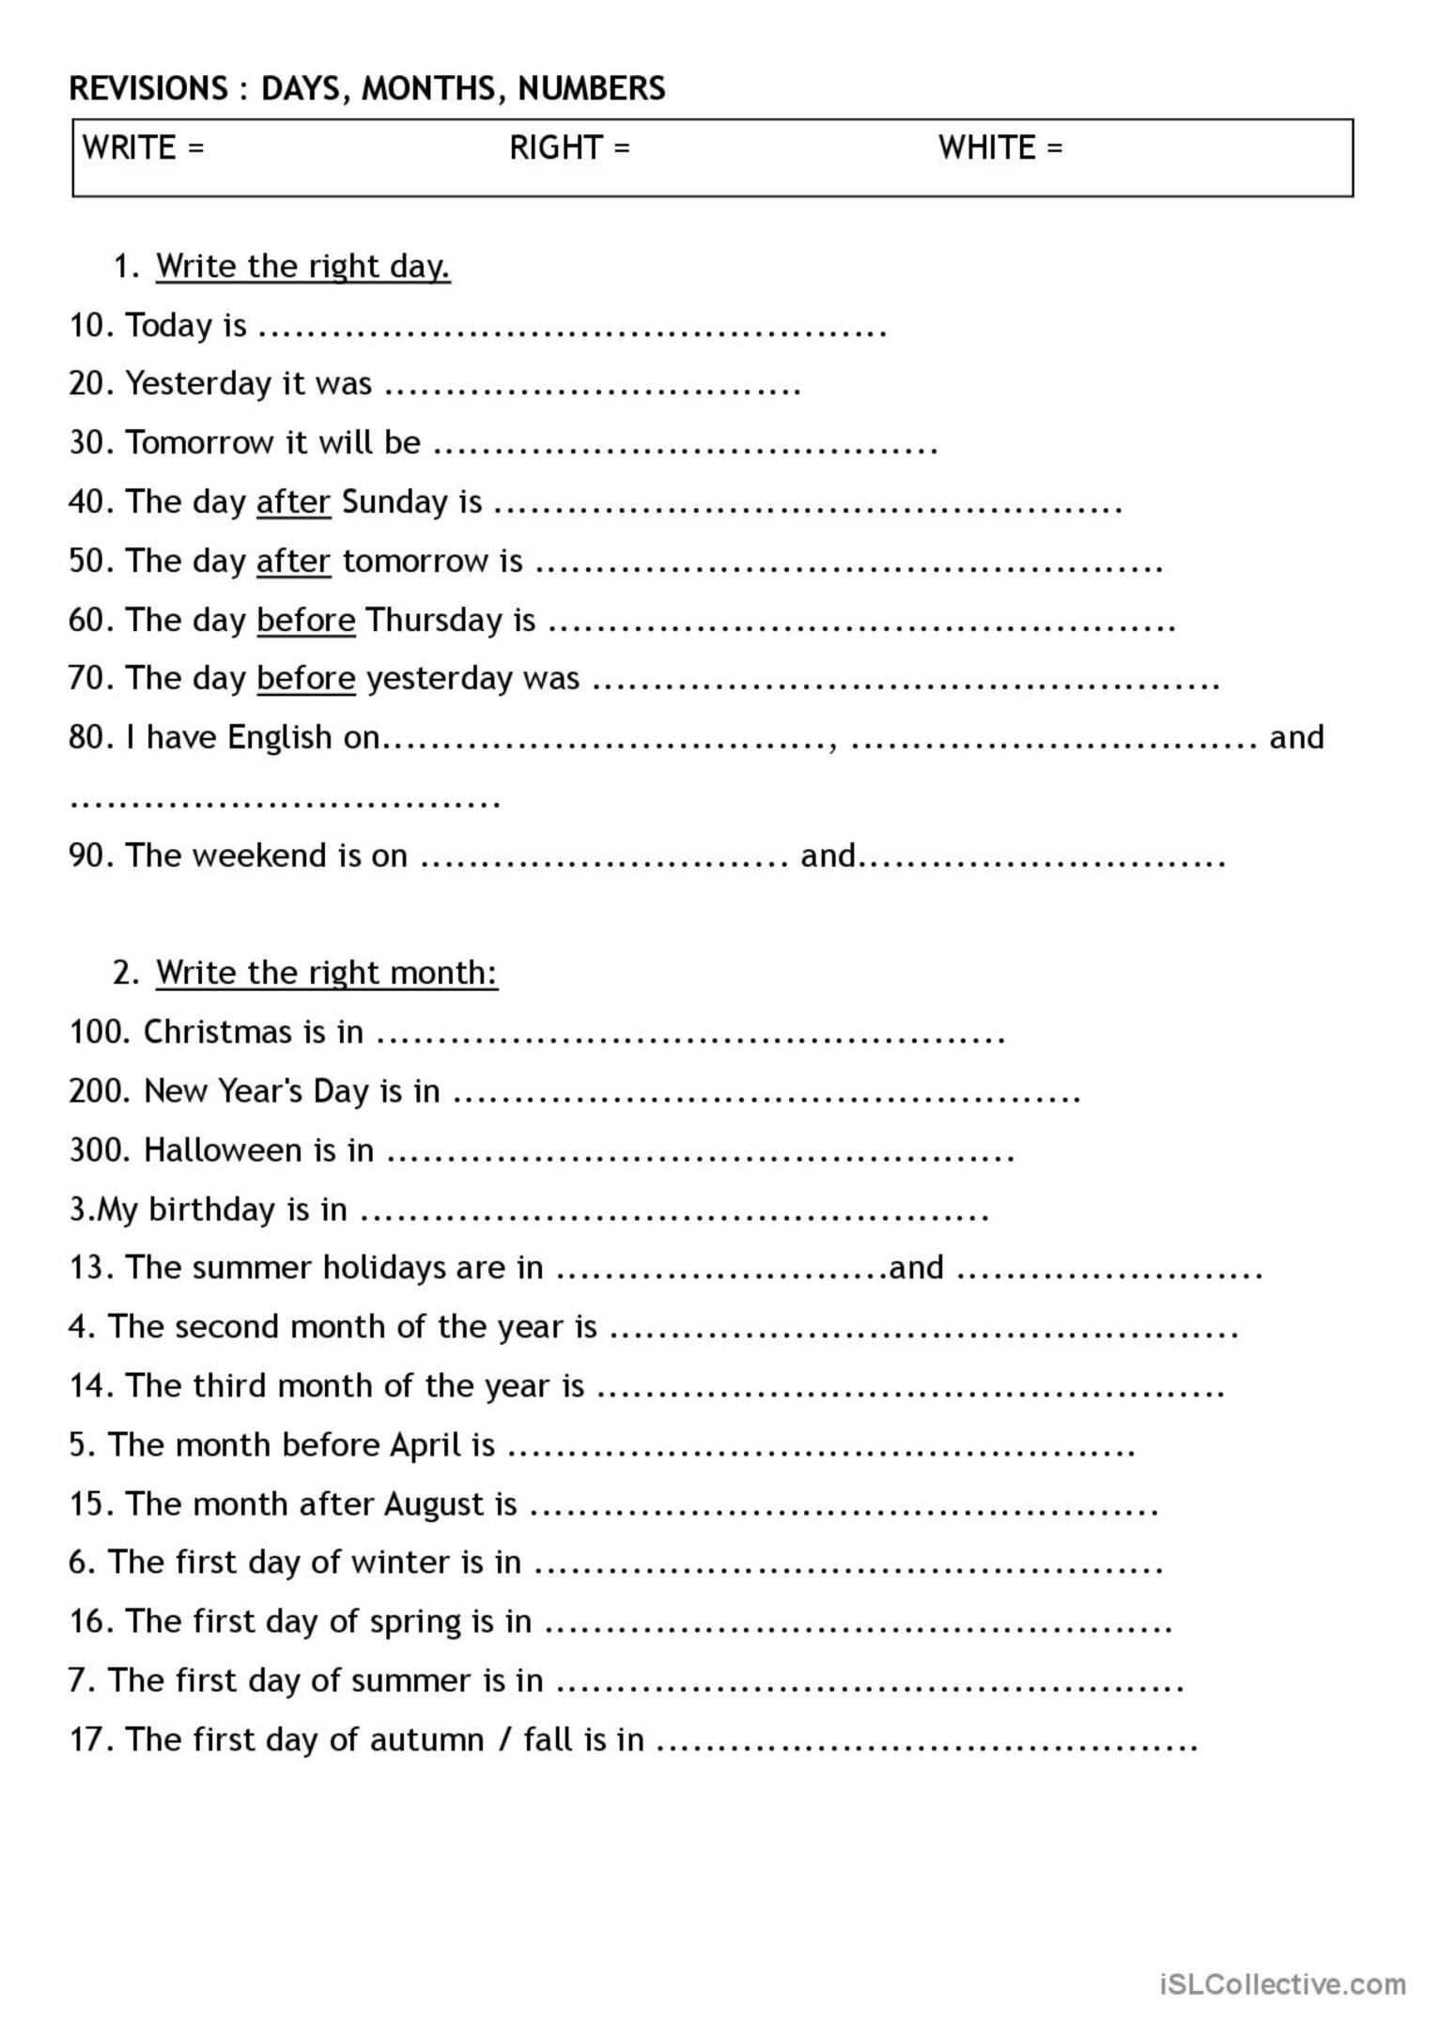
- https://test-english.com/grammar-points/a1/at-in-on-prepositions-time/
- https://test-english.com/grammar-points/a1/at-in-on-prepositions-of-place/2/

