The forgotten story of European refugee camps in the Middle East

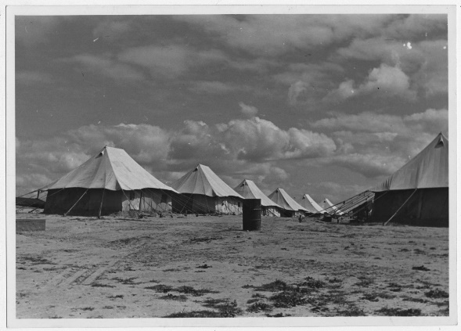
A picture from 1945 of a camp for Greek refugees in Nuseirat, southern Palestine. (United Nations Relief and Rehabilitation Administration)
Tens of thousands of refugees fled a war. They journeyed across the Eastern Mediterranean, a trip filled with peril. But the promise of sanctuary on the other side was too great.
No, this is not the plight faced by Syrian refugees, desperate to escape the desolation of their homeland and find a safer, better life in Europe. Rather, it's the curious and now mostly forgotten case of thousands of people from Eastern Europe and the Balkans who were housed in a series of camps across the Middle East, including in Syria, during World War II.
As the Nazi and Soviet war machines rolled through parts of Eastern Europe and the Balkans, vast civilian populations were displaced in their wake. In areas occupied by fascist troops, Jewish communities and other undesired minorities faced the harshest onslaught, but others, particularly those suspected of backing partisan fighters, also were subject to targeted attacks and forced evacuations.
Amid the upheavals, the clearest route of escape for some European refugees was south and east. Many ethnic Croats living along the Dalmatian coast fled to the Adriatic isle of Vis; Greek inhabitants of the Dodecanese, a string of islands in the Aegean, found their way to British protection in Cyprus.
A British-led scheme known as the Middle East Relief and Refugee Administration, launched in 1942 and facilitated by officials based in Cairo, helped provide for some 40,000 Poles, Greeks and Yugoslavs. (By 1944, the initiative would be subsumed under the auspices of the "United Nations," the formal term for the Allied alliance.) The refugees were spread out between camps in Egypt, southern Palestine and Syria — yes, Syria. Aleppo, an ancient and thriving metropolitan center, was already a veritable hub of emigres, exiles and spies in the 1940s.
A 1945 photo from El Shatt camp in Egypt shows women washing their clothes in the open air. (United Nations Relief and Rehabilitation Administration)
As a study of these camps published in April by Public Radio International notes, the effort attracted the involvement of myriad international aid groups and organizations, which helped feed and shelter the refugees and educate hundreds of refugee children.
PRI describes the process of their settlement:
Once registered, recent arrivals wound their way through a thorough medical inspection. Refugees headed toward what were often makeshift hospital facilities — usually tents, but occasionally empty buildings repurposed for medical care — where they took off their clothes, their shoes and were washed until officials believed they were sufficiently disinfected.
Some refugees — such as Greeks who arrived in the Aleppo camp from the Dodecanese islands in 1944 — could expect medical inspections to become part of their daily routine.
After medical officials were satisfied that they were healthy enough to join the rest of the camp, refugees were split up into living quarters for families, unaccompanied children, single men and single women. Once assigned to a particular section of the camp, refugees enjoyed few opportunities to venture outside. Occasionally they were able to go on outings under the supervision of camp officials.
When refugees in the Aleppo camp made the several-mile trek into town, for example, they might visit shops to purchase basic supplies, watch a film at the local cinema — or simply get a distraction from the monotony of camp life. Although the camp at Moses Wells [in Egypt], located on over 100 acres of desert, was not within walking distance of a town, refugees were allowed to spend some time each day bathing in the nearby Red Sea.
Toys made by refugees in El Shatt refugee camp in Egypt in 1945. (United Nations Relief and Rehabilitation Administration)
Conditions were squalid, but not entirely miserable. There were playgrounds and sports tracks and opportunities for leisure; residents who wanted to make a living or hone a craft were able to apply their trades or learn some through vocational training. In other cases, refugees were compelled to take up menial labor. Food was rationed and, in some instances, refugees were able to buy their provisions from local shops. Camp officials would stage plays and other recreational events.
The politics of the homeland often figured into the circumstances of the refugees' exile. In El Shatt camp in the Egyptian desert, according to one account, communist-sympathetic Yugoslav cadres dominated the functioning of the camp, bullied those who did not readily join their ranks, and attempted to indoctrinate myriad children with their propaganda.
In general, though, children were able to obtain at least a rudimentary education, as PRI details:
For the most part, classrooms in Middle Eastern refugee camps had too few teachers and too many students, inadequate supplies and suffered from overcrowding. Yet not all the camps were so hard pressed. In Nuseirat, for example, a refugee who was an artist completed many paintings and posted them all over the walls of a kindergarten inside the camp, making the classrooms “bright and cheerful.” Well-to-do people in the area donated toys, games, and dolls to the kindergarten, causing a camp official to remark that it “compared favorably with many in the United States.”
Croatian children write the words for "our school" in the sand at Tolumbat camp in 1945. (United Nations Relief and Rehabilitation Administration)
Meanwhile, under a similar scheme, Iran had participated in the settlement of tens of thousands of Poles who were escaping Nazi slaughter and Soviet work camps. It's estimated that somewhere between 114,000 and 300,000 Poles reached Iran between 1939 and 1941, when waves of desperate and often feebly ill migrants arrived on the Iranian shores of the Caspian Sea.
A fascinating U.S. newsreel film of the time, see above, depicts a Polish refugee camp equipped by the American Red Cross in northern Iran, where Poles fleeing war can keep their language and customs alive while "tilling the ancient soil of Persia" and training in the ranks of a new anti-fascist Polish army.
For many Poles, arriving in Iran was a huge relief, a respite from the trauma of Nazi and Soviet atrocities. They were largely greeted with open arms by their hosts. "The friendly Persian people crowded round the buses shouting what must have been words of welcome and pushed gifts of dates, nuts, roasted peas with raisins and juicy pomegranates through the open windows," recalled one Polish schoolteacher who took up residence in the city of Isfahan.
Ultimately, after the conclusion of World War II, most of the European refugees in Iran and elsewhere in the Middle East either returned home or moved elsewhere. And the positive memory of their Middle Eastern sojourn features little in contemporary conversations now about the current influx of Muslim migrants entering Europe — Poland's right-wing government has been vociferously opposed to housing any Syrian refugees.
According to an Associated Press article in 2000, only 12 survivors of the Polish exodus were still living in Iran. They lived their own lives, married locals, and were not particularly close. "Occasionally, they get together for Christmas at the embassy or at rare reunions," the AP reported. But it added: "They would rather forget the tragedy that binds them."

By Ishaan Tharoor June 2, 2016

