KEY
Pre-listening activities
I.
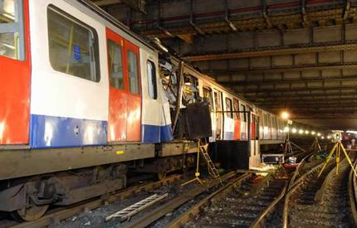 | 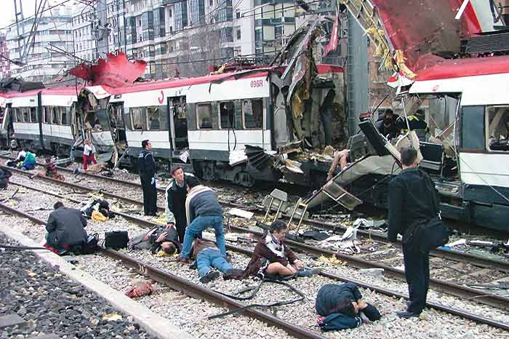 | 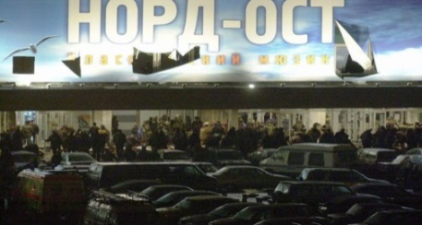
LONDON(UK) | MADRID(Spain) | MOSCOW(Russia)
July 7th, 2005 | March 11th, 2004 | October 26th, 2002
Al-Qaeda | Islamic militants | Chechen rebels
 | 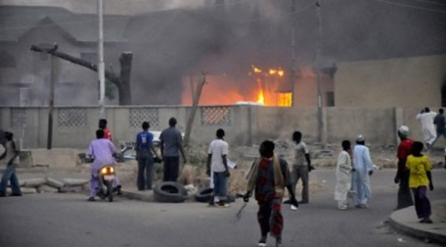 | 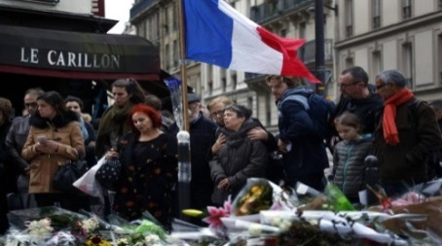
NEW YORK(USA) | KANO(Nigeria) | PARIS(France)
September 11th, 2001 | January 20th, 2012 | November 13th, 2015
Al-Qaeda | Boko Haram | ISIS

III.

Endure | to suffer something difficult or unpleasant in a patient way over a long period
Tip off | to give someone a warning or secret information about something
Scrutiny | careful examination of someone or something
Atrocity | a cruel and violent act, often in a war
Awareness | knowledge or understanding of a subject, issue, or situation
Disrupt | to interrupt something and prevent it from continuing by creating a problem
Plot | a secret plan to do something bad, made by two or more people
Militants | someone who uses militant methods to achieve something
Raid | a sudden short military or police attack
Counter-terrorism | the actions and methods that are intended to stop the activities of people who use violence to achieve political aims
Go to ground | to hide from people who want to catch you, usually for a long time

Listening activities

IV.

5.000 – number of Europeans who traveled to Syria to join the fight there
Raffaello Pantucci – the director of international security studies at the Royal United Services Institute
France, Belgium and Germany – there were raids going on to track suspected terrorists
battlefield – Syria and Iraq
legislation – that means you can be convicted for planning to join an organization or conduct a terrorist act abroad
lone actor terrorist threats – terrorist threats that don't appear on existing radars

V.

- What case did Mr.Pantucci mention when he was talking about the raids to track possible terrorists?

Belgian case, they seem to disrupt what looked like a very active group of individuals who were plotting an atrocity.

- How do security agencies track someone who comes back from Syria?

authorities have some awareness of them, the individual may have been on a broader security radar

- Why is it difficult to track suspected individuals?
the huge number of people going back and forth and the relative ease of mobility from a lot of continental European countries to Turkey and ultimately to Syria and Iraq
- What are some European countries doing to disrupt terrorist networks?

traditional counter-terrorism work

Post-listening activities

VI.

Complete the prepositions into the text.

1. Police in France, Belgium and Germany have swept ___up____ more than two dozen suspected terrorists in the last couple of days as investigators search Western Europe ___for___ possible militants.
2. At the same time, do some of these raids just tip ___off____ other members of the network and they go to ground?
3. …….the individual may have been on a broader security radar, and then suddenly his telephone goes ___off___ in Turkey.
4. There are some indicators of people they should be watching ___out___ for.
5. Mr. Pantucci, what keeps you ___up___ at night?
6. The point at which they become interested in these ideas to the point at which they take action is a process that can stretch ____over____ almost a decade.

Post-reading activities

IV.

Answer the questions.

- According to the article, what is wrong with locking up suspected terrorists indefinitely?

No one should be imprisoned, deported or executed without the independent judgment of a court of law. This is an essential part of what is known as the rule of law.

- What justification is given for compromising the principle that people should not be kept in prison without being given a fair trial?

Extraordinary situations call for extraordinary measures.

- What is the criticism of the intelligence reports that often form the basis for the arrest of suspected terrorists?

The reports relied on unproven allegations in foreign newspapers or on allegations from informers who were being paid and had reasons to lie.

- What is the alternative policy that has been adopted in Sweden?

When evidence was lacking, they adopted the policy of releasing suspects and then keeping them under constant surveillance. The suspects know they are being watched and having their calls intercepted 24 hours a day.

V.

Find the words or collocations in the text.

- detain
- tried
- contravene
- execute
- deported
- plotting
- trample
- convicted
- wreak havoc
- prone
- distorted
- scrutiny
- surveillance

