LISTENING

TERRORISM

Pre-listening activities

- Complete the table using the information below. What do you know about the events? Discuss in pairs or groups.

city/country date terrorist groups

LONDON(UK)
MOSCOW(Russia)
MADRID(Spain)
KANO(Nigeria)
NEW YORK(USA)
PARIS(France)

September 11th, 2001
March 11th, 2004
July 7th, 2005
January 20th, 2012
November 13th, 2015
October 26th, 2002

Al-Qaeda
Al-Qaeda
Chechen rebels
Boko Haram
ISIS
Islamic militants

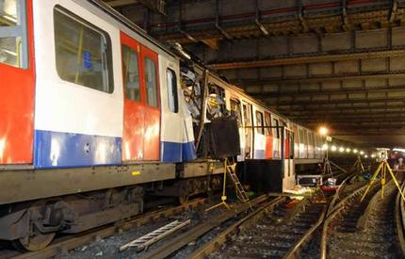 | 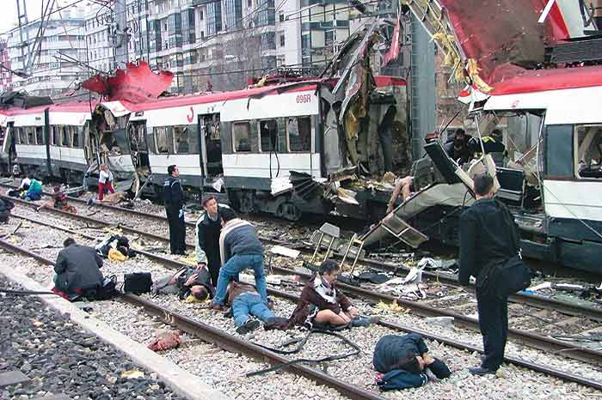 | 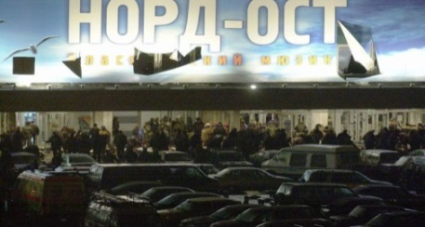
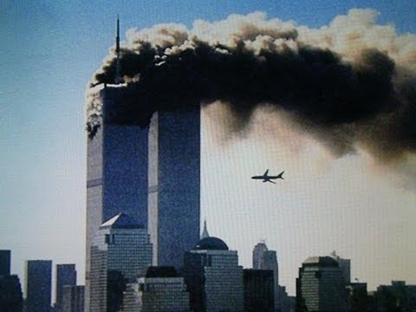 | 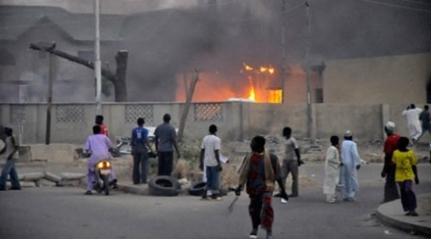 | 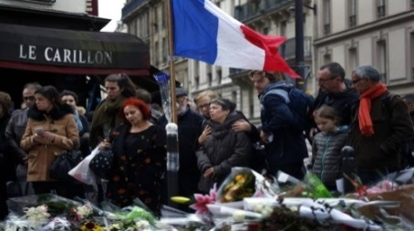
- Discuss the questions in pairs.

- There is no agreed definition of terrorism. People and groups accused of terrorism do not usually see themselves as terrorists. They see their violence as justified, and usually talk about it in terms of a struggle for freedom. This has given rise to the cliché – ‘one person’s terrorist is another person’s freedom fighter.’ Should perpetrators of political violence be considered terrorists, freedom fighters, or maybe even a mix of the two?

- In deciding whether something is terrorism, is the motive behind the violence important or should we just consider the violence itself?

- Match the expressions with their definitions, make sure you understand what they mean. All the expressions occur in the interview you are going to hear.

Endure | the actions and methods that are intended to stop the activities of people who use violence to achieve political aims
Tip off | a secret plan to do something bad, made by two or more people
Scrutiny | a cruel and violent act, often in a war
Atrocity | to suffer something difficult or unpleasant in a patient way over a long period
Awareness | to give someone a warning or secret information about something
Disrupt | a sudden short military or police attack
Plot | knowledge or understanding of a subject, issue, or situation
Militant | careful examination of someone or something
Raid | to interrupt something and prevent it from continuing by creating a problem
Counter-terrorism | someone who uses militant methods to achieve something
Go to ground | to hide from people who want to catch you, usually for a long time

Listening activities
Europe's Massive Task: Tracking Extremists By The Thousands

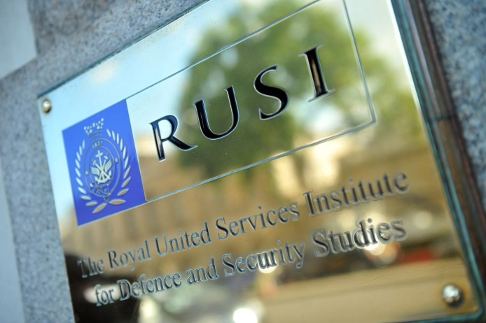

- Listen and write down what the expressions refer to:

5.000 Raffaello Pantucci France, Belgium and Germany

battlefield legislation lone actor terrorist threats

- Listen again and answer the questions.

- What case did Mr.Pantucci mention when he was talking about the raids to track possible terrorist?

- How do security agencies track someone who comes back from Syria?

- Why is it difficult to track suspected individuals?

- What are some European countries doing to disrupt terrorist networks?

Post-listening activities

- Complete the prepositions into the text.

1. Police in France, Belgium and Germany have swept _______ more than two dozen suspected terrorists in the last couple of days as investigators search Western Europe ______ possible militants.
2. At the same time, do some of these raids just tip _______ other members of the network and they go to ground?
3. ...the individual may have been on a broader security radar, and then suddenly his telephone goes ______ in Turkey.
4. There are some indicators of people they should be watching ______ for.
5. Mr. Pantucci, what keeps you ______ at night?
6. The point at which they become interested in these ideas to the point at which they take action is a process that can stretch __________ almost a decade.

- Discuss the questions in pairs.

- What motivates people to join organisations which carry out violent attacks on non-military targets? In what extreme circumstances might you be motivated to join such an organization?

- What can people do to protect non-military targets from violent attacks?

- What, in your opinion, do bombing campaigns achieve?

- Divide into 3 groups, each group will choose the most effective strategy for international change, prepare arguments, present (or persuade).

Which do you think is the more effective strategy for international change (and why)?

peaceful protests such as
marches, demonstrations, petitions etc.

peace talks, diplomacy,
international summit meetings etc.

violent attacks such as
assassinations, bombings etc.

