READING

TERRORISM

Pre-reading activities

- As a group, discuss what the following words mean. What features make them different from each other? Or are they the same?

freedom fighters rebels guerrillas terrorists

- Answer the questions in pairs.

1. Describe examples of acts of terrorism.
- Thinking about those particular examples, what might have been the motives of the terrorists? What might they have been trying to achieve?
- Is it necessary to understand why people carry out violent acts? Is it helpful to understand the political and social causes?
- Is there a difference between condoning something (approving of it, saying it is ok)
and trying to understand it?
- Read the information about African National Congress and then answer the question
below.
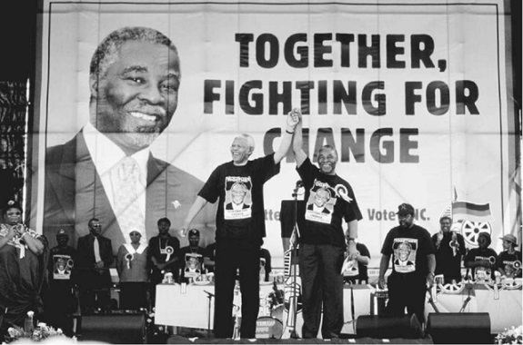
African National Congress
The African National Congress was in many ways the backbone of the resistance against Apartheid. It began by using peaceful methods to oppose the system. The Sharpville Massacre in 1960 – where many black peaceful demonstrators were shot in the back by police – was a powerful factor in the ANC decision to take up arms against the system. In 1964 Nelson Mandela – leader of the ANC’s armed wing – was sentenced to life imprisonment for terrorism. Margaret Thatcher, prime minister of Britain in the 1980s, called the ANC a terrorist organisation, and her spokesman famously said that anyone who believed that the ANC would ever form the government of South Africa was ‘living in a cuckoo land.’ Apartheid came to an end in 1994 and ANC formed the new government with Nelson Mandela as president.

Was ANC or was not a terrorist group? What are your arguments?

- Do you know what an allegation is?
(If I allege that you are a terrorist, I accuse you of being a terrorist even though we can’t yet prove for certain that you are one.)
Reading activities

- Read the text and write down the main idea.
_________________________________________________________________________________________________________________________________________________________________________________________________________

The Rule of Law:
A victim in the war against terrorism?

If the police in the UK or the USA receive information alleging that someone is connected somehow with a terrorist organization, they can arrest the person and hold him in a prison cell indefinitely. American authorities have also arrested suspects abroad (e.g. Omar Deghayes, who grew up in England, was arrested in Pakistan and then detained in a special American prison in Cuba). Suspects have been kept locked up for years like this, without being taken to court and tried, and without even being told why the authorities suspect that they are terrorists.
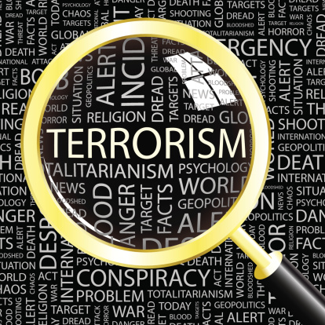
This contravenes some of the basic principles established over the centuries in our legal systems. One very basic principle is that no one should be imprisoned, deported or executed without the independent judgment of a court of law. This is an essential part of what is known as the rule of law. There may be a number of people the government would like to lock up or execute or deport, but if there is respect for the rule of law it will have to gather the evidence and prove its case in court. For the proceedings to be fair, the accused must have an independent lawyer, and both he and his lawyer must be able to question the evidence that has led to the arrest.

It is often argued that extraordinary situations call for extraordinary measures. The rule of law may be fine in ordinary circumstances but when you have someone who may be plotting to kill hundreds or thousands of people, you don’t want to take any risks, even when that means trampling on a few long-established principles. If you are pretty sure you have a terrorist in your prison cell, but you don’t have enough evidence to convict them, it is better to keep them locked up than to release them and find out later that they have hijacked a plane and are going to crash it into your capital city.

The problem is that many innocent people are locked up along with the few individuals who are determined to wreak havoc. The acute sense of injustice in the communities from which they came means that more young people will find extremist ideas attractive. In this way the supposedly anti-terror legislation may turn out to be legislation that actually helps the spread of terrorism.

One of the reasons why so many innocent people are locked up concerns the intelligence reports that are usually the basis for the arrests. Sir Peter Heap, a former ambassador, said he had often seen reports which were little more than gossip – reports which relied, for instance, on unproven allegations printed in foreign newspapers or on allegations from informers who were being paid and had reasons to lie. “The whole system of intelligence gathering is prone to producing inadequate, unreliable and distorted assessments... Very rarely is intelligence material subject to the same scrutiny and testing as information governments receive from other sources.”

There is an alternative approach. Take Sweden, for example. When the Swedish government debated the issue of whether to detain terrorist suspects without a proper trial or to maintain the high standards of their legal system, it chose the latter. When evidence was lacking they adopted the policy of releasing suspects and then keeping them under constant surveillance. The suspects know they are being watched and having their calls intercepted 24 hours a day.

Post –reading activities
- Answer the questions.
1. According to the article, what is wrong with locking up suspected terrorists
indefinitely?
2. What justification is given for compromising the principle that people should not be
kept in prison without being given a fair trial?
3. What is the criticism of the intelligence reports that often form the basis for the
arrest of suspected terrorists?
4. What is the alternative policy that has been adopted in Sweden?

- Find the words or collocations in the text.
- (paragraph 1) If you keep someone in a place against their will, you d...................
them.
- (paragraph 1) You are t................ when you are brought before a judge in a court of
law.
- (paragraph 2) A more formal alternative for the verb “break” when we talk about
people breaking laws and rules is c.....................................
- (paragraph 2) Different countries use different techniques when they e........................... prisoners: hanging, lethal injection, the electric chair, firing squad, etc.
- (paragraph 2) If you are a foreigner and are d........................., the police put you on a plane or a boat back to your country of origin.
- (paragraph 3) Instead of saying that someone is planning a crime, you can say they
are p.............................. to commit the crime.
- (paragraph 3) Literally the word t......................means step on something or walk
over it and damage it in the process.
- (paragraph 3) When a judge or jury decides that the accused is guilty of a crime,
that person is c.............................. of the crime.
9. Which 2-word phrase in paragraph four means: “to cause widespread destruction”?
...................................................
- (paragraph 5) I am very forgetful. In other words, I am p..................... to forget
things.
- (paragraph 5) I gave a talk that was mildly critical of the government. A journalist then wrote an article making it sound as if I was plotting to overthrow the government. He d............................. what I had said. (i.e. he changed it in a way that created a false impression)
- (paragraph 5) If you think that reports should be looked at carefully and checked, you think that they should be subject to s......................
- (paragraph 6) If you are being followed by detectives wherever you go, and if your phone is being tapped, the police are keeping you under s............................

- Work in pairs and discuss this situation.
When thinking about the treatment of terrorist suspects we have the perfect example of a moral dilemma. Imagine you are the chief of police and you have arrested a man who you think knows where a bomb has been planted. If he refuses to admit that he knows and reveal the location, is it acceptable to use a little torture to “persuade” him to cooperate? The renowned lawyer and professor at Harvard University, Alan Dershowitz, has argued that in such a situation the police would be justified in using torture to extract the information. Do you agree with him? What are your reasons?

WRITING
What is your opinion about the best way to respond to the threat posed by terrorism? In the face of a threat like this, is it right to compromise the principles that have been cornerstones of a fair legal system?

