English in the News

Intermediate level

Football racism: Messages of support to be saved
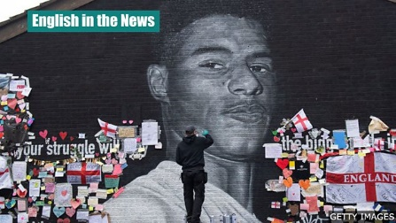

The story
Messages of support and solidarity have been left on a mural of footballer Marcus Rashford. These messages will now be preserved.

Useful vocabulary
solidarity – feeling of unity or agreement of an action
mural – large picture painted onto a wall
preserved – saved
defaced - damaged
heartfelt – emotional
cover up – hide or stop from being seen
street artist – artist who paints on walls in the streets
portrait – picture of a person
commissioned – chose someone to do some artwork
retained – kept; continue to have something
recorded – document or evidence of something kept
swear words – bad or offensive language
spot kicks – informal word for a penalty kick
forward – striker; footballer who plays in attack
tackle – deal with a problem
force – department of the police
tribute – something said or written which shows respect
gathered – grouped in once place
What has happened?
Hundreds of supportive notes were placed on an image of Marcus Rashford which was defaced following England's Euro 2020 final defeat to Italy.
The wall art is located in Withington, Manchester, and the heartfelt messages were placed to cover up damage.
Akse, the street artist who created the portrait, has now repaired the damage. Ed Wellard, who commissioned the mural, stated that a final decision had yet to be made but the notes and messages would be "retained, recorded and if possible displayed".
What happened before the mural was damaged?
The artwork was defaced with several swear words shortly after Rashford missed a penalty in the 3-2 shootout loss to Italy on Sunday.
Marcus Rashord, Jadon Sancho and Bukayo Saka all missed their spot kicks in the final. The three players were also targeted with racist abuse on social media after the game.
Who is Marcus Rashford?
Marcus Rashford is a forward who plays for England and Manchester United.
Outside of football, he is known for his campaigns to tackle child hunger.
What have the police done?
Greater Manchester Police have launched an investigation. The force received a report of racially aggravated damage at the mural at 02:50 BST on Monday.
A social media post which was directed at the England players on Sunday is also being investigated.
A 37-year-old man, from Trafford, has since been arrested.
What has Marcus Rashford said?
Rashford said he was sorry for missing his penalty and that he "wished it had gone differently". He also paid tribute to those who added the supportive messages to the mural.
The Manchester United forward also said he was "lost for words" as hundreds of people gathered for an anti-racism demonstration at the mural on Tuesday evening.
People took the knee at the Stand Up to Racism demonstration and several speakers addressed a crowd of around 700 people.
Find out more from the original BBC report and read reaction here.

Questions about the story...
1. When was the mural damaged?
2. Where is the mural located?
3. Who is Akse?
4. Outside of football, what is Marcus Rashford known for?
5. What has Marcus Rashford said about that penalty miss?

The answers
1. When was the mural damaged?
The mural was defaced following England's Euro 2020 final defeat to Italy, shortly after Marcus Rashford missed a penalty.
2. Where is the mural located?
The wall art is located in Withington, Manchester.
3. Who is Akse?
The street artist who painted the mural.
4. Outside of football, what is Marcus Rashford known for?
Outside of football, he is known for his campaigns to tackle child hunger.
5. What has Marcus Rashford said about that penalty miss?
Rashford said he was sorry for missing his penalty and that he "wished it had gone differently".

