CLAUSES OF CAUSE OR REASON

Clauses of cause or reason are introduced by the subordinating conjunctions because, as, since and that.
- I sing because I like singing.
- He thinks he can get anything because he is rich.
- Since he has apologized we will take no further action against him.
- As he was not there I left a message with his mother.
- I am glad that you have come.
- My parents were disappointed that I didn’t get the scholarship.
- He was furious that his book was panned by most reviewers.
Notes
The conjunction that is often omitted.
- I am glad you like it. OR I am glad that you like it.
- They were disappointed you weren’t in. OR They were disappointed that you weren’t in.
As and since are used when the reason is already known to the listener.
- As it is raining again we will have to cancel the match.
As and since-clauses are relatively formal. In an informal style, the same idea can be expressed with so.
- It is raining again, so we will have to cancel the match.
Because-clauses are used to give information which isn’t already known to the reader or listener.
- Because he had not paid the bill, his electricity was cut off.
Note that a because-clause can stand alone. As and since-clauses cannot be used like this.
- ‘Why are you looking at her like that?’ ‘Because she smiled at me.’ (NOT As she smiled at me.) (NOT Since she smiled at me.)

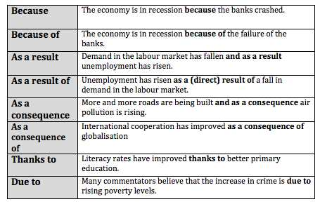

Purpose:
- We had a meeting today so as to discuss next year's programme.
- He did all he could for her not to worry.
- I moved to France so that I could improve my French.
- Everyone did their best in order to finish the work.
- He is looking for a part time job to save some pocket money.
Reason:
- Since you don't believe me, I won't give evidence.
- Because of his lack of training he had difficulties finding a job.
- He gave him his jacket out of pity.
- On account of the weather we didn't go for a walk.
- Billy was punished for lying to his teacher.
- Owing to the snow, the planes couldn't take off.
- As you are a foreigner you can't express your opinions on the situation in the area.
- Seeing that you aren't interested I' ll do it by myself.
Result:
- He missed the early train, as a result he was too late for the job interview.
- The result of his trial, therefore, could hardly have been other than a foregone conclusion.
- If he locked the door, then Kitty is trapped inside.

https://www.ecenglish.com/learnenglish/lessons/clause-purpose
http://www.englishexercises.org/makeagame/viewgame.asp?id=6268
https://www.myenglishpages.com/site_php_files/grammar-exercise-purpose.php
https://www.test-english.com/grammar-points/b2/clauses-contrast-purpose-reason-result/

CONTRAST AND CONCESSION CLAUSES

1. Although, even though, and though
Although and even though are two common adverbs to express unexpected results or surprises. They are subordinators: adverbs that show that one idea is more important than the other.

I managed to fall asleep although we were watching an action movie.
Although we were watching an action movie, I managed to fall asleep.

In both sentences, the subordinating conjunction although is attached to the clause that contains the less important idea. “Although we were watching an action movie,” cannot stand alone as a sentence; it is a subordinate clause. If the subordinate clause comes first, we must separate the two by using a comma. If the subordinate clause comes second, there is no comma.

These students already know how to read even though they are still in kindergarten.
Even though these students are still in kindergarten, they already know how to read.

Though is less formal than although and even though. It is more common in spoken English.

Though John waited for almost an hour, his doctor never showed up.
John’s doctor never showed up though he waited for almost an hour.
To make your sentence even more conversational, you can move though to the end:
John waited for almost an hour. His doctor never showed up, though.
2. In spite of, despite
In spite of and despite are also subordinators to show unexpected results. They also come attached to the subordinate clause. However, they require a different sentence structure.

That man has saved a lot of money in spite of earning a small salary.
That artist is very creative despite having limited resources.
In these examples, in spite of and despite are followed by a gerund.
Despite and in spite of can also be followed by noun phrases.
My brother has managed to save a lot of money in spite of his small salary.
That artist is very creative despite her limited resources.

In spite of that
In spite of that can also be used to indicate contrast or concession, but it works as a coordinating conjunction. Therefore, it is used to connect two independent clauses.

Most students had understood the explanation; in spite of that, the teacher wrote a few more examples.
It rained for almost three hours non-stop. In spite of that, the ground is already dry.

http://www.ats.edu.mx/ifs/salc/?tag=concessive-clauses-exercises

